TABLE OF CONTENTS

- Background of the Political Disorder in Lebanon
  - From Independence to Civil War
  - Lebanese Civil War
  - Taif Accord
  - Cedar Revolution and Second Lebanese War
- Special Tribunal for Lebanon
  - Its Origins, Mandate, and Failure
  - The mandate of the Tribunal in this Committee
- Lebanese Parliament
  - March 8 Coalition
    - Hezbollah
    - Amal Movement
    - Free Patriotic Movement
    - Marada Movement
  - March 14 Coalition
    - Lebanese Forces
    - Future Movement (now defunct)/National Moderation Bloc
    - Kataeb/Phalange Party
  - Non-Aligned and Anti-Establishment Groups
    - Progressive Socialist Party
    - Taqaddom/Progress Party
    - Lana
- External Forces

1. Background of the political disorder in Lebanon

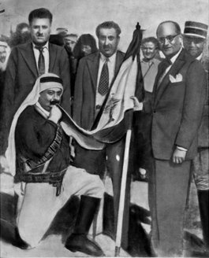
It is indeed possible to trace the origins of the current situation of Lebanese society and politics back to the late 18th century, but such a long trail may drive us away from contemporary realpolitik; therefore, we will take a closer look towards the recent history of Lebanon, in which lies the key events that have laid the cornerstones of the social and political structure of Lebanese life.

- From independence to the civil war

The country’s political system has been in place ever since the creation of Lebanon’s modern republic under the French mandate in the 1920s and was consolidated with the National Pact brokered between Lebanon’s sectarian leaders when the country gained independence in 1943 from Vichy rule; thus ever since Lebanon’s independence from France in 1943, the country has been ruled through consociationalism in which power is allocated based on sectarian affiliation. While the original motivation behind the implementation of this system was meant to be political inclusiveness for all Lebanon's recognized religious confessions (of which there are 18 as of 1974), the system ended up causing Lebanon to become a modern feudal state, in which political leaders did not work for the national interest but rather for the interest of the sectarian community they represented. No other phenomenon but the National Pact (al Mithaq al Watani) of summer 1943 can explain the main characteristics of post-independence Lebanese social-political structure; this unwritten agreement involved two major groups: the political elite of the Maronites representing the Christians in general and the political elite of the Sunnis representing the Muslims. In the National Pact, many issues were settled by the two leaders of Lebanese high politics: President Bishara al-Khuri and Prime Minister Riad al-Sulh. First, they agreed to view Lebanon as a neutral, independent, and sovereign entity having an Arab character (wajh arabi). Second, they agreed that Lebanon would not seek unity with Syria and the Arab World nor special ties to France in particular or the West in general. Third, the National Pact established a confessional formula providing for the representation of Christians and Muslims in a six to five-ratio throughout government. Furthermore, the offices of the President, Prime Minister, and Speaker of the House were assigned to the Maronite, Sunni, and Shia sects respectively. In practice, a sectarian formula was also applied to cabinet posts that, more often than not, were apportioned among the six largest religious communities in the country (and the Armenians who are considered a separate community). Other officially recognized religious communities were often excluded from cabinet representation. Similarly, parliamentary seats were distributed among the various religious communities following an agreed sectarian formula which, on the whole, favored the Christian community. The Christian sects combined were entitled to 55 percent of the total number of seats.
Picture 1: Sabri Hamadah (center), Speaker of the Lebanese Parliament, and Majid Arslan (kissing the flag), leader of the Druze faction, with the new Lebanese flag, late 1943.

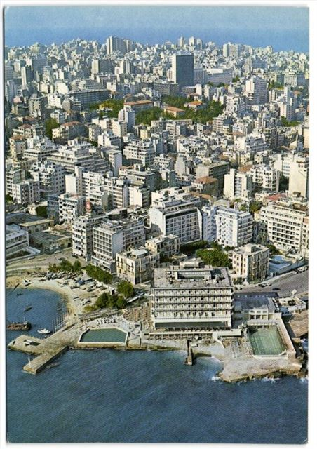
Many of Lebanon's political leaders after independence came from prominent, often feudal, families, and upon their death, their political roles would be inherited by their heirs. With the Lebanese state itself being institutionally weak and lacking in resources, these political leaders would often control the distribution of state services, such as the provision of electricity, or influence recruitment in the civil service and the army. In doing so, they would allocate these resources and opportunities to members of the sectarian community they represent and/or the geographical area they hail from. Although Lebanon appeared to be a modern state, the country's leaders engaged with citizens based on a patron-client relationship.
Picture 2: Beirut in the summer, of 1960. Known as the "Paris of the East", Beirut was a bustling metropolis before the Civil War.

Consequently, although intended to become a safety valve that could limit further sectarian conflicts within the confines of the constitutional system, consociationalism has led the country towards immense structural pressure which in return intensified the popular discontent towards the ruling elite and sectarian hatred between Maronites and Muslims. Also, it hindered the development of an internally unified Lebanese society, the results of which would erupt violently as the geopolitics of the region turned more severe during the Cold War era.

- Lebanese Civil War

Lebanon in the 1970s faced major political tensions and confrontations. The underlying reasons were both domestic and regional. The domestic factors were directly related to the sectarian system for power sharing which had been institutionalised with the National Pact. The Lebanese state's inherent weakness had at first resulted in a surprising consequence: A flourishing economy. The pre-war Lebanese economy grew rapidly during the years 1946–75. The private sector, which was primarily trade- and services-oriented, with no significant natural resource wealth, played the dominant role in economic development. Governmental policy was mostly noninterventionist and supportive of private-sector initiatives. Domestically, a conservative fiscal policy was followed. Monetary policy began to play a role only toward the end of the pre-war period. Public sector management of economic enterprises was confined to a few public utilities. Externally, a free foreign exchange system had been maintained since the early 1950s, permitting the private sector to interact freely with the outside world.

This macroeconomic success, however, led to a drastic wage and wealth gap between the social classes of Lebanon. This was manifest in the strikingly uneven development among the various regions of the country and in the limited progress made by the state in narrowing the gap between rich and poor. A study conducted in the mid-1970s indicates that for 1973–74 about 54 percent of the population could still be classified as poor or relatively poor, 25 percent as middle class, and the remaining 21 percent as well-to-do and very rich. The delicate sectarian balance that had led to the emergence of a weak state, as a consequence, resulted in the inability to implement substantive administrative reforms. The prevailing political system tended to foster corruption, nepotism, clientelism, and laxity in upholding the public interest when it conflicted with private interests. Additional strains emanated from the uneven development among the various regions and wide disparities in income distribution that led to migration from rural to urban centers and the unchecked and rapid growth of poor suburbs around the major cities (Beirut in particular).

The prevailing weaknesses of the political system were also exploited by Palestinian organizations - especially the Palestinian Liberation Organisation (PLO) - to enhance their political and military positions. For this purpose, they forged alliances with disenchanted Lebanese sectarian (Muslim) and non-sectarian political parties, as well as with groups that regarded such an alliance as a means to pressure the Maronite establishment to accept political reforms

This combination of domestic and external factors eventually led to the outbreak of war on 13 April 1975. On that day, armed clashes broke out in a Beirut suburb between members of the Maronite-dominated Kataeb (Phalange) party and members of Palestinian organizations. Although there were two main warring camps, the combatants in the civil war included both major and minor militias and parties. The main traditional Christian (Maronite) parties included the Kataeb and National Liberal parties. These parties were forcibly united in 1980 into one organization called the Lebanese Forces, whose combined fighting force was estimated to be 8000 -10000 fighters. This camp favored the existing political system. The opposing camp was more heterogeneous. Apart from the PLO, it included several Lebanese political parties and groups, notably Amal (Shi’a) and the Progressive Socialist Party (Druze). The Palestinian armed groups numbered close to 8000 fighters before the Israeli invasion of 1982. They constituted the main fighting force in the early years of the conflict. As the war unfolded, the Lebanese armed groups became stronger, especially after the bulk of Palestinian forces had to withdraw from the country following the Israeli invasion. The Amal Movement fighters were estimated at 3500 and the Progressive Socialist Party fighters at more than 5000. The last few years of the war witnessed the growth of the Hezbollah Party (over 4000 fighters), which operated mostly in southern Lebanon.

Alongside the local camps fighting with each other for political superiority, the presence of PLO triggered another actor to intervene. On June 6, 1982, Israel invaded Lebanon. Prompted by the fringe group Fatah- Revolutionary Council’s June 3 attempted assassination of the Israeli ambassador to the United Kingdom, the Israel Defence Forces bombed Palestine Liberation Organization offices in Beirut. In retaliation, the PLO launched missiles from South Lebanon toward civilian settlements in northern Israel. The Israeli cabinet launched a long-planned invasion to destroy the PLO’s armed forces. Syria initially supported the Christian/government camp with direct military intervention but subsequently shifted its support to the opposing camp. Throughout the war, other forms of external intervention took place, mainly via financial support.

The combatants in the civil war thus comprised a multitude of parties that could be divided into two main camps: one in support of the state and one opposed to it. Within each camp there occurred frequent intra-militia fighting. The war was thus not one pitting the state against a well-defined rebel group. There was extensive military intervention by neighboring countries in support of one camp or the other.

A significant development in July 1980 was the success of Bashir Gemayel, leader of the Kataeb militia, in uniting by force all Christian militias into one organization named the Lebanese Forces. The country became effectively divided into regions that were militarily controlled by Syria, the Lebanese army and Lebanese forces, and the PLO and the Lebanese parties allied with it. Beirut was again divided into an eastern part, controlled by the Lebanese Forces and the Lebanese army, and a western part, controlled by the PLO/Lebanese coalition. Israel attempted to impose a friendly government with the election of Bashir Gemayel as president by the Lebanese parliament on September 14, 1982. However, Bashir was assassinated before taking office. Israeli troops then entered West Beirut and briefly occupied it. Following the assassination of Bashir Gemayel, parliament again met on September 22 and elected Amin Gemayel (the older brother of Bashir) for a six-year term as president. In the meantime, four Western powers (the United States, Britain, France, and Italy) agreed to send troops to Lebanon, ostensibly on a peacekeeping mission, which had as one of its goals the protection of the refugee camps in the greater Beirut area following the withdrawal of the PLO. These forces departed in early 1984; their mission ended without accomplishing its main objectives.
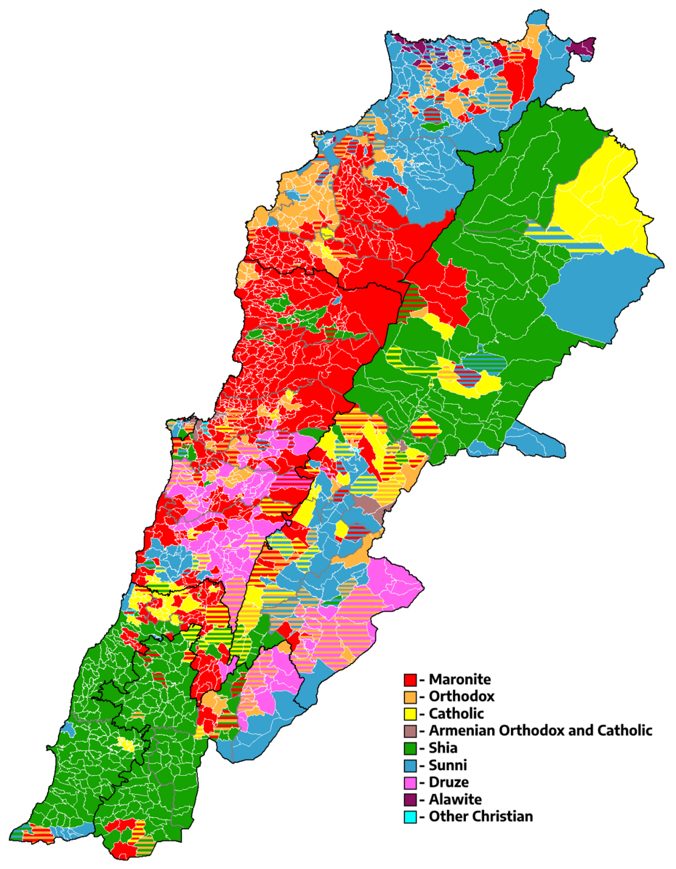
Picture 3: Sectarian map of Lebanon on a municipal basis. The demographic distribution is relatively unchanged for more than a century.
After Amin Gemayel’s six-year term ended, the failure to elect a new president in September 1988 led to a unique two- government situation. When the six-year term of President Amin Gemayel was about to end in September 1988 without agreement on a successor, he unilaterally appointed the commander of the army, General Michel Aoun, as president of a council of ministers composed of the six members of the army command. The three Muslim members of the appointed council refused to serve. The existing government at the end of Gemayel’s term refused to acknowledge the legitimacy of the council appointed by Gemayel and considered itself the sole legitimate government of the country. Hence, two competing governments emerged. The two governments stood against each other and each claimed exclusive legitimacy. The legislative authority also experienced a vacuum because the parliament failed to renew the one-year term of the speaker or to elect a new one.
- Taif Accord

The Taif Accord constituted a compromise among the Lebanese deputies, political groups and parties, militias, and leaders. It tackled many essential points about the structure of the political system and the sovereignty of the Lebanese state. Indeed, these two issues are interrelated. It was, in essence, a revision of the National Pact system founded shortly before the independence. the Accord was decisive in determining the Arab identity of Lebanon, emphasizing that Lebanon was an independent, sovereign, free country and a "final homeland" for all Lebanese. Second, it confirmed the unity of Lebanon. Third, it defined the nation's political system as a parliamentary democracy, based on the principles of separation, balance, and cooperation among the various branches of government. Fourth, it clearly defined the socio-economic system as a free economy favoring individual initiative and the right to private property. However, it also emphasized the necessity for balanced and even development in all the regions to ensure a form of social equity. Fifth, it stated that the abolition of political sectarianism constitutes a basic national goal to be achieved according to a gradual scheme.
The Accord left two sets of issues open to future discussion. The first set concerns the process of re-establishment of complete sovereignty in Lebanon. This issue is related to the resolution of the regional conflict through the peace negotiations between Israel on the one hand and Syria and Lebanon on the other hand.

The reforms did not fundamentally alter the political structure, which is still predicated on political sectarianism. The Taif Accord implicitly ratifies the National Pact of 1943 and emphasizes confessional compromise and inter-communal cooperation. The changes aimed at creating a new and more equitable confessional formula (one that distributes power fairly among all confessional communities), but although the Accord stated that the abolition of confessionalism was a national goal, no specific deadline or timetable was provided for its actualization.
This accord intended to eradicate the dominant position of the Maronites as it was ensured by the old formula and to allow for equitable participation of Christians and Muslims in the Cabinet. This parity may also be observed in the system of distribution of seats in Parliament and public service Jobs. The post of President, traditionally assigned to a Maronite, provided him with power as the head of state and the symbol of its unity. The president was also considered the custodian of the country's unity, independence, territorial integrity, and constitution.
The position of Prime Minister, a traditionally Sunni post, as the President of the Council of Ministers, was strengthened; similarly, the power of the ministers as members of the Council increased. The Prime Minister presides over the Council of Ministers; he is to be nominated by the President who conducts mandatory parliamentary consultations and shares the results with the Speaker of Parliament.
In Parliament, the position of the Speaker, a traditionally Shia post, has gained importance because the Speaker's term of office was extended to four years. National Pact had set the Lebanese Parliament's seats following the sectarian distribution of the country based on the population census of 1932. As a result, the ratio of MPs between Muslims and Christians (of various sects) was 6 to 5 in favor of the Christians within a total of 99 MPs. Since 1932, due to religious and ethnic issues in Lebanon, no census has been carried out; thus, in light of clear patterns indicating a demographic increase in the number of Muslims concerning Christians, it was agreed that parity of representation would be instituted and that the Shi'ites would receive increased parliamentary representation. The number of MPs was increased from 99 to 128.
As of 2022, Taif Accord is still relevant and being practiced at the institutional level. For the parliamentary/political structure the Accord has placed and its implications for the Lebanese political arena, please examine the results of the 2022 elections and their comparison with the 2018 results:
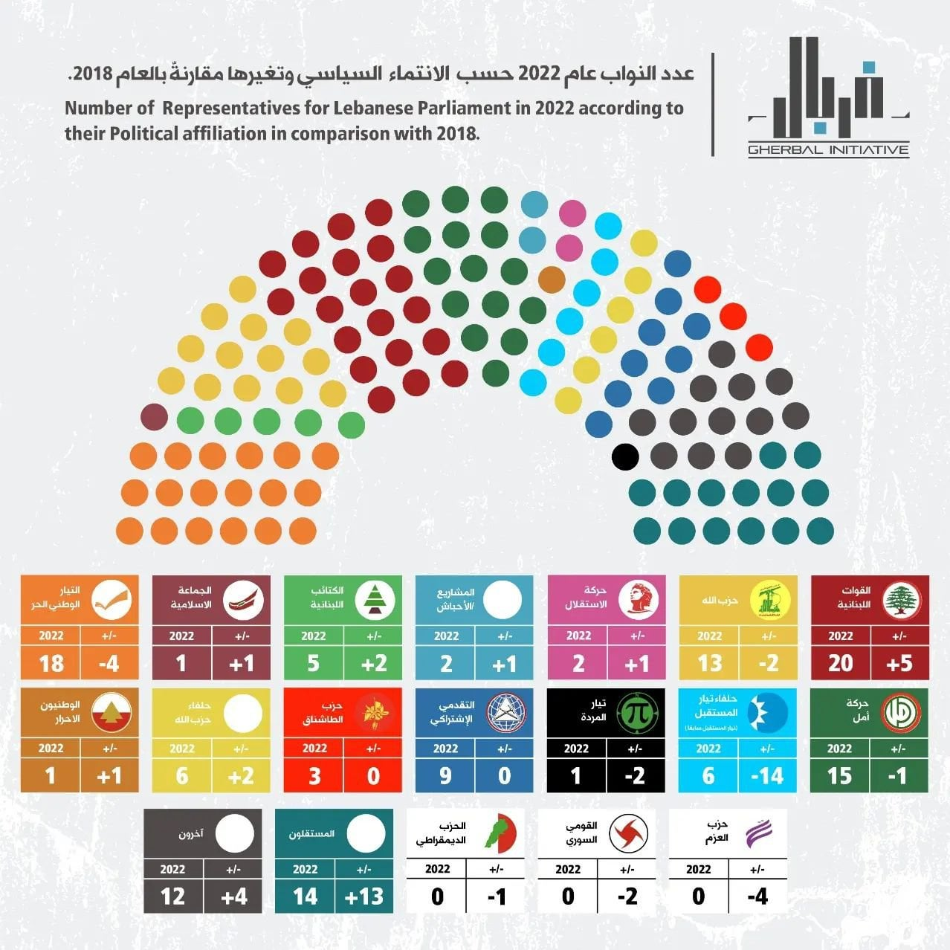

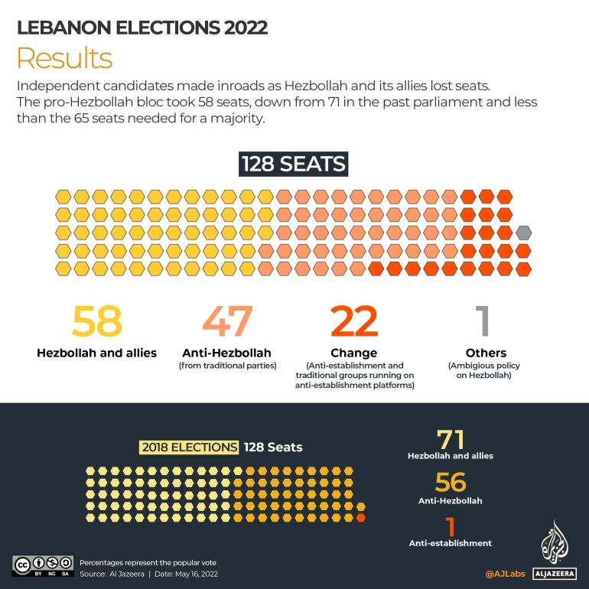
- Cedar Revolution and Second Lebanon War

Taif Accord had ended the civil war and called upon all militia groups to disband. However, the Lebanese government exceptionally allowed Hezbollah to retain its weapons while disbanding all other militias on the basis that Hezbollah was a "resistance" movement fighting for the liberation of southern Lebanon from Israeli occupation. On the night of 23 May 2000, the Israeli Defence Forces (IDF) withdrew from the security zone in southern Lebanon. The move received international legitimacy under UN Security Council Resolution 425, which was adopted in 1978 following Operation Litani and called for an IDF withdrawal from Lebanon. IDF forces deployed south of the international border along the Blue Line that was delineated by a team of UN cartographers. Thus came an end to an 18-year presence and intensive IDF activity in Lebanon. The IDF's withdrawal from the international border and the international legitimacy it received undermined the internal Lebanese justification for Hezbollah's existence as an organization with a military infrastructure, and ran contrary to the image it sought to create for itself as the "defender of Lebanon." The legitimacy enjoyed by the organization when Israel was present on Lebanese soil was now gone and the image it worked so hard to create was now being questioned. Rather, they aroused criticism among the anti-Syrian alliance, namely, that Hezbollah was the only organization allowed to retain its military infrastructure in the country since the Taif Accord, in contrast to the other militias, which were forced to disarm.

The September 11, 2001 terror attacks led to the United States' invasion of Iraq and President Bush's classification of Syria as part of the "axis of evil." Consequently, and given the growing unrest in Lebanon, international pressure for the disarming of Hezbollah and the withdrawal of Syrian forces from Lebanon increased. This was reflected in the diplomatic initiative by the United States and France aimed at the removal of Syrian forces from Lebanon, which was part of a plan to disrupt the Syrian order that had tightened its grip following the IDF withdrawal. The American-French initiative culminated in UN Security Council Resolution 1559 of September 2, 2004, which called for the withdrawal of all non-Lebanese forces from Lebanon and the disarming of all the militias in the country.

On February 14, 2005, former Prime Minister Rafiq Hariri was assassinated by a massive car bomb in the hotel district of Beirut, the very area with which he had become so closely identified in rebuilding post-war Beirut. Rafiq Hariri was an important figure in Lebanese business and politics, serving as prime minister in 1992-98 and 2000-04. In death, he became the focus of a mass outpouring of grief with around 1 million people gathering in Martyrs Square in Beirut. His dramatic death became the impetus for a political movement, the Cedar Revolution, demanding the recovery of Lebanese sovereignty through Syrian withdrawal and the truth about the crime. Hariri's supporters immediately accused Syria of being behind the assassination and demanded its withdrawal from Lebanon following UN Security Council Resolution 1559 (September 2, 2004) and called for the establishment of an international tribunal to prosecute those responsible for his murder.
The protests were distinguished by being cross-sectarian. People from different backgrounds gathered in downtown Beirut carrying Lebanese flags and shouting patriotic slogans. The scale of the protests was huge and signaled widespread anger about Syria’s role in the assassination of Hariri and its meddling in Lebanese affairs. However, what began as grassroots mobilization was soon co-opted by the political parties, which were divided into a pro-Syrian and an anti-Syrian camp. Each camp mobilized their supporters to go to downtown Beirut to demonstrate. Rival protests led by pro-and anti-Syrian parties took place respectively on March 8 and March 14, 2005, leading to the labeling of the coalition of pro-Syrian parties the “March 8” coalition (with Hezbollah being the leading party) and the anti-Syrian parties the “March 14” coalition (with Hariri’s party, the Future Movement, the leading party, which came to be led by his son Saad).
The international pressure, combined with the protest that erupted in Lebanon following the murder of Prime Minister Rafiq Hariri, forced Bashar al-Assad to withdraw the Syrian army from Lebanon in April 2005. Five years after the IDF left the country, the Syrian military presence there also came to an end – the very presence that made possible the growth and consolidation of Hezbollah.

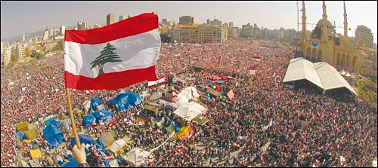
Picture 6: Following the murder of Rafiq Hariri, more than a million people gathered in Martyr’s Square to protest against the Syrian presence and the political malfunctions of Lebanon.
The period following the Hariri assassination ushered in the Independence Intifada/Cedar Revolution, the broad civil and political cycle of protest that put an end to the Syrian military presence in Lebanon. With the Syrian withdrawal from Lebanon in April 2005, the post-civil war years of Syrian “tutelage” finally ended, seemingly leaving the political forces behind the revolution free to pursue a new, post-Syrian domestic and foreign policy agenda. In reality, the same political coalition that had supported the Independence Intifada did attempt to stir Lebanon in this new direction but only to find that the Syrian legacy in the country went far deeper than its military presence. Similarly, the new “revolutionary” forces soon discovered that any effort to alter the country’s political outlook significantly would encounter deep and entrenched resistance. In the end, rather than a radical reshuffling of the political game, Lebanon settled for an uneasy balance between pro- and anti-Damascus sentiments.

In this context, the Cedar Revolution and its aftermath saw the rise of two largely antagonistic political blocs, the March 14 revolutionary forces, and the March 8 resistance camp. For the past decade, the former has been a favorite of the West, backed by Saudi Arabia and led by al-Hariri's son Saad, head of the Tayyar al-Mustaqbal (Future Movement), a political party that largely represents Lebanon’s Sunni community. The resistance camp, on the other hand, is led by Hezbollah and supported by Iran and Syria, and (for the most part) speaks for the country’s Shiites. With the Lebanese Maronite Christian community more or less evenly divided across the two political camps, March 14 and March 8 quickly became more than just an expression of sectarian politics: they reflected rooted and divergent political, sectarian, and geostrategic interests.

In the meantime, in South Lebanon, tensions were once again on the rise. Hezbollah took advantage of Israel's focus on the second intifada (PLO campaign against Israel) to build an extensive military infrastructure in Lebanon with aid from Syria and Iran and without any significant interference from Israel. Hezbollah also became more important for Syria as a preferred proxy organization precisely because the Syrian border in Lebanon declined. In the era following the withdrawal of the Syrian forces from Lebanon, the Bashar al-Assad regime regarded Hezbollah as an important tool for safeguarding Syria’s interests there, in place of the traditional tools it had used in the years of its involvement in Lebanon, which were made possible by the local presence of the Syrian intelligence mechanisms and the Syrian army. The improved infrastructure built during this period turned Hezbollah from a terrorist and guerrilla organization into an organization with quasi-state military capabilities, which in certain aspects (its missile deployment, for example) exceeded the military capabilities of regular armies.

In the years of the second intifada leading up to the Second Lebanon War, Hezbollah assisted the terrorist organizations operating in Judea, Samaria, and the Gaza Strip. This aid was part of a comprehensive Iranian policy designed to augment the quantity and quality of terrorist operations against Israeli civilians and to improve their operational capabilities. This aid included direction, financing, smuggling weapons, training, and technological know-how. While doing this, Iran and Hezbollah tried to disguise the source of the aid and avoid being dragged into a confrontation with Israel.

Essentially, the Second Lebanon War was a result of the ongoing erosion in Israel’s deterrence, which motivated Hezbollah to carry out a provocative kidnapping operation, under the erroneous assumption that it would not necessarily lead to escalation. Despite Israel’s problematic decisions and flaws in preparedness and use of force in the Second Lebanon War, the realization of the gaps in force between Israel and Hezbollah left the Lebanese organization badly wounded and forced it to change its modus operandi and strategic conduct towards Israel. In the years after the war, Hezbollah was drawn into the Syrian civil war, leaving Israel’s northern border calm for the decade that followed.

2. The Special Tribunal for Lebanon

- Its Origins, Mandate, and Failure
The Special Tribunal for Lebanon established under the UN Security Council Resolution 1757 in 2007 represents the expansion of international criminal law into international relations. The Tribunal as “emergency law” is limited by its narrow focus on a single crime, the Hariri assassination, leaving the war crimes and crimes against humanity of the Civil War and the casualties of post-civil war violence untouched.
Unlike the special international criminal tribunals and courts, such as International Criminal Tribunal for the Former Yugoslavia and Rwanda, which have prosecuted international crimes under international jurisdiction, or jointly under domestic jurisdiction; the Tribunal's adjudication is the prosecution of the crime of "terrorism" under Lebanese domestic law and jurisdiction. The Tribunal is not investigating the history of political violence, assassination, and impunity which have characterized the Lebanese political arena. Between 1950 and 2005 there were more than 80 assassinations or attempted assassinations of leading political, religious, or intellectual figures; yet almost none have been investigated.
In Lebanon, political peace has been constantly bought by confessional pacts between political elites, auto-impunity, forgetting, and rendering victims invisible. The very basis of Lebanese sovereignty has rested on temporary political pacts justified as "once only" solutions; but in practice, these exceptions are the rule. In such circumstances, "the right to intervene" emerges according to international law. When a state is seen as unwilling or incapable of protecting its citizens, then the international community must intervene to save lives.

These types of international tribunals have legitimacy in the eyes of victims and NGOs but not necessarily with political groups and their social bases. These interventions are almost inevitably seen as political and partisan, especially if the distribution of crimes committed is unequally discovered and prosecuted.

The Tribunal is an attempt to practice "transitional justice", an approach to the management of internal conflicts and state crises through international criminal law, international tribunals, and restorative justice. Transitional justice involves international criminal law as a source of legitimacy in the face of state crises. Its "emergency law" aspect seeks to instrumentalize the prosecution based on the imperative to get to the scene of an ongoing crime to investigate and verify the fact of the atrocities and to provide the justification for the establishment of international tribunals to prosecute international crimes. In the case of the Special Tribunal for Lebanon, it only has the jurisdiction over acts of:
(a) The provisions of the Lebanese Criminal Code relating to the prosecution and punishment of acts of terrorism, crimes, and offenses against life and personal integrity, illicit associations, and failure to report crimes and offenses, including the rules regarding the material elements of a crime, criminal participation, and conspiracy; and
(b) Articles 6 and 7 of the Lebanese law of 11 January 1958 on "Increasing the penalties for sedition, civil war, and interfaith struggle".

Lebanese political opponents of the Tribunal worked to undermine its legal authority and credibility from the beginning. Pro-Syrian March 8 coalition denied the joint basis of the Tribunal’s UN and Lebanese authority by preventing its ratification. This forced the Security Council to establish the Tribunal under Chapter VII of the UN Charter which allowed it to intervene to "maintain or restore international peace and security."

The Tribunal as an emergency law intervened in the Lebanese political crisis in response to the enormous expectations of many Lebanese and the international community that international law could change the corrupt order of things in Lebanese politics. However, from its beginning, the force of the law of the Tribunal has been continuously challenged by its Lebanese opponents by labeling it political, not legal. The lack of indictments, the political grey zone created by March 8 Coalition members, and their creation of a climate of crisis in which the cost of proceeding with justice is seen as too high.

The Tribunal crisis encompasses far more than the legal tricks and grey zones; it embodies all the complex challenges of Lebanon: Sunni-Shia tensions, consociationalism, regional powerholders, influential regional actors, and clashes between Hezbollah and Israel as a part of a larger fight. As a result, the Tribunal as a solution became obsolete each day and the crises that followed have been solved with Lebanese solutions: elite agreements, amnesty, and impunity. The narrow jurisdiction focused on Hariri's assassination puts victims of the civil war and all the atrocities committed outside its mandate. The accountability of leaders for their mass crimes risked political instability. Consequently, transitional justice in Lebanon did not even go so far as to identify the victims.

- The mandate of the Tribunal in this Committee

Instead of focusing on a single crime - Hariri assassination, the Special Tribunal for Lebanon as it is structured for this committee will broaden its mandate to investigate and adjudicate all political crimes and atrocities committed between 1975 and 2023.
Not only the atrocities of the Civil War but also post-civil war political crimes, terrorism, foreign support for crimes against humanity, the Beirut port explosion, and corruption will be under the mandate of the Tribunal.
Again, rather than a standard criminal tribunal’s setting, this tribunal will follow an adversarial procedure with a General Assembly-like setting where the Lebanese Parliament will form the defendant bloc, a six-state group will form the applicant bloc, and an eleven-state group will form the third-party bloc.
The Lebanese Parliament is expected either to support or reject the applicant bloc's motions to deepen the investigation of the Lebanese political arena, based on its dominant faction following biennial elections - another new mechanic which will is explained in the introductory video.
The applicant bloc is expected to further the application of the Tribunal's mandate over the Lebanese political arena with their motions and bargaining with the third-party states. Acceptance of their motions, however, depends on the level of danger they pose to Lebanese MPs and third-party states.
Third-party bloc is expected to rally their support behind the Lebanese parliament (whether anti-Tribunal or pro-Tribunal based on the outcome of elections) or the applicant bloc based on their interests in Lebanon. In a situation of deadlock formed by one negative vote by the Lebanese Parliament and one positive vote by the applicant bloc, their attitude towards a motion will be a tiebreaker.

3. Lebanese Parliament

Ever since the National Pact, the consociational model of Lebanese high politics remained unchanged except for the revision of the Taif Accord. Yet, discontent towards the system grew among new generations as those who placed and institutionalized it passed their turns in the political arena. Multiple events that fuelled this discontentment have shaken the classical proportion of political parties and movements that are represented in Parliament and Government. Even though old players are still making up a significant bulk of the system as they always were, anti-establishment parties and movements grow in size and popularity, especially after the October Revolution. Still, the Parliament can be split into two major camps as it was formalized in Cedar Revolution: March 8 coalition and March 14 coalition. Alongside these two giants, anti-establishment parties are in a crucial position since no coalition can form a majority on their own. It is important to note, however, that political dynasties and influential personalities form the pillar of many political blocs and parties since the political arena in Lebanon is mainly based on these veteran figures of the Civil War, rather than organized nomothetic parties with popular bases as it is the case in deliberative parliamentary democracies around the world.

- March 8 Coalition

As of the 2022 elections, it is the ruling alliance of Lebanon. Comprising political movements and figures that have demonstrated in favor of Syrian presence on 8 March 2005, its main actors are Hezbollah, Amal Movement, and the Free Patriotic Movement of Michel Aoun, who at first was in favor of anti-Syrian March 14 movement but shifted his and the party's affiliation to March 8 with the memorandum of understanding with Hezbollah in 2006. The Coalition is against the Special Tribunal’s adjudication and claims its illegitimacy.

i. Hezbollah

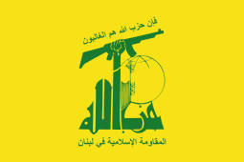
Hezbollah was founded in 1982 in response to the Israeli invasion of Lebanon, and subsumed members of the 1980s coalition of groups known as Islamic Jihad. It has close links to Iran and Syria. Sheikh Mohammed Hussein Fadlallah is considered the group’s spiritual leader. Hassan Nasrallah is Hezbollah’s senior political leader. Nasrallah was originally a military commander, but his military and religious credentials - he studied in centers of Shiite theology in Iran and Iraq - quickly elevated him to leadership within the group.

Hezbollah has been described as a "state within a state" and has grown into an organization with seats in the Lebanese government, a radio and a satellite TV station, social services, and large-scale military deployment of fighters beyond Lebanon's borders. The group currently receives military training, weapons, and financial support from Iran and political support from Syria.

According to its Open Letter describing the Hezbollah program, their self-identification is by no means a classic political party. "By the above, we do not constitute an organized and closed party in Lebanon. nor are we a tight political cadre. We are an umma linked to the Muslims of the whole world by the solid doctrinal and religious connection of Islam.” Thus, Hezbollah portrays its mission as “to repel aggression and defend our religion, our existence, our dignity” against the “West”, in which the main antagonists being the United States of America and Israel. According to the program, Hezbollah's main enemies are "the Phalanges, Israel, France, and the US." As for its objectives, these are:

(a) to expel the Americans. the French and their allies definitely from Lebanon, putting an end to any colonialist entity on our land;
(b) to submit the Phalanges to a just power and bring them all to justice for the crimes they have perpetrated against Muslims and Christians;
(c) to permit all the sons of our people to determine their future and to choose in all the liberty the form of government they desire.

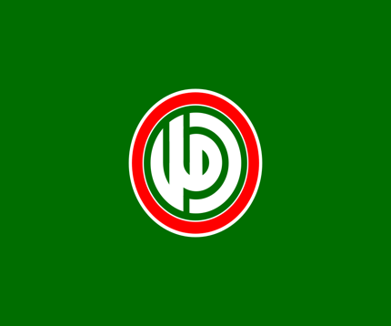
ii. Amal Movement
Founded by Musa al-Sadr and Hussein al Husseini as the "Movement of the Dispossessed" in 1974, the Amal movement gained attention from Shia outcry after the disappearance of Musa al-Sadr and saw a renewal in popularity after Israel invaded Lebanon in 1978. The Iranian Revolution of 1978–79 also provided momentum for the party and the politicization of the Shia population of Lebanon. Its leader, Nabih Berri serves as the Speaker of the Lebanese Parliament - a position reserved for the Shia population - since 1992.

Amal has close relations with Syria, Iran, and Hezbollah as a part of the Shia political community; yet, especially with Hezbollah as a local political adversary, Amal, and its allies have disagreements on minor issues in several cases. In 1988, Hezbollah and Amal succumbed to an armed clash that became to be known as the "War of Brothers". Only after the Taif Accord and with Syria and Iran brokering negotiations, the two camps finally ceased armed conflict with each other. It is the largest Shia party in Lebanon and it is traditionally closer to Syria rather than Iran, which is the main supporter of Hezbollah.

iii. Free Patriotic Movement

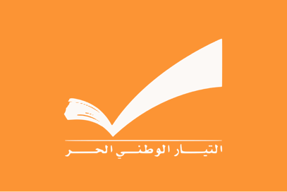
Founded by ex-General Michel Aoun in 1994, the party is currently led by Aoun's son-in-law Gebran Bassil since 2015. Michel Aoun served as President between 2016 and 2022. Since the end of his term, the position is vacant due to the Parliament’s inability to elect a new one with co-optation. According to its program, the movement is a liberal-centrist party with moderate views on consociationalism. It is the second largest Christian party in Lebanon and its alliance with Hezbollah since the memorandum of 2006 continues, although there are many indications of discontent with this status quo among its leaders.

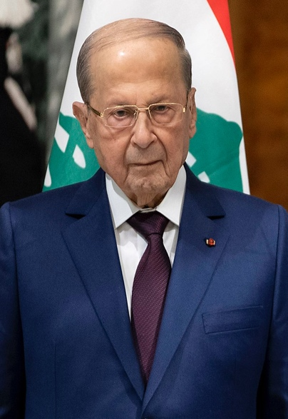
iv. Marada Movement

It was a prominent militia group in the Civil War and In June 2006, the Marada Movement was officially launched as a political party during a ceremony attended by supporters and representatives from Hezbollah, Amal Movement, the Free Patriotic Movement, and several pro-Syrian political figures.
Picture 7: Michel Aoun is a prominent Civil War veteran who also served as the President of Lebanon. (also known as “Devlet Bahçesiz” in Turkiye)

- March 14 Coalition

It is the coalition of the anti-Syrian and anti-Hezbollah groups and parties in Lebanon who also take a milder attitude towards "the West". The Coalition accuses Hezbollah of the Second Lebanon War and calls Special Tribunal for Lebanon to judge the assassins of Rafiq al Hariri, yet it does not support a complete judgment of the Lebanese political arena.

i. Lebanese Forces

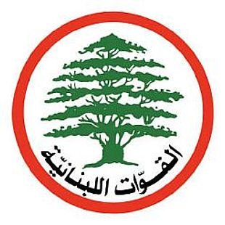
It is an umbrella organization of former civil war militia groups who supported Bashir Gemayel and, after his assassination, Amin Gemayel against PLO, the Syrian Armed Forces, and the Lebanese Armed Forces under General Michel Aoun. The Lebanese Forces was an active participant in the Cedar Revolution of 2005. In the subsequent parliamentary election held in May and June, the Lebanese Forces formed part of the Rafik Hariri Martyr List, which also included the Future Movement, the Popular Socialist Party, the reformed Phalange Party, and other anti-Syrian political groups. Its leader, Samir Geagea is a civil war veteran and one of the most important figures in Lebanese politics as the leader of the group since 1986. In 2016, Geagea made a historical agreement with his old rival Michel Aoun, and supported his candidacy for the post of President. The party seeks to empower Christians against the Syrian/Iranian-backed Shia and Sunni groups.

ii. Future Movement (now defunct)/National Moderation Bloc

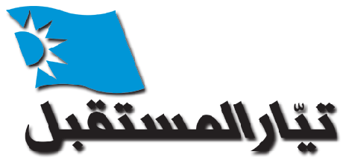
Representing the Sunni Muslim population in Lebanon, it is the party of Rafiq al Hariri and his son, Saad who led the party until the October Revolution. After the Revolution, Saad Hariri tendered his resignation from the post of Prime Minister, and in 2022, he retired from politics, leaving the Movement without a leader. After Hariri's retirement, the Movement practically dissolved into minor groups arising from its cadres. With those who raced at elections on the Movement's behalf, the ex-Future Movement gained 10 seats in Parliament as the National Moderation Bloc. It is the liberal party of Lebanon and a natural advocate of the Special Tribunal's adjudication over the Hariri murder.

iii. Kataeb/Phalange Party


It was a major player in the Civil War and a prominent rival of Hezbollah. Rather than the prominent Arab nationalism, Kataeb promotes a unique "Phoenician" identity and advocates for Lebanon's independence from all foreign influences, including its Arab neighbors both in political and cultural fields. Before the civil war, it was a state within a state, just like Hezbollah as it is today. Kataeb Party succeeded in getting two of its leaders elected to the presidency: Bashir and Amin Gemayel. After Cedar Revolution, the Party reformed itself and developed a moderate-liberal stance, in favor of market economy and implementation of all UN decisions.
- Non-Aligned and Anti-Establishment Groups

It is a heterogeneous mixture of anti-establishment and anti-sectarian movements of the October Revolution and old political groups with shifting allegiances. Their attitude towards Arab states, Iran, "the West" and the Special Tribunal may vary

i. Progressive Socialist Party

It is the Druze party of Lebanon. It was founded by Kamal Jumblatt in 1948 and is led by his son Walid since 1977. In the civil war, Jumblatt was the dominant force at Mount Lebanon with a powerful militia organization under his leadership. After the civil war, he supported Syrian presence until 2003; but the occupation of Iraq shifted its support. In the post-Civil War period, Jumblatt was known for switching allegiances and acting as a kingmaker in deals between factions. His view on the disarmament of Hezbollah shifted several times in 20 years. For now, the Party is anti-Syrian.

ii. Taqaddom/Progress Party
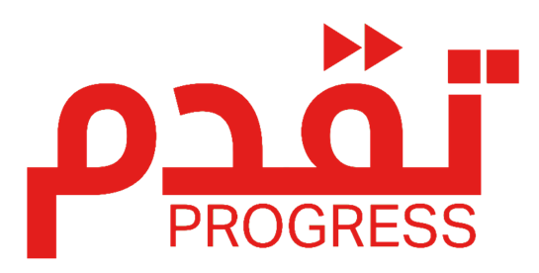
It is a reformist political party founded after the October Revolution. It currently has 2 seats in the Lebanese parliament, which is part of a 13-member reformist bloc. It is, as the reformist bloc it represents, anti-Hezbollah, anti-establishment, and anti-consociationalism. In general, this party desires to cleanse Lebanese politics from its old, malfunctioning situation. It is, unlike classic political groups of Lebanon, not a movement gathered around a prominent figure, but a collective group. It also advocates Lebanese independence from foreign influences and interventions.

iii. Lana
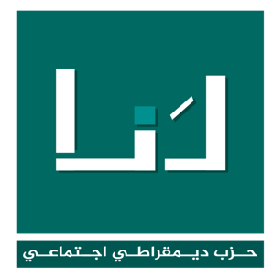
It is a reformist political party founded after the October Revolution. It has 1 seat in Parliament and is a part of the 13-member reformist bloc. Its MP is one of 8 women in Parliament. Its goals are similar to Taqaddom's.

- External Actors

As is the case with the recent political developments, Lebanon's relations with external actors are quite complex and prone to abrupt shifts; however, certain actors have more or less maintained a stable agenda toward Lebanon. Those actors who have the most intricate and unique relations with Lebanon - Syria, Israel, and Iran, will not be listed below simply because their influence and special position in Lebanon can be felt in the entirety of this study guide.

- Lebanon and the United States:

- The United States has provided economic assistance, military aid, and humanitarian support to Lebanon over the years.
- The U.S. has expressed concerns over political instability, Hezbollah's influence, and Lebanon's economic crisis.
- The U.S. has also supported efforts to promote stability, democracy, and the rule of law in Lebanon by rallying support behind anti-Hezbollah and popular anti-sectarian protests.
- However, U.S.-Lebanon relations have faced challenges due to Hezbollah's involvement in Lebanese politics and its designation as a terrorist organization by the U.S. government.

- Lebanon and the United Arab Emirates:

  - Lebanon has historical and economic ties with the United Arab Emirates that have exponentially increased in recent years thanks to the expansion in the number of Emirati investments.
  - The UAE has been involved in investment and trade activities in Lebanon, particularly in sectors such as real estate, banking, and tourism.
  - However, the relationship has experienced strains at times due to regional tensions and political differences.
  - Following the explosion in Beirut in 2020, the UAE, alongside other Gulf countries, provided aid and assistance to Lebanon in significant numbers.

- Lebanon and France:

- The relationship between France and Lebanon has a long history and is characterized by cultural, historical, political, and economic ties. France's influence in Lebanon can be traced back to the early 16th century when the region came under Ottoman rule. However, it was during the 19th and 20th centuries that the relationship between the two countries became more significant.

- Historically, France played a crucial role in the establishment of modern Lebanon. Following the collapse of the Ottoman Empire after World War I, Lebanon came under French mandate in 1920, as per the League of Nations' decision. The French Mandate lasted until 1943 when Lebanon gained its independence. During this period, France had a profound impact on Lebanese society, institutions, and governance structures. The French influence is still evident today in Lebanon's legal system, education system, and cultural practices. Culturally, France and Lebanon share strong connections. Lebanon has a sizable Francophone population, and the French language has historically been an important aspect of education and administration in Lebanon. French cultural institutions, such as schools, universities, and cultural centers, have a presence in the country. Many Lebanese intellectuals, artists, and writers have also been influenced by French literature, philosophy, and art.

- Politically France has maintained a special interest in Lebanon. It has often played a role as a mediator in Lebanese politics and has supported Lebanon's stability and sovereignty. France has been actively involved in peacekeeping efforts, particularly through its contribution to the United Nations Interim Force in Lebanon (UNIFIL), which was deployed after the Lebanese Civil War (1975-1990) to help maintain peace and security in the southern part of the country.

- Economically, France has been a significant partner for Lebanon. French companies have investments in various sectors in Lebanon, including banking, construction, telecommunications, and energy. Trade between the two countries has also been substantial, with France being one of Lebanon's major trading partners within the European Union.

- In recent years, the relationship between France and Lebanon has faced challenges due to the political and economic crises in Lebanon. France has been actively engaged in diplomatic efforts to address the political deadlock and provide humanitarian assistance to Lebanon. French officials have expressed concerns about the country's stability and have called for reforms to address corruption and governance issues. Overall, the relations between France and Lebanon are multifaceted, encompassing historical, cultural, political, and economic dimensions. Despite the challenges, France continues to maintain an interest in Lebanon's well-being and has been involved in efforts to support its stability and development.

- Lebanon and Egypt

- Egypt has historically maintained close ties with Lebanon. During the 1950s and 1960s, Egypt, under the leadership of President Gamal Abdel Nasser supported the pan-Arabist ideology and sought to unite Arab countries - which later came to be known as Nasserism. Lebanon, with its diverse religious and political factions, was seen as an important part of this vision. Nasser's ideology of Arab nationalism resonated with some Lebanese groups, particularly left-wing and nationalist factions.

- In the late 1960s and early 1970s, Lebanon became a battleground for regional rivalries and conflicts, including the Israeli-Palestinian conflict. Egypt played a role in mediating some of these tensions, particularly during the Lebanese Civil War (1975-1990). Egypt hosted peace talks and sought to broker ceasefires between the warring factions in Lebanon. Egyptian diplomats were involved in diplomatic efforts to resolve the conflict and restore stability.

- In recent years, Egypt's political involvement in Lebanon has been relatively low-key. However, it has continued to maintain diplomatic relations and engage in bilateral cooperation with Lebanon in areas such as trade, security, and cultural exchange. Egypt has also expressed support for Lebanon's stability and sovereignty, particularly in the face of regional challenges.

- Lebanon and Saudi Arabia

- Saudi Arabia has had a more complex and evolving relationship with Lebanon. Historically, Saudi Arabia has had economic ties with Lebanon, particularly through investment and trade. Many Lebanese nationals work in Saudi Arabia, and remittances from Lebanese expatriates in the country have been significant for Lebanon's economy.

- Saudi Arabia's political involvement in Lebanon has been more pronounced in recent years, often tied to its regional rivalry with Iran. Lebanon has been caught in the broader power struggle between Saudi Arabia and Iran, with competing interests and influences from both sides. Saudi Arabia has supported various political factions in Lebanon, primarily those aligned with Sunni interests.

- In 2016, Saudi Arabia's involvement in Lebanon intensified when then-Prime Minister Saad Hariri, who has close ties to Saudi Arabia, unexpectedly resigned from his post while in Riyadh. The move was seen as a Saudi attempt to pressure and influence Lebanese politics. The resignation was later rescinded, and Hariri returned to Lebanon, but it highlighted the geopolitical tensions and external influences on Lebanon's political landscape.

- In recent years, Saudi Arabia has continued to provide financial support to Lebanon, particularly during periods of economic crisis. However, its political involvement has become more nuanced, and it has scaled back some of its overt interventions. Nevertheless, Saudi Arabia's position in Lebanon remains significant, and its actions and policies continue to have an impact on Lebanese politics.
Appendix: Special Mechanics of the Committee

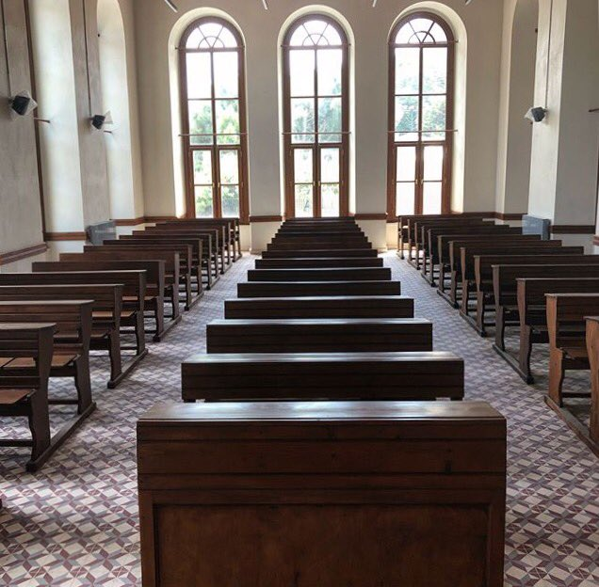
- Bloc-voting: Moderated and Unmoderated caucuses will be voted based on bloc preferences. As it is seen here, three rows will entertain three separate blocs: Lebanese Parliament (left), Applicant States (center), and Third Parties (right). In each voting procedure, the majority in each bloc will determine the vote of the bloc - in favor or against.
An example: A motion for a moderated caucus is being voted. When those who are in favor of the motion are asked to raise their placards, the chair board will count each bloc separately:
Lebanese Parliament-7/10, Applicant States-2/6, Third Parties-5/11.
Again, delegates who are against the motion are as follows:
Lebanese Parliament-3/10, Applicant States-4/6, Third Parties-6/11.
The result is:
In favour-1/3, Against 2/3. The motion fails.

As it can be seen, if the vote would have been based on individual delegates, it would be 14/27 in favor, thus the motion would pass. But, since it is based on bloc votes, the majority in each bloc determines the outcome.
With this procedure, even a single individual vote in a fractured bloc may change the outcome. In our example, if a delegate in the Third Parties' bloc would have voted in favor of the motion, the motion would pass. In this model, possible outcomes of voting procedures are 2-1 or 3-0 in favor, 1-2, or 0-3 against.

Although nearly impossible due to the nature of our committee, what would happen in this instance: Lebanese Parliament-6/10 in favor, Third Parties-9/11 against, and the Applicant States 3/6.
As can be seen, the Bloc vote of the Lebanese Parliament is in favor, the Third Parties bloc is against, but the Applicant States bloc is in a deadlock. In this case, Chair Board casts a decisive vote to break the deadlock - as it is practiced in the U.S. Senate by the Vice President.

Then, what happens if the deadlock happens in the Lebanese Parliament (5/10)? This question leads us to another special mechanic:

- Elections in Lebanon: At the end of each two sessions, Parliamentary elections will occur in the Lebanese Parliament to decide upon which coalition takes the government post. The committee will entertain a 10-minute unmoderated caucus for the Lebanese Election Campaign.
As they have been presented in previous pages, the Lebanese Parliament entertains two coalitions and Non-Aligned parties: March 8 Coalition with 4 members, March 14 Coalition with 3 members, and 3 Non-Aligned parties.
For the Coalitions to take the government post, they need 6/10 of the votes in the Lebanese Parliament. Since the two Coalitions are adversaries, for them there is only one way to gather the majority: Persuading Non-Aligned parties. Methods of persuasion are completely up to the Coalitions and Parties. All tactics and promises are allowed (yes, even the illegal ones…).
Applicant States and especially the Third Parties can join the efforts to “buy” Non-Aligned votes so that the Coalition that they support may win the election. Again, no limits.
Another tactic may be persuading a Coalition member to "abstain" from the voting. Once again, it is up to you to make it possible.
Delegates may "sell" their votes by asking for future support in motions, political concessions, etc. Get your hands dirty, esteemed delegates.

What happens if the results came as such: March 8 Coalition-5/10, March 14 Coalition-5/10?
The answer is Snap elections in 5 minutes.
What happens if the results came as such: March 8 Coalition-4/10, March 14 Coalition-5/10? (It appears that there is an absent vote)
The answer is Snap elections in 5 minutes.

With each deadlock, the campaign will keep running until a majority is reached. It is prone to cause instability and frustration among delegates and that is exactly what we are aiming at Instability, frustration, fluctuation, "dirty business", corruption, bribery, etc. just like the Lebanese elections in real life.

What is the benefit of taking the government post? In the case of a 5/10 deadlock in a bloc vote, the tendency of the ruling Coalition prevails.
An example: March 14 Coalition has won the last election and is the government. In a voting procedure for a moderated caucus, the results of the Lebanese Parliament are as follows: In favour-5/10, Against-5/10. If the March 14 Coalition members tended to vote in favor, then the bloc vote of the Lebanese Parliament will be in favor of the motion. If otherwise, the bloc vote will be against the motion.
Thus, the government Coalition will acquire a powerful weapon to enforce its agenda to the Lebanese Parliament. Coalitions may as well “sell” the usage of this weapon to possible “donors” and “allies”.

- Mechanics for the Applicant States and the Third Parties: All tactics and promises to acquire a majority in Lebanese Parliamentary elections also apply to gather support in one of these blocs. Although the Applicant States are more or less homogenous compared to the other two blocs, even they may split up in some "sensitive" issues. The Third Parties are almost completely heterogeneous, meaning that a lot of possible rooms and tools for lobbying exist here to gather support for motions and resolution(s).

Hudson, M. 1988. "The problem of authoritative power in Lebanese politics: Why consociationalism failed," in Lebanon: A History of Conflict and Consensus, eds. N. Shehadi and D. Haffar Mills. London: Center for Lebanese Studies and 1. B. Tauris & Co. Ltd. Publishers. p.233
Krayem, H. (1997). The Lebanese civil war and the Taif Agreement. Conflict resolution in the Arab world: Selected essays, 411-436. p.412
Dubar, C. and Nasr, S. 1982. al-Tabakat al-Ijtimai'a Fi Lubnan [Social Classes in Lebanon]. Beirut: Arab Research Institute.
MAKDISI, S., & SADAKA, R. (2005). The Lebanese Civil War, 1975–90. In P. Collier & N. Sambanis (Eds.), UNDERSTANDING CIVIL WAR: Evidence and Analysis (pp. 59–86). World Bank. http://www.jstor.org/stable/resrep02484.7 p.61
Khatib, L. (2022). Cycles of Contention in Lebanon. In L. Blaydes, A. Hamzawy, & H. Sallam (Eds.), Struggles for Political Change in the Arab World: Regimes, Oppositions, and External Actors after the Spring (pp. 175–196). University of Michigan Press. http://www.jstor.org/stable/10.3998/mpub.12237894.14 p.177
Labaki, B., & Abou Rjeily, K. (1993). Bilan des guerres du Liban, 1975-1990. Editions L'Harmattan. p.182
MAKDISI, S., & SADAKA, R. (2005). The Lebanese Civil War, 1975–90 p.63-64
Parkinson, S. E. (2022). SOCIAL NETWORKS AND WARTIME VIOLENCE: Comparing Repertoires during the 1982 Israeli Invasion. In Beyond the Lines: Social Networks and Palestinian Militant Organizations in Wartime Lebanon (pp. 52–70). Cornell University Press. http://www.jstor.org/stable/10.7591/j.ctv310vjrz.10 p.52
Reut Institute. (2006). Taif Accord. Reut Institute. http://www.jstor.org/stable/resrep10548
Norton, A. R. 1991. Lebanon after Taif. is the civil war over? Middle East Journal 45, no.3 p.466
Mallat, C. 1990. "A new constitution for Lebanon: examining the ways to institutional normalization." Paper presented at the Carter Center Consultation on Lebanon held at the Carter Presidential Center, Atlanta, Georgia, 27-28 November 1990.
Erlich, R. (2017). The Road to the Second Lebanon War, 2000-2006: Strategic Changes in Lebanon, the Middle East, and the International Theater. In U. Dekel, G. Siboni, & O. Einav (Eds.), The Quiet Decade: In the Aftermath of the Second Lebanon War, 2006-2016 (pp. 13–24). Institute for National Security Studies. http://www.jstor.org/stable/resrep17017.4
Berti, B. (2017). The Lebanese Political Arena, 2006-2016: A Turbulent Decade. In U. Dekel, G. Siboni, & O. Einav (Eds.), The Quiet Decade: In the Aftermath of the Second Lebanon War, 2006-2016 (pp. 107–114). Institute for National Security Studies. http://www.jstor.org/stable/resrep17017.12
Ibid. p.107
Erlich, R. (2017). The Road to the Second Lebanon War, 2000-2006: Strategic Changes in Lebanon, the Middle East, and the International Theater. In U. Dekel, G. Siboni, & O. Einav (Eds.), The Quiet Decade: In the Aftermath of the Second Lebanon War, 2006-2016 (pp. 13–24). Institute for National Security Studies. http://www.jstor.org/stable/resrep17017.4 p.17
Humphrey, M. (2011). THE SPECIAL TRIBUNAL FOR LEBANON: EMERGENCY LAW, TRAUMA AND JUSTICE. Arab Studies Quarterly, 33(1), 4–22. http://www.jstor.org/stable/41858644
https://www.stl-tsl.org/en/documents/legal-documents/statute-of-the-tribunal
"Hezbollah (a.k.a. Hizbollah, Hizbullah)". Council on Foreign Relations.2023
https://web.archive.org/web/20071029000205/http://www.standwithus.com/pdfs/flyers/hezbollah_program.pdf
Ibid.
https://www.lebanonfiles.com/articles/أخبار-محليّة/باسيل-في-مؤتمر-الدولة-المدنية-نحنُ-في-ا/

