TABLE OF CONTENT

- Letter from the Secretary-General
- Letter from the USG and the Academic Assistant

- First Agenda Item: The Issue of going colonialism and imperialism in certain parts of the world
  - Where is Imperialism being practiced?

  - Colonialism in Western Sahara

  - The Issue of East Türkistan

  - Turkish Imperialism

  - The Russian Imperialism

  - Saudi Arabia and UAE Yemen

  - Iranian imperialism in Iraq

- Second Agenda Item: Israeli Practices and settlement activities affecting the rights of the Palestinian people and other Arabs in the territory
  - Overview

  - Chronology

  - Acts of Violence and Human Rights by Israel

  - Other Examples of Human Rights Violations Done by Israel

  - Golan Heights

  - Other Human Rights Violations Around the World

- What's Expected?

- Bibliography

Letter from the USG and the Academic Assistant

Most of us think of Africa when we hear the word "colonialism" and European countries as "Colonists". Yet the issue is way deeper and more complex. There are new imperialism and colonialism being practiced in various parts of the world. Therefore, we have been very careful while selecting the regions and countries to try our best to educate you and make you search about the issues. This agenda item is too rare to find in any other MUN conference since the topics are too sensitive and new. For the second agenda item, the foundation and practices of the Israeli state have been questionable and discussed by so many scholars and human rights activists. The Israeli state violates too many human rights of the civilian Palestinians
yet no punishment has been given nor any action has been taken to stop the ongoing violations. Not only the Palestinians are affected but the whole region since millions of Palestinian refugees had to leave their home and immigrate to neighbouring countries since the foundation of Israel.
This topic is highly important to discuss in this committee and please take this as an opportunity to gain as much knowledge as possible and make this experience fruitful.

You can find enough information about every agenda item in the study guide, however, you need to do your own research about the policies of your country, international law, and the history of your country regarding the issue.

We hope you enjoy your time in IUMUN'23 and learn as much as you can!

Best of luck!

Under Secretary-General Maia Alhares
Academic Assistant-Rana Ece Alper

- The Issue of going colonialism and imperialism in certain parts of the world

Imperialism is the policy or the act of extending a country's power into other territories or gaining control over another country's politics or economics.

The issues of colonialism and imperialism are complex and have had significant impacts on various parts of the world throughout history. Colonialism refers to the establishment and maintenance of political and economic control by one country over another territory or group of people, often accompanied by the settlement of people from the colonizing power. Imperialism, on the other hand, refers to the policy or ideology of extending a nation's authority over other countries, often through economic or military means.

While colonialism and imperialism have shaped the modern world in numerous ways, they have also generated significant controversies and negative consequences. Here are some key points to consider:

- Exploitation of Resources: Colonizing powers often sought to exploit the resources of the colonized territories, including minerals, agricultural products, and labor. This exploitation was often done to benefit the colonizers' economies, leading to the depletion of resources and economic disparities in the colonized regions.

- Cultural and Social Impacts: Colonialism and imperialism frequently disrupted existing social structures, cultural practices, and traditions of the colonized people. The imposition of

the colonizers' language, religion, legal systems, and societal norms often resulted in the erosion of indigenous cultures and values.

- Loss of Autonomy and Self-Determination: Colonized nations typically experienced a loss of political autonomy and self-determination. The colonizers controlled the political institutions and decision-making processes, limiting the ability of the colonized people to shape their own destinies.

- Conflict and Violence: The process of colonization often involved military conquest and resistance from indigenous populations. This led to conflicts, uprisings, and violence, resulting in the loss of lives and destruction of communities.

- Legacy of Inequality: Even after the end of formal colonization, the impacts of colonialism can persist in the form of economic disparities, social inequalities, and institutionalized discrimination. The effects of colonialism are often deeply ingrained and can be difficult to overcome.

It is important to note that the historical context, motives, and outcomes of colonialism and imperialism vary across different regions and time periods. While some colonies achieved independence and experienced positive developments, others continue to face the legacies of colonization.

Addressing the issues arising from colonialism and imperialism requires recognizing historical injustices, promoting inclusive and equitable systems, fostering cultural preservation and diversity, and supporting the self-determination of affected communities. It also involves acknowledging the interconnectedness of nations and promoting global cooperation to address the enduring effects of colonialism.

a. Where is Imperialism being practiced?

Countries that have practiced imperialism include Britain, France, Germany, Spain, and the U.S. Competition among Eyropean countries t claim parts of the Africa and Asia was among the driving forces behind the world war I.

  - Colonialism in Western Sahara

I. Absract

The Sahrawi are a hybrid people in parts of northwest Afric, mostly Western Sahara and they are victims of multiple colonialism. The decision by European powers to include oarts of their land in various colonies sybjected many Sahrawi to different French and Spanish colonial policies and experiences in Morocco, Algeria, Mauritania and Western Sahara. The Spaniards took control of Western Sahara and when they decided to leave, Morocco, with it's irredentist dreams stepped in. Morocco became the new colonial power as it claimed Western Sahara territory as a province. It behaves in the sa,e way as the French did when they claimed that Algeria was a province of France. Morocco exploited the prevailing international climate to advance it's colonialist proclivities at time when territorial colonialism

had become anthem internationally. That climate made the big powers. whether communistic or capitalistic, appear to support Morocco. This way their perceived interests seemed to dictate that they be in good books with Morocco and they thus condoned Morocco's annexation ist designs. The fact that Morocco itself used to be colonized by the French and the Spaniards tends to hide the fact that ot os a colonial power imposing itself on the Sahrawi.
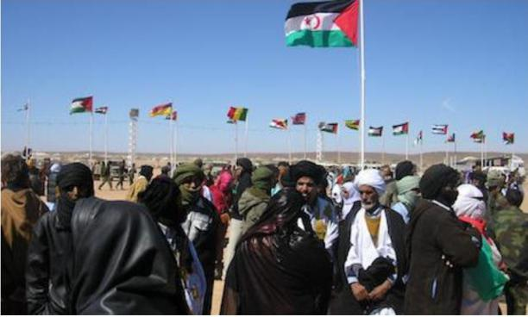

- Spanish Colonialism in Western Sahara

During the period of intensified competition between European powers to expand their empires, there was a rush among them to acquire African territories, which I. William Zartman referred to as "the great African hunt." However, this hunt primarily turned into a fierce competition for territory between the English and the French, with other European countries playing a minor role. Among the minor participants, Spain had the least impact, with its acquisitions in the hunt, including Western Sahara, which it claimed in 1884, being relatively small and lacking significant natural resources.

Spain waited for France to determine the extent of its claims. Through a series of treaties from 1900 to 1912, the French forced Spain to accept a defined portion of the territories as its own. France ensured that the wealthier parts of the territories remained within the borders of its colonies of Mauritania, Algeria, and Morocco, while allowing Spain to claim Rio de Oro, Seguiet-el-Hamra, and the southern region of Morocco, also known as Tarfaya.

Before World War II, Spain paid little attention to its colony, Western Sahara. However, after the war, it became necessary for Spain to take notice. The colony was considered a strategic military outpost during the Spanish Civil War, and it could have been used as a bargaining chip with Adolf Hitler if Germany had emerged victorious. In 1947, the discovery of large phosphate deposits at Bu Craa increased the colony's significance. Spain seized the opportunity presented by the growing Cold War to align itself with the Western Camp by presenting itself as an anti-communist stronghold. However, as Spain sought acceptance among the international community, its colonial policies faced increased scrutiny. Its admission to the United Nations in 1955 implied an acceptance of new rules calling for colonial accountability, although Spain was initially reluctant to comply.

Spain remained hesitant to be accountable, even as anti-colonial movements gained momentum in Algeria, Morocco, and Mauritania, ultimately leading to the independence of the three French colonies surrounding its Sahara territories. Particularly in southern Morocco, these movements sparked the emergence of an Army of Liberation, which inspired the Sahrawi people to fight against both the Spanish and the French. Morocco gained independence in 1956 and subsequently collaborated with France and Spain to suppress the remnants of the Army of Liberation. Those who sought refuge in Morocco were disarmed. As a reward, Madrid handed over Tarfaya to Rabat in 1958. Although defeated, the Sahrawi had experienced a liberation war against two colonial powers and a potential third one.

Spain decided to establish a tangible presence in the territory by investing in human and material resources. It increased budget allocations, developed infrastructure, established schools, and encouraged investments in mineral exploration, particularly in oil and iron. The production of phosphate at Bu Craa was a significant development, facilitated by the construction of a 62-mile conveyor belt to transport the phosphate to a port near Al-Ayoun, from where it would be shipped to Spain. The harsh drought that struck the area also contributed to the sedentarization of the population, as it devastated livestock and drove people to seek alternative livelihoods in growing towns. These activities brought different Sahrawi clans into closer contact with each other and with the Spanish authorities, fostering interactions through residence, schools, and new governance systems.
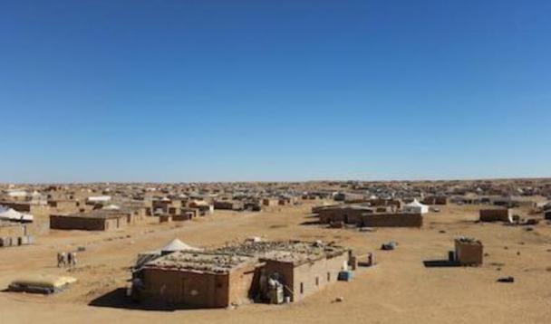

- Sahrawi Anti-Colonialism

The Sahrawi people in Western Sahara, influenced by political events in neighboring French colonies and with diverse experiences, began demanding independence. The administrative and political institutions established by the Spanish to maintain their rule treated the Sahrawi as subordinate, providing an opportunity for them to envision Western Sahara as a distinct geopolitical entity separate from its neighbors. While their neighbors, who had experienced French colonization, had gained independence, the Sahrawi experienced Spanish colonization and remained under colonial rule. Initially, they sought involvement in provincial affairs, but eventually transformed into an anti-colonial movement advocating for independence.

In the 1960s, the first significant group to challenge Spanish control in urban areas was Harakat Tahrir, led by Mohammed Sidi Ibrahim Bassiri. Bassiri, who had been evacuated by Sahrawi guerrillas during the Sahrawi anti-Spanish war of 1957-1958, acquired nationalist

ideas while studying in Middle Eastern universities. He returned to Morocco in 1966, started a newspaper, and then moved back to Western Sahara in 1967 as a Quranic teacher in Smara. He founded Harakat Tahrir Saguia el-Hamra wa Oued ed-Dahab (Organization of the Liberation of Saguia el-Hamra and Oued ed-Dahab), also known as Harakat Tahrir. The movement even managed to infiltrate loyal Sahrawi members of the military and government bureaucracy. Their calls for reforms and progress towards independence attracted many followers. A confrontation with the government in Zemla led to the Zemla massacre in 1970, after Harakat Tahrir presented their demands, which the government rejected. Some leaders were arrested, and when a riot broke out, some people were shot. Bassiri, the charismatic agitator, was among those arrested and was never seen again, resulting in the disintegration of Harakat Tahrir.

The collapse of Harakat Tahrir reignited Sahrawi nationalism, which resurfaced a few years later as POLISARIO. However, opposition to Sahrawi independence came from two powerful sides that sponsored alternative anti-colonial movements favoring their own interests. Morocco and Mauritania desired anti-colonial movements that would lead to annexation, not independence. Spain sought movements that emphasized Spanish benevolence and a continued presence, thus sponsoring and registering PUNS (Partido de la Union Nacional Saharaui), which rejected Moroccan and Mauritanian irredentism and advocated close relations with Spain. However, PUNS made little progress and quickly disintegrated. Morocco also sponsored its own party, FLU (Frente de Liberacion y de la Unidad), to discredit POLISARIO and advocate union with Morocco. Additionally, there was MOREHOB (Movement de Resistance des Hommes Bleus), associated with an opportunistic former policeman named Bachir Figuigui, also known as Eduardo Moha, who frequently shifted political positions. POLISARIO initially faced difficulties but eventually brought about a change in attitude and the international dynamics of Western Sahara.

However, Algeria underwent a shift in its stance when it perceived a significant threat to its security interests. This occurred when Morocco and Mauritania deliberately obstructed a United Nations-mandated referendum and excluded Algeria from a settlement with Spain concerning Western Sahara. Feeling disregarded and sensing a potential threat to its interests, Algeria made the decision to provide comprehensive support to POLISARIO in order to counter the expansionist ambitions of Mauritania and Morocco. This support enabled POLISARIO to establish a strong foundation of backing, thereby becoming a formidable force to be reckoned with.

IV. Spain and External Forces

The decolonization process in Western Sahara was further complicated by the interests of external actors, as evidenced by Algeria's actions, resulting in Spain losing control and the Sahrawi people becoming pawns in a power struggle. Central to this complexity was Morocco's imperialistic irredentism, which posed a threat not only to Western Sahara but also to Algeria and Mauritania. The notion of a "Greater Morocco," including Mauritania, parts of Senegal, Mali, Algeria, and all Spanish colonies in Northwest Africa, was initially voiced by Allal el-Fassi, the leader of Istiqlal, on July 7, 1956. This claim was endorsed by the party and King Mohamed V, becoming an integral part of Morocco's ideology. To

reinforce its claims on Mauritania, Morocco supported Hurma Ould Babana, who sought a union between Mauritania and Morocco to diminish the influence of Mauretania's black population. At the United Nations in October 1957, Morocco opposed including Mauritania, Western Sahara, and IFNI on the UN list of Non-Self-Governing Territories, asserting that they were integral parts of its territory. Subsequently, Morocco experienced conflicts with two territories included in its "Greater Morocco" aspirations after they gained independence: Mauritania and Algeria. Morocco refused to recognize Mauritania's independence from France in 1960, attempted to block its entry into the UN, and even severed ties with Tunisia for recognizing the new state. Conversely, Mauritania's President Mokhtar Ould Daddah responded to Morocco's "Greater Morocco" claims by asserting his own vision of a "Greater Mauritania" in July 1957, encompassing territories up to the Moroccan borders. Similar to his political rival, Babana, Ould Daddah held unfavorable views towards the black population and aimed to dilute their influence by uniting Western Sahara and Mauritania as ard al-bidan, a region combining Arabic and Berber characteristics. Considering Western Sahara as a buffer zone between Mauritania and irredentist Morocco, Ould Daddah consistently presented Mauritania as "a hyphen between the Maghreb and Central Africa" during OAU meetings. Eventually, Morocco recognized Mauritania in 1969, and the two countries began collaborating at the expense of Western Sahara. King Hassan II of Morocco also harbored ambitions towards Algeria and capitalized on the vulnerability of Algerian revolutionaries. In exchange for anti-colonial support, he pressured Ferhat Abbas in July 1961 to agree to border adjustments following Algerian independence. When Algeria gained independence in July 1962, Moroccan troops entered Algeria to enforce their claim and awaited official endorsement. However, Algerian President Ahmed Ben Bella, preoccupied with consolidating his position and dealing with numerous challenges, including the Kabyle Revolt in the south, was not in a position to discuss border changes and maintained that the colonial borders should remain unchanged. In response, Hassan decided to annex the territory through military means, resulting in what became known as the "war of the sands" in 1963. The conflict ended when the newly established OAU persuaded Hassan to withdraw his troops from Algeria, but suspicion lingered between the two countries.

- The OAU ambivalence

Initially, the OAU faced uncertainty and mixed feelings regarding the Western Sahara issue, partly due to the diverse interests of newly independent African nations. Many of these nations gained independence in 1960 and became full members of the United Nations. Their presence, along with other Third World countries, influenced the adoption of UN Resolution 1514 in 1960, which emphasized the right to self-determination and the freedom to choose their economic and political futures for all peoples. Although they all agreed on the importance of decolonization, they disagreed on how self-determination should be implemented when conflicting claims arose, especially regarding the adjustment of colonial boundaries.

Some countries, including Morocco, displayed irredentist tendencies, claiming to be "progressive" while coveting land in other states. They advocated for the elimination of colonial boundaries to align with genuine African interests rather than those determined by

colonialists. On the other side, there were those who insisted on preserving colonial boundaries, despite their unfairness, to prevent chaos and potential violence. This was the context when independent African states convened in Addis Ababa in May 1963 to establish the Organization of African Unity (OAU). They agreed to uphold the sanctity of colonial boundaries and asserted that the right to self-determination should remain within those borders. They also pledged non-interference in the internal affairs of member states. These provisions seemed to target the "progressive" states that were perceived as violating boundaries and interfering in the internal affairs of others. However, the OAU did establish a Liberation Committee to support the liberation of remaining colonies.

The Liberation Committee held its inaugural meeting in July 1963 but appeared uncertain about how to approach smaller colonies, which potentially made concessions to irredentists. It attempted to classify colonial powers and colonies based on their readiness for decolonization and the viability of the entities to be decolonized. Spain, alongside Britain and France, was seen as a country that recognized the right to self-determination but required diplomatic pressure to expedite decolonization. The committee also tended to postpone decisions concerning the fate of small colonies like Spanish Sahara and Djibouti, which were deemed unviable if left on their own. This stance was encouraging to both the colonial powers and neighboring irredentist nations. As a result, in August 1963, Madrid announced its intention to grant administrative and economic autonomy to Guinea and IFNI, allowing them to join Morocco, but it did not make any commitment regarding the Western Sahara. Equatorial Guinea gained independence in 1968.

VI. The UN Position

While the OAU initially hesitated to engage with Spain regarding the Western Sahara issue, the United Nations took a different approach. In December 1960, the United Nations General Assembly passed Resolution 1514(XV) concerning the Declaration on the Granting of Independence to Colonial Countries and Peoples, which affirmed the right to self-determination for all peoples. According to the resolution, peoples are entitled to freely determine their political status and pursue their economic, social, and cultural development. Additionally, Resolution 1514 prohibited any attempts to disrupt a country's national unity and territorial integrity. In 1961, the UN established a dedicated Special Committee on the Situation with Regard to the Implementation of the Declaration on the Granting of Independence to Colonial Countries and Peoples to oversee the final stages of decolonization in various territories.

In September 1963, the UN specifically identified Western Sahara as a territory affected by Resolution 1514, and in 1964, the UN expressed concerns about Spain's reluctance to comply with UN resolutions. The General Assembly, in 1965, called upon Spain to take all necessary measures to decolonize Western Sahara and conduct a referendum on self-determination. Madrid, however, became increasingly obstinate, claiming that Western Sahara was a province of Spain and not subject to self-determination. Nevertheless, under pressure, Spain eventually had to acknowledge the potential for Sahrawi independence. In 1966, Morocco and Mauritania, both driven by irredentist ambitions to incorporate Western

Sahara as one of their provinces, countered Spain by emphasizing the Sahrawi people's right to self-determination.

In response, Spain established a general assembly of compliant elders called the Djemaa in 1967, but this did not alleviate the UN's pressure, as it continued to affirm the Sahrawi people's right to independence. In September 1973, Franco granted the Djemaa powers to legislate on internal matters, excluding external affairs and defense, and promised the Sahrawi people the right to vote for their future when they freely requested it. The UN insisted that the Sahrawi exercise their right to determine their future freely and authentically. Ultimately, Spain, cornered by international pressure, agreed in 1974 to hold a referendum in Western Sahara in 1975 under UN supervision. However, Spain eventually lost control over the situation.

VII. Imposing Morocco's Colonialism

With Spain's change in position, Morocco also shifted its stance, and from that moment onward, Rabat, supported by Washington and Paris, effectively replaced Madrid as the determining force for the future of Western Sahara. Alongside Mauritania, Morocco denied the existence of the Sahrawi as a distinct historical group and insisted on incorporating Western Sahara into its territory. For Hassan II, Sahrawi self-determination leading to independence rather than annexation to Morocco was unacceptable. To undermine the concept of self-determination, he devised strategies to nullify its impact.

Secretly, he struck a deal with Mauritania to divide the territory into two parts, with Mauritania retaining control over Rio De Oro while Morocco claimed Saguiet el-Hamra. This maneuver aimed to derail the anticipated referendum, supported by Mauritania. Hassan II proposed involving the International Court of Justice (ICJ) to settle the ownership dispute over Western Sahara, employing it as a delay tactic. Kenyan delegate Frank Njenga voiced his disgust, stating that this approach treated the Sahrawi people as possessions rather than individuals. It should be noted that the discussions in the UN prior to referring the Western Sahara issue to the ICJ made it clear that such action did not negate the right to self-determination. Eventually, the matter was referred to the ICJ, which, in October 1975, ruled that neither Morocco nor Mauritania had sovereignty over Western Sahara and affirmed the Sahrawi people's right to self-determination. Furthermore, a UN inspection team found that the majority of the population desired independence and supported the POLISARIO movement.

Despite disappointment, Hassan II, aware of the backing from the United States and France, correctly assessed that Spain could be influenced, partly due to the declining health of Franco. He publicly declared his intention to invade Western Sahara with an army of
350,000 pilgrims carrying the Holy Koran to lay claim to the territory. This action violated a UN resolution from October 1970, which prohibited the use of force or threats of force to acquire territories. However, Hassan II succeeded in creating tensions to manipulate the situation in his favor. With France and the United States protecting Morocco at the Security Council, the UN was rendered ineffective and failed to condemn the Moroccan invasion. France and the United States preferred Morocco to control the territory rather than seeing a revolutionary group replace Spain.

By leveraging the support of the United States and France, Hassan II managed to avoid condemnation. These two influential countries exerted pressure on Spain to reach an agreement with Morocco regarding the future of Western Sahara. Subsequently, Spain indicated its willingness to negotiate with Morocco and Mauritania concerning the territory's future. In December 1975, the three parties met and agreed that Spain would simply withdraw, allowing Morocco and Mauritania to divide the territory between them. In February 1976, Spain abruptly departed, leaving its "African brothers" to be invaded by Moroccan and Mauritanian forces. In April 1976, the two expansionist countries officially agreed on a demarcation line separating their respective claims in Western Sahara.

Morocco had developed the ability to manipulate larger powers to its advantage. It had demonstrated its skill in balancing the support of both the United States and the Soviet Union during the "war of the sands." While the weapons provided by the Soviets were used to defeat a weak Algeria, the United States offered logistical support to Morocco. Moscow chose to maintain a favorable relationship with Rabat and refrained from criticizing Morocco's expansionist ambitions. Moscow endorsed Moroccan irredentism under the guise of supporting anti-colonialism against Spain, partly to secure phosphate supplies. Morocco found its connections with Moscow useful leverage in the Western world.

The convergence of interests between the United States and Morocco allowed irredentist Morocco to exploit American preoccupation.

Conclusion

Various forces, through conquests and counter-conquests, gave rise to a mixed population with a unique identity. Within their heritage, one can find diverse African peoples, a range of Arab tribes, and a small European influence, primarily from Iberians and some French individuals. These groups interacted, intermarried, and assimilated into different communities, creating new peoples. Among them were the Sahrawi, who inhabited parts of present-day Morocco, Algeria, and Mauritania, with their distinct cultural lifestyle and language.

During these interactions, two cultural zones appeared to distinguish Moroccans from the Sahrawi. The Atlas Mountains became the southern frontier of Morocco proper, known as bilad el-makhzen, where Moroccan authority was unquestioned. Beyond this demarcation line lay the troubled land, bilad es siba, where Morocco had little control. The Sahrawi were regarded as a separate people in a separate territory, which eventually became known as Western Sahara and was predominantly occupied by nomads. This marked the emergence of Morocco as a geographical reality in the northern region.

As Sahrawi, people resisted the French and the Spaniards, with Ma el-Ainin becoming a symbolic figure of Sahrawi nationalism, although unable to halt the European presence. France played a significant role in defining the size and location of the Sahrawi territory, which Spain received as its colony. However, Spain showed minimal administrative interest in the region, treating it primarily as military outposts and relying on France for protection

against the Sahrawi. Administratively divided between the French and Spanish colonies, the majority of the Sahrawi population remained in Spanish Sahara.

Spain, unsure of its position regarding its small African colonies, was externally influenced. Following its stance in World War II, which led to international isolation, Spain was rehabilitated and admitted into the UN in 1955, largely driven by the dynamics of the Cold War. The new international norms demanding decolonization also applied to Spain, which attempted to present Western Sahara as a Spanish province where its "African brothers" were well-treated. Spain began exploiting phosphate deposits in Bu Craa and encouraged Sahrawi settlements under new administrative and political structures. However, rising anti-colonial Sahrawi movements, inspired in part by successful uprisings in neighboring French colonies, posed a challenge to Spanish control. Among these movements was POLISARIO, which became a symbol of Sahrawi aspirations for independence and self-identity, be it Arab, African, or a blend of both. However, their aspirations were disrupted by the irredentist ambitions of Mauritania and Morocco once it became clear that Spain's influence was waning. Spain eventually left Western Sahara without a proper exit strategy, losing control and opening the door for Mauritania and Morocco to assume control.

Mauritania and Morocco engaged in a competition to become the new colonial masters of Western Sahara, similar to the earlier rivalry between France and Spain. Ultimately, Morocco gained the upper hand, aided by the support of powerful countries such as the United States and France, and gradually pushed Mauritania out of the region. Despite Morocco's violation of UN principles and territorial annexation, it faced minimal international reprimand due to its favorable relationships with major powers who turned a blind eye to its transgressions.

Similar to Spain, Morocco referred to Western Sahara as a province rather than a colony. It faced some anti-colonial resistance, but this opposition was limited due to various factors. Morocco appealed to Arab solidarity, which garnered support from Arab nations, and it enjoyed backing from Western powers as a bulwark against potential revolutionary movements. The Soviet Union, instead of condemning Morocco's expansionism, endorsed it to secure phosphate supplies and continued selling military equipment to Morocco, which Morocco leveraged to its advantage

Western Sahara at News

- A new report shows that the British scramble for Africa is a continuation of the country's foreign policy legacy." Tom Lebert writes.

Over the past few decades, as world commodity markets have boomed, there has been a new ‘scramble for Africa’ with governments and companies seeking to control the continents valuable mineral, oil and gas resources.

‘The New Colonialism: Britain’s scramble for Africa’s energy and mineral resources’, a new War on Want report, reveals that as many as 101 companies listed on the London Stock Exchange (LSE), most of them British, have mining operations in Africa. Combined these

companies now control resources of oil, coal, gold, diamonds, gas and much else, worth in excess of $1 trillion.

While the scale and scope of the UK’s involvement in the exploitation of Africa’s resources is staggering, so too is the complete disregard by these companies, and the British establishment, for the rights of the people concerned. A key example of this is the scramble for gas and oil in Moroccan-occupied Western Sahara.

Morocco has occupied much of Western Sahara since 1975. Most of the population has been expelled by force, many to camps in the Algerian desert where 165,000 refugees still live. Morocco’s occupation is a blatant disregard for international law, which accords the saharawi people the right to self-determination and the way in which their resources are to be used. Over 100 UN resolutions call for this right to self-determination but UN efforts to settle the conflict by means of a rederendum have been thwarted by Morocco. The International Court of Justice has stated that there are no ties of sovereignty between Morocco and Western Sahara, and no state in the world recognizes Morocco's self-proclaimed sovereignty over the territory.

Despite this, six British and/or LSE-listed companies have been handed permits by the Moroccan government to actively explore for oil and gas resources, making them complicit in the illegal and violent occupation of Western Sahara.

Cairn Energy, based in Edinburgh and LSE listed, is one such company. It is part of a consortium, led by US company Kosmos Energy, that in December 2014 became the first to drill for and later discover oil off the coast of Western Sahara.

Saharawis have consistently protested against the exploration activities of oil companies in Western Sahara, but by doing deals with the Moroccan government oil companies such as Cairn are directly undermining the Saharawis’ right to a referendum on self-determination.

Foreign oil investment boosts Morocco’s frail veneer of international legitimacy, finances the expensive occupation and undermines the UN peace process. As oil is increasingly developed, the economic implications for Morocco are huge, further cementing its resolve to hold on to its lucrative colony.

Cairn’s claim to support human rights are therefore hard to square with Morocco’s activities in Western Sahara, where basic rights and freedoms are routinely suppressed by the same authorities which have given oil companies ‘rights’ to operate.

But instead of reining in companies such as Cairn, the British government has actively championed them through trade, investment and tax policies. Successive British governments have long been fierce advocates of liberalised trade and investment regimes in Africa that provide access to markets for foreign companies. They have also consistently opposed African countries putting up regulatory or protective barriers and backed policies promoting low corporate taxes.

Furthermore, British governments have continually promoted voluntary rather than legally binding mechanisms to address corporate human rights abuses committed abroad. Such voluntary mechanisms are effectively meaningless.

And let’s not forget the ‘revolving door’ between Whitehall and the private sector. Many senior civil servants leave their posts for directorships on the boards of these mining companies. Kosmos Energy is no exception. The former Director of Britain’s Secret Intelligence Service, MI6, Sir Richard Dearlove, has been a member of the Kosmos Board of Directors since 2012.

The current phase of the British scramble for Africa is a clear continuation of British foreign policy goals since 1945. Then as now, access to raw materials is a major factor — often the major factor — in British foreign policy in Africa.

c. The Issue of Türkistan
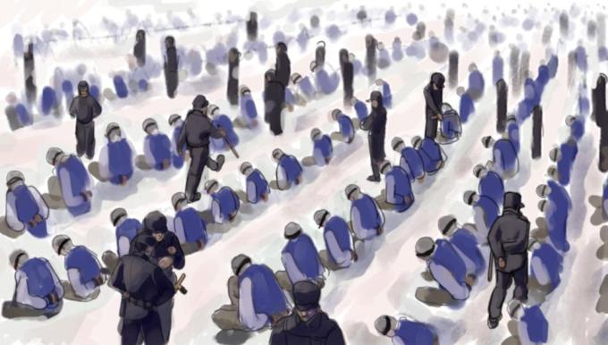

An Overview

The issue of East Turkistan (also known as Xinjiang) is a complex and controversial one. East Turkistan refers to the Uyghur-majority region in northwest China. Some Uyghur activists and human rights organizations argue that China's policies and actions in the region constitute a form of colonization, cultural suppression, and human rights violations. They highlight the Chinese government's control over the region's political, economic, and cultural aspects, as well as the restrictions on religious practices and the alleged mass detention of Uyghurs in internment camps.

On the other hand, the Chinese government views its actions in the region as necessary measures to combat separatism, terrorism, and extremism. They argue that their policies aim to promote stability, economic development, and social harmony in the region. The Chinese government denies the existence of internment camps and emphasizes the importance of integration and national unity.

- Who are the Uyghurs?

The Uyghurs are a largely Muslim Turkic ethnic group, with their own language and culture. Roughly 11 million are in China, and 1.5 million more live around the world. For centuries, Uyghurs have lived in a vast region of deserts, mountains and lakes in the far northwest of China, known today as Xinjiang. For thousands of years, leaders, tribes and China’s imperial dynasties have fought for control of this resource-rich territory. Around the 10th century, Arab influence arrived in the region and Islam became a part of Uyghur life.

During the Qing dynasty, the region was brought once again under Chinese control. In the late 19th century it was given its current name, Xinjiang, which means “new frontier” in Mandarin.

Today, Xinjiang’s Uyghurs are subject to a comprehensive, targeted campaign of surveillance and control. According to leading researchers and human rights groups, as many as 1.5 million have been placed in concentration camps. This ongoing program of repression follows decades of tension between the Uyghurs and the Chinese government.

- 1949: Declaration of the People’s Republic of China

As civil war raged in China in the 1940s, Xinjiang experienced a brief period of independence and became known as East Turkestan. On October 1, 1949, Chinese Communist Party leader Mao Zedong declared the creation of the People’s Republic of China and brought Xinjiang under its control.

In 1954, the People’s Republic designated the Uyghurs as one of China’s officially recognized ethnic minorities. The classification of these groups went hand-in-hand with the state’s aim of fostering "a great family founded in primciple on ethnic equality" and bringing minorities together under the common vision of a communist china.

In 1955, the People’s Republic established the Xinjiang Uyghur Autonomous Region. In practice, the Uyghurs were not given any significant political power. This focus on ethnic identity and autonomy was seen as a way of quelling independence movements while maintaining Beijing’s power over China’s regions.
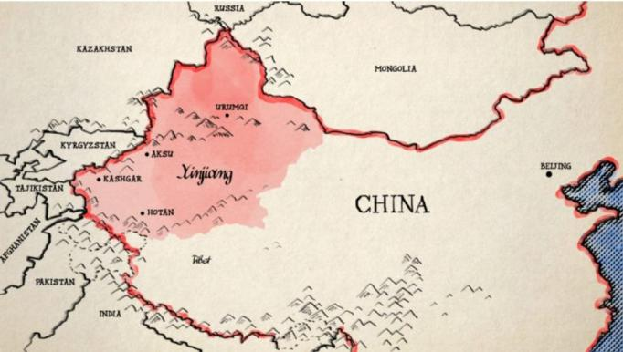

- 1966: The Cultural Revolution arrives in Xinjiang

In 1966, an ageing Mao was keen to quash his opponents once and for all. He wanted to reinvigorate the Communist revolution and purge China of any lingering remnants of capitalism and traditional life. To achieve this, he called on the Communist Red Guards to attack the “four olds” – old ideas, old culture, old habits, and old customs.

In Xinjiang, Uyghur life was upended. Mosques were destroyed or converted into Communist Party buildings. Religious texts and Uyghur-language books were deemed anti-revolutionary, and were confiscated and burned. During this period, Mao ordered millions of China’s educated, urban youth to the countryside to do hard labor on the land. Many were sent to rural Xinjiang. Mao called the program “re-education” – a phrase that would come to haunt the region more than 50 years later.

IV. Developing Xinjiang

Xinjiang is rich in natural resources like coal and gas, and shares borders with eight countries. From 1950 on, the Chinese Communist Party wanted to develop Xinjiang’s economy and infrastructure, and shore up support for the People’s Republic of China along its outer borders. The state began to encourage Han Chinese people – China’s dominant ethnic group – to migrate to Xinjiang. They were often lured with the promise of employment, housing and a better life.

Skilled Han migrants were strategically relocated and placed in jobs to develop the region’s oil, gas and cotton industries, and frequently given priority over Uyghurs and other local minorities. Over time, inequality and segregation between Han Chinese and Uyghurs began to grow. Uyghurs earned less and had a lower standard of living than their Han counterparts, a trend which continues to do this.

- Reform and opening

After Mao’s death in 1976, his successor, Deng Xiaoping, led a policy of “reform and opening” that gave Uyghurs space to explore their cultural history and revive their traditions and religion.

By the early 1990s, Xinjiang had witnessed a resurgence of Islamic devotion and ideology, and the Uyghurs had built thousands of new mosques.

Political activism also increased in the region, and protests became more common, with some protesters calling for Uyghur independence, prompting authorities to once more tighten control of the region and clamp down on religious expression. During this period, several riots erupted between Uyghurs and Chinese police and open resistance to the Communist Party became more common.

Demonstrations, civil unrest, bombings and other attacks increased during the 90s, with violence reported on both sides. Amnesty International described the 1997 protests in the city of Gulja, as a peaceful demonstration turned massacre, quoting the exiled Uyghur activist Rebiya Kadeer. “I have never seen such viciousness in my life.” “Chinese soldiers

were bludgeoning the demonstrators.” The Chinese government ascribed any violence in Xinjiang during that time to “inhuman, antisocial and barbaric acts,” and made it clear that the state saw Uyghur separatism and Islamic ideology as at the root of the unrest.

In the immediate aftermath of 9/11, China began a renewed crackdown on the Uyghurs, warning its people that Uyghur separatism and religious extremism posed a terrorist threat.
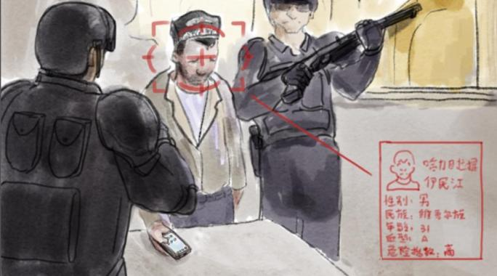

VI. 2009: Riots in Urumqi

In late June 2009, a fight broke out between Uyghur and Han workers at a toy factory in the city of Shaoguan in Guangdong Province, southeast China. Two Uyghurs were killed and 120 people, mostly Uyghurs, were injured. The news was met with shock by Uyghurs thousands of miles away in Xinjiang. On July 5, a group of Uyghur students took to the streets of Urumqi, the region’s capital, to protest.

Clashes between the protesters, police and Urumqi’s Han residents quickly escalated. Protesters threw rocks and burned cars; troops and paramilitary police responded with bullets. Around 200 people were killed – according to the authorities, most were Han. In the following days, armed mobs of Han vigilantes ran through the city, seeking revenge on the Uyghurs. During the protests, the authorities cut off the internet in Urumqi. It was one of the first times in history that a government implemented this measure, now a favored tactic of authoritarian regimes across the world.

VII. 2012: The ascent of Xi Jinping

The 2009 riots marked a turning point for government policy in Xinjiang. In 2012, Xi Jinping was named leader of the Chinese Communist Party. During the first 18 months of his presidency, several high-profile outrages – including a suicide car attack in Tiananmen Square, a train station stabbing in southern China and the bombing of a market in Urumqi – were attributed to Uyghur militants. Xi made his first and only trip to Xinjiang in 2014. On the last day of his visit, two Uyghur militants attacked passengers at a station in Urumqi with knives and explosives. Three people were killed in the suicide attack, including the two assailants, and dozens injured. Xi launched what he referred to as a “People’s War on Terror” in 2014. For ordinary Uyghurs in Xinjiang, life began to change dramatically.

By 2015, the state began to roll out a massive surveillance network across the region, placing extensive restrictions on freedom of expression and religion in the name of counter-terrorism. Police checkpoints were introduced everywhere and Xinjiang residents were required to submit biometric information including iris scans, blood samples, DNA and voice samples and facial scans to the authorities. Millions of cameras and state-of-the-art facial recognition technology were deployed to track residents’ every move.

Xinjiang became a testing ground for the latest developments in surveillance technology. It was also given a new regional boss: Chen Quanguo, whose previous job had been to enforce a security crackdown in Tibet. Shortly after his appointment in August 2016, Chen issued an order to “round up everyone who should be rounded up.”

VIII. 2017-2020: Camps

As the crackdown intensified in Xinjiang, authorities arrested Uyghurs for any behaviour deemed potentially “extremist” – making trips or phone calls abroad, wearing a hijab, growing a long beard, or keeping Islamic books in the house. When the authorities began to confiscate passports for "safekeeping" on some parts of Xinjiang, it became nearly impossible for many Uyghurs to leave China. Police stations sprang up every few hundred yards in Xinjiang’s cities.

Most troublesome of all, vast, mysterious facilities were built in the region’s deserts. Human rights organizations, journalists and activists raised the alarm: they appeared to be camps. Hundreds of thousands of Uyghurs began to disappear into them. Initially, the Chinese authorities denied the existence of the camps. In August 2018, a report put together by the UN estimated that a million Uyghurs and other Muslims in Xinjiang had been imprisoned within them.

After the UN report, the Communist Party referred to the camps as “vocational training centers” intended to “re-educate” Xinjiang’s Muslim population. That word brought back grim memories of the Cultural Revolution. The camps are guarded with great secrecy, though the state has allowed propaganda images to circulate of Uyghurs in classrooms, being cleansed of their religious ideology, taking lessons in communist history and Mandarin.

Uyghurs were also held in prisons and detention centers, for crimes such as having WhatsApp (a banned app in China) on their phone or messaging people abroad. Uyghurs who have been released from these centers described cramped, inhumane conditions and constant surveillance. In the fall of 2019, drone footage emerged of hundreds of blindfolded and shackled men, being marched off a train in Xinjiang. All had their heads shaved; all appeared to be Uyghur or other minority prisoners.

IX. 2020: Rebranding Xinjiang

Today, Xinjiang is promoted heavily by the Chinese state as a tourist destination. Images coming out from the region are tightly controlled, and video footage often shows Uyghurs happily dancing for visitors. Last summer, the Chinese government claimed “most people” had been released from Xinjiang’s camps and returned to society. However, according to

human rights groups, as many as 1.5 million Uyghurs remain in detention, while arrests, detentions and prison sentences have surged in Xinjiang.

Uyghurs outside China who have spoken to Coda Story say they are still waiting for their relatives to be released from the camps. A leaked cache of documents published in November 2019 showed how the camps – which China maintains are for education and training – are run like high-security prisons. In March 2020, a report was published that showed Uyghurs were being transferred to factories used by global brands, including Nike and Apple, and made to work “under conditions that strongly suggest forced labor.”

d. The Turkish Imperialism

Neo-Ottomanism refers to the foreign policy adopted by the Justice and Development Party (AK Party) in Turkey after coming to power in 2002 under Prime Minister Erdoğan. This policy represents a significant departure from the traditional Turkish foreign policy based on Kemalist ideology, which focused on a Western-oriented approach. The shift towards Neo-Ottomanism began during Turgut Özal's government and marked a change in Turkey's perception of its multiple identities, moving away from the unitary concept of the Kemalist republic. Economic aspects were prioritized over politico-state and security considerations.

Religious circles played a role in shaping Neo-Ottomanism, with influential Islamic leader Fethullah Gülen promoting personal transformation, social and political activism, and Turkish nationalism with Islam as the defining characteristic. This approach also embraced economic neoliberalism while emphasizing continuity with Turkey's Ottoman past. The late Ottoman state's transformation, conflicts in the Balkans and Soviet expansion, influenced the emphasis on the state's role and neoliberalism.

The Ottoman Empire's historical significance and its control over the Balkans and the modern-day Middle East have influenced Neo-Ottomanist foreign policy, which seeks increased engagement and influence in these regions. This approach has led to improved relations with neighboring countries such as Iraq, Iran, and Syria but strained relations with former ally Israel, particularly due to events like the 2008-09 Gaza War and the 2010 Gaza flotilla raid.

While Ahmet Davutoğlu, who served as Turkey's foreign minister from 2009 to 2014, rejected the term "neo-Ottomanism" to describe the new foreign policy, he advocated for a policy of "zero problems with neighbors" and emphasized the use of "soft power."

The rhetoric of civilizational encounters, as well as former President Turgut Özal's approach, influenced Davutoğlu's foreign policy. Özal aimed for national harmony, recognizing the specificity of Turkish citizens and seeking dialogue with the Kurds to resolve conflicts and improve Turkey's international image.

During his presidency, Erdoğan revived Ottoman traditions, which sparked controversy as it was seen as a departure from the republican values established by Mustafa Kemal Atatürk. Erdoğan's AK party made references to the Ottoman era during election campaigns, and he endorsed using the term "külliye" for university campuses, reminiscent of Ottoman terminology. Critics accused Erdoğan of aspiring to become an Ottoman sultan, jeopardizing the secular and democratic principles of the Republic.

Erdoğan rejected these claims and likened his role to that of Queen Elizabeth II of the United Kingdom, emphasizing a ceremonial role with a dominant element of national unity.

In 2020, Erdoğan ordered the reclassification of Hagia Sophia as a mosque after the annulment of the 1934 Cabinet decision that had turned it into a museum. This decision, along with the transfer of the Chora Church's administration to the Directorate of Religious Affairs for worship, sparked international condemnation. Erdoğan justified these actions by invoking the concept of conquest within the context of justice commanded by Allah.

On August 26, 2020, Erdoğan stated that conquest in Turkish civilization meant establishing justice, not occupation or looting. He emphasized Turkey's intention to assert its rights in the Mediterranean Sea, the Aegean Sea, and the Black Sea.

On May 2023 before and during the Turkish elections, Turkey was observed by the whole world as it was the most important elections of the century for too many countries that have strong relations with Turkey. A very remarkable thing was the celebrations taken place in Uskup (Macedonia), Albania and Sandžak (Serbia) on 14th May, the day of the Turkish elections though they had to have a runoff election. On the other hand, the incredible number of well-known news channels that completely covered the elections process in Turkey shows how much the world is concerned about Turkey's future. Most Western media were supporting the opposition by adding posters on their profiles like "Erdoğan must go". Meanwhile, Al Jazeera covered the elections process and showed that Erdoğan is taking the majority of the votes which was true at the beginning as Erdoğan won 60% of the votes until it decreased to 49% in the end of the day.
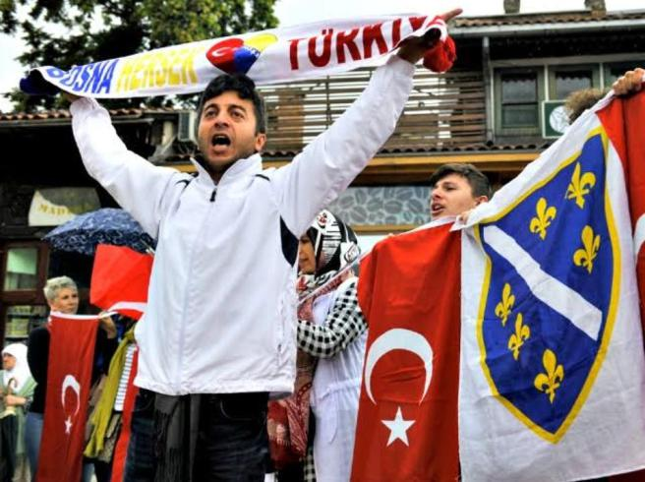

It is too obvious that the West -except for the Balknas- is trying its best to fight the Turkish Imperialism while Russia, and most of the MENA region are supporting it.
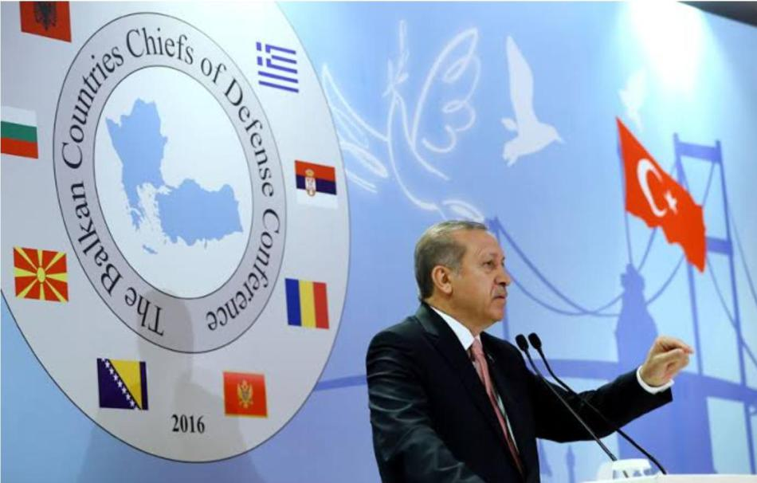

Turkish Occupation of Northern Syria

Since August 2016, the Turkish Armed Forces and their ally, the Syrian National Army, have held control over parts of northern Syria during the ongoing Syrian Civil War. While these areas formally recognize a government associated with the Syrian opposition, in practice, they function as a distinct proto-state under the joint administration of decentralized local councils and the Turkish military.

The Turkish-controlled regions in Syria encompass an area of 8,835 square kilometers, comprising more than 1,000 settlements, including notable towns like Afrin, al-Bab, Azaz, Jarabulus, Jindires, Rajo, Tal Abyad, and Ras al-Ayn. Most of these locations were previously held by the Islamic State (IS) and the Syrian Democratic Forces (SDF), which the Turkish government designates as terrorist organizations. However, certain towns, such as Azaz, were under the control of the Syrian opposition prior to Turkish intervention. The Syrian Interim Government has established its presence in these Turkish-controlled territories, gradually expanding its limited authority and providing official documentation to Syrian citizens. Turkish authorities refer to these areas as "safe zones." Unfortunately, the occupation has resulted in human rights violations, including instances of ethnic cleansing, in some of these regions.

1. Background

As early as May 2011, Turkey and the Syrian opposition put forth a proposal to establish a secure area in northern Syria. However, the United States and other Western countries were hesitant to endorse these plans. Following the advances made by ISIL in Iraq in 2014,

Turkey and the United States engaged in negotiations for a "safe zone," although the US officials were cautious about implementing a no-fly zone and instead agreed to an "ISIL-free zone."

2. European comments

Following the assaults carried out by ISIL in Syria, a significant number of non-Sunni individuals, including Christians and Yazidis, sought refuge in Turkey. In early 2015, refugees started crossing the Greece-Turkey border in large numbers, making their way to various European countries. This substantial influx of refugees prompted a reevaluation of establishing a safe zone in Syria to protect civilians. In February 2016, German Chancellor Angela Merkel expressed the idea, stating, "Given the current situation, it would be beneficial to have an area where no parties are permitted to launch aerial attacks – essentially, a type of no-fly zone."

3. U.S - Turkish negotiations

The establishment of a safe zone encountered obstacles in early 2016 as the United States and Turkish governments disagreed on the order of eliminating key actors. Turkey advocated for the swift overthrow of the Syrian government, while the US prioritized the fight against ISIL. Additionally, the US expressed concerns about the potential bombing of the area by the Syrian Air Force, which would render the concept of a safe zone unworkable. The government rejected the idea of a safe zone, as it was seen as providing sanctuary for both civilians and rebels.

The discrepancy over the structure of the safe zone contributed to the disagreement between the parties involved. Turkey argued for the inclusion of a no-fly zone as part of the safe zone, whereas the US opposed establishing a no-fly zone due to potential conflict with the Syrian government.

Turkey viewed the Kurdish YPG as a threat due to its close affiliation with the PKK. Conversely, the US acknowledged the PKK as a terrorist organization but considered the YPG as a distinct entity and a key ally in the fight against ISIL.

There was also a dispute regarding the naming of the safe zone. Turkey referred to it as a 'safe zone from ISIS, the Syrian regime, and YPG,' while the US insisted on an 'ISIS-free zone' as the acceptable term.

4. Ethnic cleansing and kidnapping of women

Following the capture of Afrin District (Afrin Canton) by Turkish-led forces in early 2018, a resettlement policy was implemented whereby predominantly Arab fighters and refugees from southern Syria were relocated to vacant homes belonging to displaced locals. This often prevented the previous Kurdish or Yazidi owners from returning to Afrin. While some Kurdish militias of the Syrian National Army (SNA) and Turkish-backed civilian councils opposed these resettlement policies, the majority of SNA units supported them. Refugees from Eastern Ghouta in Damascus described it as an orchestrated demographic change

aimed at replacing the Kurdish population of Afrin with an Arab majority. By March 2018, over 200,000 people had fled from Afrin District due to the Turkish intervention, while 458,000 displaced individuals from other parts of Syria were settled in Afrin.

In a report submitted to the UN Human Rights Council, the Independent International Commission of Inquiry on the Syrian Arab Republic presented evidence of numerous human rights abuses committed against the civilian population, particularly Kurdish civilians, by the Turkish state and non-state factions, including the Syrian National Army acting as de facto agents of Turkey. The report highlighted incidents of looting and property appropriation, where Kurdish-owned properties were systematically looted and taken over by members of the Syrian National Army, such as Division 14, Brigade 142 (the Suleiman Shah Brigade). Instances were reported where Kurdish families with fewer than three members were instructed to vacate their homes to accommodate individuals arriving from outside of Afrin.

Reports indicated that Yazidi and other Kurdish women and girls were abducted by the Syrian National Army since the occupation of Afrin began in 2018. These abductions were carried out for various reasons, including ransom, rape, forced marriage, or perceived links to the Democratic Union Party. It was alleged that many of these women and girls were subsequently killed. Such activities were seen as part of an Islamist policy to discourage women from leaving their homes and to curtail their participation in civic activities encouraged under the Autonomous Administration of North and East Syria. They also served a broader agenda of discouraging the return of Yazidi and other Kurdish refugees who had fled Afrin in 2018.

5. Politics and Administration

The area of occupation is officially governed by the Syrian Interim Government, which is an alternative government of the Syrian opposition based in Azaz. However, the actual governance of the region is carried out by several autonomous local councils that maintain close cooperation with Turkey. These councils function similarly to a "Turkish-European style government." Turkey holds direct influence over the regional government, with Turkish civilian officials, including governors, being appointed to oversee the area. Turkish officials primarily act as advisors, allowing the local councils to manage the day-to-day operations of the government and collect taxes independently. In essence, Turkey is in the process of establishing a proto-state in northern Syria, and experts suggest that the country is willing to quasi-annex the region to prevent its recapture by the Syrian government. Turkish Minister of the Interior Süleyman Soylu stated in January 2019 that northern Syria is considered "part of the Turkish homeland" according to the Misak-ı Millî of 1920.

Since the establishment of the occupation zone, the Turkish authorities have been actively working to restore civil society in the areas under their control and strengthen the region's ties with Turkey. As part of these efforts, military checkpoints have been dismantled, and local militias have been relocated to barracks and camps outside civilian-populated areas to demilitarize towns and villages. However, certain military members still hold influential positions in the governance of the zone. For instance, the commander of the Hamza Division, Sayf Balud, has acted as the de facto military governor of al-Bab since 2017.

Turkey also provides funding for education and healthcare services, supports the regional economy, and has trained a new police force. Additionally, Turkey has constructed a new hospital in al-Bab. Some locals perceive these developments as a form of "Turkification" of the region. However, many locals have accepted or even welcomed these changes, as they believe that the area has experienced improved economic, political, and social conditions under Turkish protection. The entry of White Helmets volunteers into the Afrin region occurred after Turkey occupied the area. According to Turkish officials, their presence aims to restore order and improve the situation in northern Syria, reflecting a sense of justice and fraternity dating back to Ottoman times, as explained by one deputy governor. The presence of Turkish soldiers acts as a deterrent against a potential offensive by the Syrian government into the area.

6. Toponymic Turkification

After the establishment of Turkish control in the region, a number of streets, squares and villages have been renamed. Examples are the villages Kastal Mekdad, Kutana and the city of Ra'i, which are officially called Selçuk obası, Zafer obası and Çobanbey. The Saraya Square in Afrin bears the name Erdoğan Square. Signs with both Turkish and Arabic name stress the former with a bigger font.

7. Law enforcement

In early 2017, Turkey implemented a new law enforcement authority called the "Free Police" within the zone. This police force is comprised of both male and female officers and is divided into two branches: the National Police and the Public Security Forces. The Free Police receives training, equipment, and salaries from Turkish authorities, making them loyal to the Turkish state.

Under the leadership of Major General Abdul Razzaq Aslan, the National Police consists of the Civil Police Force and the Special Forces. The majority of police members receive training at the Turkish National Police Academy. To ensure security in Afrin District, Turkey has also recruited former members of the Free East Ghouta Police who relocated to northern Syria after the Siege of Eastern Ghouta concluded.

Furthermore, Turkey has established several courts in the zone, employing Syrian judges and following Syria's judicial code. However, these courts are overseen and supported by Turkish judges and prosecutors. As part of this judicial system, a specialized "terrorism court" was established in Azaz, and a correctional facility was organized in al-Bab.

8. Reactions on the occupation

The Syrian government under Bashar al-Assad has criticized Turkish presence in Northern Syria on multiple occasions and called for their withdrawal. Syrian Opposition groups have expressed mixed, but generally positive opinions over the Turkish offensives. The Syrian Opposition Coalition expressed support for Turkish intervention and called for Turkey to help the Free Syrian Army launch offensives in the region. Other Opposition groups, such as Syria's Tomorrow Movement have condemned the intervention.

International reaction:

Azerbaijan – On 20 September 2016, Qənirə Paşayeva, member of parliament, said that

Turkey would have an obligation to protect the civilians in northern Syria from terror groups and would have the right to protect itself from the attacks originating from Syria with the intervention.

China – On October 29, 2021, China's Deputy Permanent Representative to the United

Nations, Ambassador Geng Shuang said "Since Turkey illegally invaded northeastern Syria, it has repeatedly cut off the water supply service from the Alouk water station" Also stating "China urges Turkey to abide by the international law, including international humanitarian law, protect civilians, maintain infrastructure operations, and guarantee humanitarian access for the UN"

Cyprus – On 9 September 2016, the Cyprus House of Representatives unanimously

adopted a resolution condemning "the unacceptable invasion of Turkey into Syria, under the pretext of war against terrorism." It also called on the international community to demand Turkey's withdrawal from Syria.

EU – On 14 October 2019, following Turkeys' offensive the Council of the European

Union released a press statement condemning Turkey's military action and called for Turkey to cease its "unilateral" military action in north-eastern Syria. It again recalled previous made statements by member states to halt arms exports licensing to Turkey and also recalled that it would not provide "stabilisation or development assistance where the rights of local populations are ignored or violated."

France – On March 30, 2018, Macron assured the SDF of France's support for the

stabilization of the security zone in the north-east of Syria, within the framework of an inclusive and balanced governance, to prevent any resurgence of Islamic State.

Iran – On 31 August 2016, Iranian foreign ministry spokesman Bahram Ghasemi urged

Ankara to quickly wrap up its military intervention in Syria, saying it was an "unacceptable" violation of Syrian sovereignty.

Russia – On October 26, 2021, Elbrus Kutrashev, the Russian ambassador to Iraq said

“there is a process of demographic change. It is done against [the] Kurdish presence there. This is what I call a disaster [against] the local population.”

Spain – On 14 October 2019 the Spanish Foreign Minister Josep Borrell Fontelles (also

High Representative of European Union Foreign Affairs and Security Policy) in an interview stated that the 28 European member states “have unanimously decided to condemn...in strong terms what in the end is a military attack.” Agreeing to also limit arms exports over its offensive in northern Syria, which Turkey “fully rejected and condemned” the decisions made by the EU regarding the issue.

United States of America – On October 7, 2021, President Joe Biden's announcement

stated "The situation in and in relation to Syria, and in particular the actions by the Government of Turkey to conduct a military offensive into northeast Syria, undermines the campaign to defeat the Islamic State of Iraq and Syria, or ISIS, endangers civilians, and further threatens to undermine the peace, security, and stability in the region, and continues to pose an unusual and extraordinary threat to the national security and foreign policy of the United States." thus extending the national emergency powers in Syria by another year.

e.The Russian Imperialism

The Russian Federation is widely recognized as the main successor state to the Soviet Union and has faced accusations of attempting to regain control over post-Soviet states. Initially, most of these states formed the Commonwealth of Independent States (CIS), and many later joined the Collective Security Treaty Organization (CSTO) to enhance their security. The Union State with Belarus represented a deeper level of integration with Russia, while other integration efforts included economic initiatives like the Eurasian Economic Union and Eurasian Customs Union.

In the political discourse of Russia and some other post-Soviet states, the term "near abroad" refers to the independent republics that emerged after the Soviet Union's dissolution. The increasing use of this term in English is connected to assertions of Russia's right to maintain significant influence in the region. Russian President Vladimir Putin has declared the region as part of Russia's "sphere of influence," considering it strategically important to Russian interests. This concept has been compared to the Monroe Doctrine.

The annexation of Crimea sparked a renewed wave of Russian nationalism, with elements of the far-right movement in Russia aspiring to annex additional territories from Ukraine, including the unrecognized Novorossiya. Analyst Vladimir Socor suggested that Vladimir Putin's speech following the annexation of Crimea could be seen as a de facto "manifesto of Greater-Russia Irredentism." Furthermore, the Transnistrian authorities, following the events in Crimea, expressed their desire for Russia to annex Transnistria, a breakaway region of Moldova.

Comtemporary Russian imperialist ideologies

The contemporary ideology known as Eurasianism has been influenced by Aleksandr Dugin, a political theorist who published "Foundations of Geopolitics" in 1997 and later founded the Eurasia Party in the Russian political landscape. Political scientist Anton Shekhovtsov characterizes Dugin's interpretation of Neo-Eurasianism as a variant of fascist ideology centered around the notion of revolutionizing Russian society and establishing a totalitarian Eurasian Empire under Russian dominance. This empire aims to challenge and ultimately overcome its perpetual adversary, symbolized by the United States and its Atlanticist allies, in order to usher in a new era of global political and cultural illiberalism. This ideology has been invoked to justify Russian imperialist actions against Ukraine.

Contemporary Russian expansionism
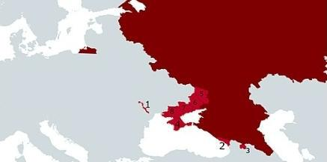

Presently, there are several regions under Russian occupation, including Transnistria (seized from Moldova), Abkhazia and South Ossetia (taken from Georgia), and certain parts of Ukraine's territory. Furthermore, the status of the four southernmost Kuril Islands is disputed, as Japan and several other nations consider them to be occupied by Russia.

Experts often regard these occupations as colonies, although a citation is needed to support this claim.

On February 24, 2022, Russia launched a significant invasion of Ukraine, surpassing the scale of its actions in 2014. This invasion is viewed as a continuation of Russia's irredentist ambitions at the expense of Ukraine. On March 27, 2022, Leonid Pasechnik, the leader of the Luhansk People's Republic, mentioned the possibility of holding a referendum to join Russia. Similarly, on March 29, Denis Pushilin, leader of the self-proclaimed Donetsk People's Republic, discussed a similar option.

Between September 23 and 27, 2022, referenda took place in the Donetsk People's Republic, Luhansk People's Republic, Kherson Region, and Zaporozhye Region, all of which were occupied by the Russian army. It's important to note that Russia did not have complete control over these regions at the time of the referenda. Following the referenda, on September 30, Russia announced the annexation of these territories and intensified its war in Ukraine. It is worth mentioning that the referenda lacked confidentiality and were conducted under the presence of armed guards. International observers have declared these referenda invalid under international law.

On March 30, 2022, South Ossetian President Anatoly Bibilov expressed his intention to initiate legal proceedings for the territory to join the Russian Federation. South Ossetia is a self-proclaimed republic recognized by the majority of United Nations member countries as part of Georgia.

Ukranian-Russian Conflict

Traces of this imperial naivety are still evident in present-day Russia under Putin's leadership. He skillfully manipulates the concept of a multicultural Russia, envisioning it as a harmonious blend of diverse peoples within the Muscovite melting pot. Like his predecessors, he strives to unite the lands of the Eastern Slavs in opposition to foreign domination. By adopting the discourse of a disadvantaged power, he rallies opponents of American imperialism. However, despite propaganda efforts, the war in Ukraine has brought Russia's colonial nature into sharper focus. Putin rejects the federalist legacy left by Lenin, including the right to secession enshrined in the Soviet constitutions, which led to the independence of numerous Union Republics in 1991, including Ukraine. He also disregards the autonomy of republics within Russia and has dismantled agreements made during Yeltsin's era, particularly with Tatarstan and Yakutia-Sakha. Thus, Putin aims to revive what he perceives as an interrupted path in Russia's imperial destiny and reinstate Moscow's dominance and guidance over other peoples.

The upcoming annual convention of the American Association for Slavic, East European & Eurasian Studies (ASEEES) will be dedicated to the theme of decolonization. The war in Ukraine challenges a predominantly Russocentric perspective in state policies and scholarly studies on the Russian, Soviet, and current Russian Empire. In hindsight, one might question whether Russia, as a member of the UN Security Council and considered a natural partner to NATO's major powers, should have been entrusted with the entire nuclear legacy of the USSR, while Ukraine, Belarus, and Kazakhstan were asked to relinquish their missiles. Today, does Russia not appear as the last remaining colonial power in Europe, conducting its special operation to avoid an inevitable decolonization that could solidify the independence of former Union Republics and even question the current borders, including internal ones, of the Russian Federation?

As long as Putin successfully presents himself to Russians and the international community as an anti-hegemonic force unrelated to colonialism, it will consolidate the oppressive authoritarian regime within Russia and reinforce its imperial order. However, the brutal colonial methods employed against Ukrainians, evident in the politics of war mobilization, may erode Russia's lingering anti-imperialist image faster than anticipated.

f. Saudi colonialism in some parts of Yemen

In response to the appeal for military assistance from Yemeni President Abdrabbuh Mansur Hadi, who had been ousted by the Houthi movement, Saudi Arabia, along with a coalition of nine countries from West Asia and North Africa, initiated an intervention in the Yemeni Civil War on 26 March 2015. The conflict emerged when the government forces, Houthi rebels, and other armed groups engaged in hostilities after the collapse of the draft constitution and power-sharing arrangements, despite progress made in the political transition facilitated by the United Nations during that period. In September 2014 and subsequent months, the Houthis and their allied armed forces took control of Sana'a and other regions in the country, prompting President Hadi to seek Saudi Arabia's intervention against the Houthis, who had backing from Iran.

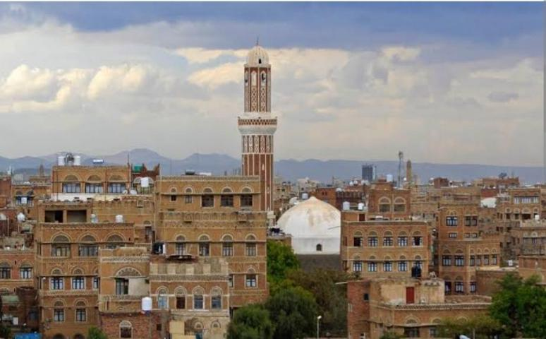

Known as Operation Decisive Storm (Arabic: مزحلا ةفصاع ةيلمع, romanized: Amaliyyat 'Āṣifat al-Ḥazm), the intervention began with an aerial bombing campaign targeting Houthi rebels and later expanded to include a naval blockade and the deployment of ground forces in Yemen. Led by Saudi Arabia, the coalition launched attacks against the Houthi militia and loyalists of former Yemeni President Ali Abdullah Saleh, who received support from Iran (see Iran-Saudi Arabia proxy conflict).

The operation involved the participation of fighter jets and ground forces from Egypt, Morocco, Jordan, Sudan, the United Arab Emirates, Oman (providing medical assistance), Kuwait, Qatar, Bahrain, and Constellis (formerly known as Blackwater). Djibouti, Eritrea, and Somalia allowed the coalition to utilize their airspace, territorial waters, and military bases.
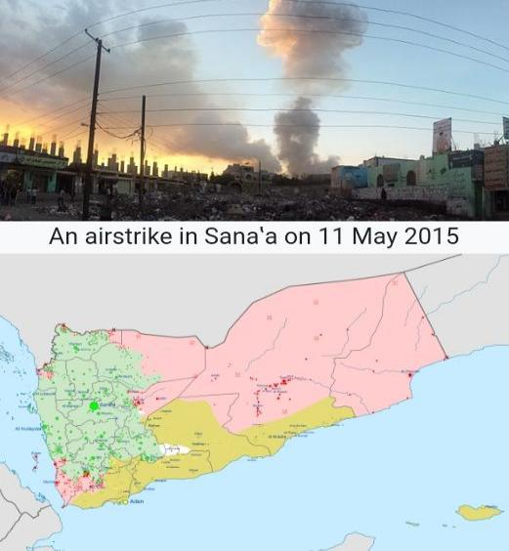

The United States provided intelligence, logistical support, aerial refueling, and search-and-rescue operations for downed coalition pilots. It also expedited the sale of weapons to coalition states and continued airstrikes against AQAP. In January 2016, the Saudi foreign minister confirmed the presence of US and British military officials in the

command and control center responsible for Saudi-led airstrikes, granting access to target lists but not involvement in target selection.

The war faced widespread criticism and significantly exacerbated Yemen's humanitarian crisis, reaching the level of a "humanitarian disaster" or "humanitarian catastrophe." The compliance of the intervention with Article 2(4) of the UN Charter has been a subject of academic debate.

By 2019, the conflict was described as a "military stalemate." The global COVID-19 pandemic presented Saudi Arabia with an opportunity to reassess its interests in Yemen. In early 2020, it was reported that Saudi Arabia was seeking an exit strategy amid the pandemic and military setbacks.

On March 29, 2022, the Saudi-led coalition announced a cessation of all hostilities in Yemen, effective from 6 A.M. the following day, to facilitate political negotiations and peacekeeping efforts.

f. Saudi Arabia and UAE in Yemen

Southern Yemen has become a battleground for the competing interests of the UAE and Saudi Arabia, two regional allies. In 2015, they joined forces to defeat the Houthi rebellion and reinstate Abdrabbuh Mansour Hadi as the approved government. However, after five years, they have diverged in their visions for the country.

The UAE strongly supports the South Transitional Council (STC), a separatist group that has turned against the Saudi-backed Hadi regime. The STC has clashed with government forces, declared self-rule in the southern region, and recently gained control of state revenues through the Aden's Central Bank. This move has strained the power-sharing agreement between the Saudi-backed government and the UAE-backed separatists.

The deteriorating relationship between these two allies has resulted in violent confrontations between the STC and Hadi forces. The most recent clash took place in the Abyan governorate, where the government forces recaptured a military camp previously seized by the STC. This escalation has dealt yet another blow to the Riyadh Agreement, which was followed by a Saudi ceasefire.

Furthermore, Saudi Arabia abruptly withdrew its ground forces from Socotra Island shortly after taking control from the UAE-backed STC. This tactical withdrawal aims to empower Socotra residents to resist the STC and prevent the complete annexation of the resource-rich archipelago by the UAE.

The United States has expressed concerns over the STC's declaration of self-rule in the south, stating that such actions undermine efforts to revive negotiations between the Yemeni government and Houthi rebels. These unilateral actions only contribute to the instability in

Yemen, particularly in the face of the COVID-19 pandemic and complicate the UN's political negotiation efforts.
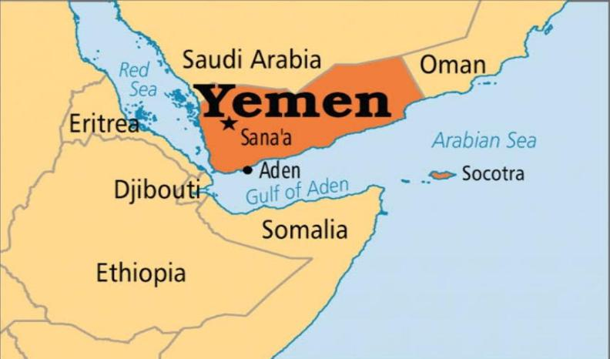

The civil war in Yemen escalated in 2015 when President Abd Rabbu Mansour Hadi fled to Saudi Arabia, leading to a coalition of Arab nations intervening against the Iran-backed Houthis in Sana'a. Despite the coalition's efforts, the Houthis remain in control of the capital, and the conflict has resulted in one of the world's worst humanitarian crises. Thousands of civilians have been killed, and the majority of the population relies on aid for survival.
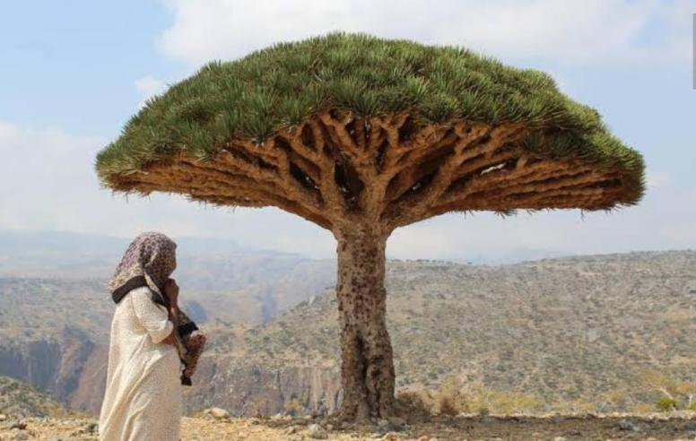

The STC aims to secede from Yemen and establish a separate state, resembling the period between 1967 and 1990 when the Soviet Union had influence. Led by General Aidarous al Zubaidi, the STC has received support from the UAE since 2017. The clash between the STC and the internationally-recognized Hadi government arose from debates about the inclusion of Yemen's Sunni party, Al Islah, in Hadi's government.

The UAE's objective, according to Yemen analyst Gamal Gasim, is to divide Yemen into two parts: one governed by the STC and the other by the Hadi government. Gasim suggests that the UAE's ultimate goal is to eradicate the Al Islah party, which has ties to the Muslim Brotherhood and is currently fighting against the Houthis in the north.
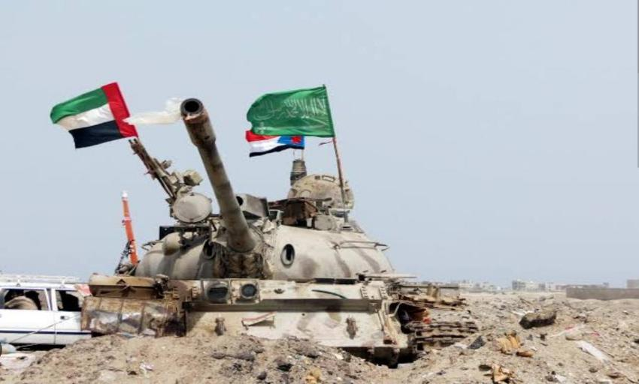

g. Iranian Imperialism

The Iranian Imperialism from a scientist perspective;

During the panel, Nadwa al-Dawsari, a Yemeni analyst and non-resident scholar at MEI, examined prevailing Western narratives about the Iran-backed Houthis in Yemen over the past six years. These narratives include portraying the Houthis as a Zaydi Revivalist movement, emerging in response to the spread of Saudi-supported Salafism in Yemen. They are also depicted as originating in 2004 due to local grievances, capturing Sana'a in 2014 because of government corruption and Yemen's division, or as an anti-imperialist homegrown movement characterized by pragmatism.

According to Al-Dawsari, all of these narratives are not only incorrect but deliberately misleading. Western analysis of the Houthis, she argues, has distorted the truth to the extent of romanticizing them, intentionally omitting historical facts to downplay Iran's involvement and the Houthis' connection to Iran. The purpose of such distortion, she asserts, is to undermine Saudi concerns about Iran's threat to its southern border. This approach has had severe repercussions for Yemen, diverting attention away from the Houthis' appalling crimes and wrongfully assigning blame to others, while absolving the Houthis of responsibility for their violence. Al-Dawsari concludes that this distortion is a consequence of research being influenced by advocacy.

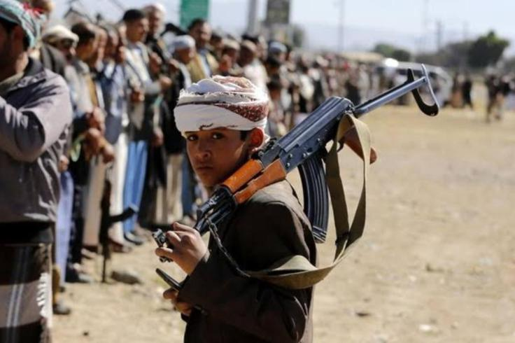

Al-Dawsari proceeds to clarify that the Houthis are not a Zaydi Revivalist movement or pragmatists. Instead, they are a radical Shi'a insurgency driven by ideology, relying exclusively on violence to achieve their political goals.

Furthermore, Al-Dawsari asserts that the Houthis serve as an Iranian proxy, integral to Iran's expansionist agenda in the region. Their existence is the result of Iran's four decades of investment in Yemen. Al-Dawsari emphasizes the significant commitment, strategic thinking, and patience displayed by Iran in supporting the Houthis, including providing training, support, advice, weapons, and financial aid as required.

Regarding ideology, Al-Dawsari reiterates that the Houthis are not a Zaydi Revivalist movement. Instead, they represent a fusion of Jarudi and Shi'a Twelver beliefs, influenced by Iran. The Houthi founder, Hussein al-Houthi, along with his father, Badreddine al-Houthi, who was a scholar, and his brother, Abd al-Malik al-Houthi, the current leader, spent a considerable amount of time in Iran during the 1980s and 1990s, studying in Qom.

During the same period, Lebanese and Iraqi Shi'as affiliated with Iran's Hezbollah movement traveled to Yemen to teach at educational centers run by the Houthi family. Hussein al-Houthi became captivated and obsessed with the Iranian Revolution, making it his life's mission to bring it to Yemen, as evident in his lectures and statements.

While the Zaydi Revivalists aimed to counter the spread of Salafism locally and domestically, the Houthis had a broader regional agenda, namely, the "fight against the enemies of Islam," including America and Israel, aligning with the Iranian Revolution.

Al-Dawsari notes two fundamental disagreements between the Houthis and the Zaydi Revivalist movement. First, the Revivalists rejected the condition that the ruler must be a descendant of the Prophet Muhammad's family, while the Houthi family insisted on this prerequisite for any ruler eligible to govern the Muslim umma (community). Second, the Revivalists advocated peaceful means, whereas the Houthis embraced violence. In the early 2000s, Hussein al-Houthi hijacked, militarized, and radicalized the Zaydi Revivalist movement, marginalizing its original founders.

Addressing the second narrative myth, Al-Dawsari explains that in the years leading up to 2004, the Houthis stockpiled weapons and started chanting pro-Iranian Revolution slogans, including "death to America," in local mosques. This led to the outbreak of the six Saada wars.

During the Arab Spring phase in Yemen after 2011, the Houthis participated in the national uprising and engaged in the National Dialogue following the nominal surrender of Ali Abdullah Saleh's presidency. However, Al-Dawsari points out that the Houthis exploited these peaceful political endeavors to consolidate their gains while continuing to expand forcefully. By 2012, they had captured Saada governorate and substantial portions of Hajjah, Al-Jawf, and Amran governorates, even before the National Dialogue Conference began.
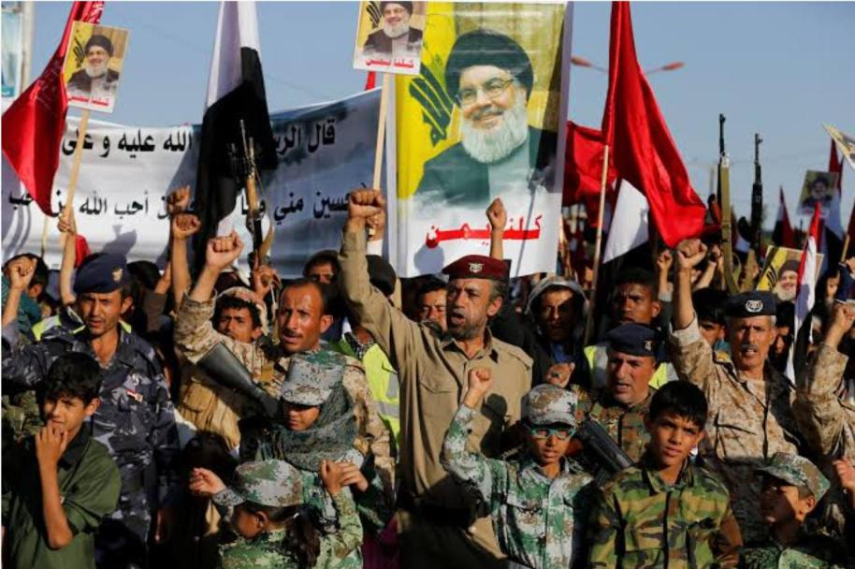

During the ongoing war, which commenced after the Houthis' coup in Sana'a, Al-Dawsari documents extensive Iranian support for the Houthis. Hundreds of Houthis received military training from the Islamic Revolutionary Guards Corps (IRGC) and Hezbollah in Iran and Lebanon. Iran supplied them with weapons and aided in the development of missile and drone technology, enabling them to strike deep into Saudi Arabia.

Iran also provided military strategizing support, with dozens of IRGC and Hezbollah military advisers and experts present in Yemen since 2015.

Michael Knights, the Jill and Jay Bernstein Fellow at The Washington Institute (WINEP), specializing in military and security affairs related to Iraq, Iran, Yemen, and the Gulf Arab states, discussed Iran's militias in Iraq during his presentation.

Before delving into the topic of Iraq, Knights expressed his interest in Al-Dawsari's account of the Houthi movement's history. He mentioned a recent report from the European Eye on

Radicalization titled "Becoming Ansar Allah," which provided a comprehensive exploration of the Houthis' long-standing relationship with the Islamic Republic of Iran, a topic often overlooked.

At WINEP, analysts have conducted extensive research on the Shiite militias in Iraq (and Syria) controlled by the Islamic Revolutionary Guard Corps (IRGC). Knights revealed an upcoming project that focuses on detailed analysis of how these Iraqi militias communicate, utilize propaganda and disinformation, establish front groups for covert activities, and exploit perceived divisions within the Muqawama (Resistance) groups. The aim is to build an evidence-based framework for attributing future attacks and determining appropriate responses, including sanctions or other measures.

According to Knights, Iran's Iraqi militias have experienced a decline since September 2019 when they mishandled the protest movement in Iraq, causing significant damage to their previously established legitimacy, which relied on their opposition to the Islamic State (ISIS) and their association with the Shia community. The removal of Qassem Suleimani and his Iraqi deputy, Abu Mahdi al-Muhandis, in January 2020 further complicated the relationship between the Islamic Revolutionary Guard Corps (IRGC) and the Iraqi militias, as they served as crucial links. Additionally, the Iraqi government, while not yet strong, has become more competitive with the militias, posing another challenge. Knights emphasizes that although the militias initially held significant power, they have a long way to fall and could potentially regain strength in the future. However, at present, their influence is waning.
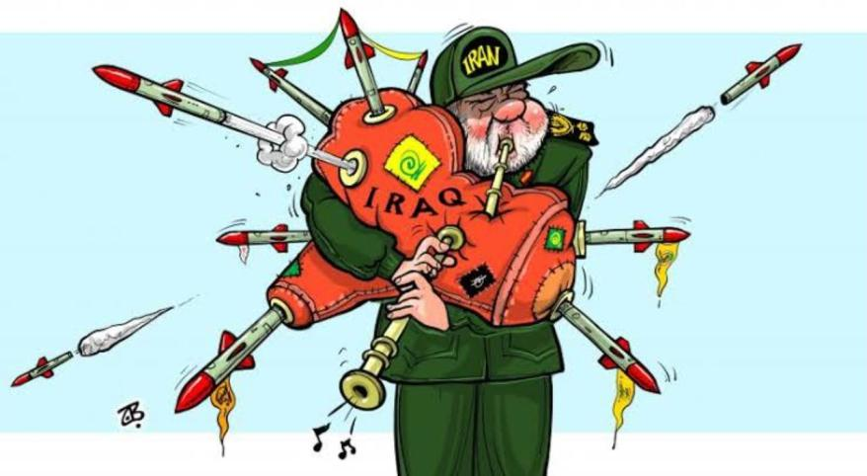

Knights argues that the central issue for the Muqawama militias is the absence of a clear adversary since the defeat of the ISIS caliphate and the relatively invisible presence of the United States. Furthermore, with the loss of Suleimani and Abu Mahdi, the militias are somewhat left to navigate on their own. They lack the same instinctive understanding of Iran's expectations, particularly since Suleimani's successor, Esmail Qaani, is less acquainted with the militia leaders.

According to Knights, in-depth analysis reveals divisions within Kataib Hezbollah (KH) along personnel-patronage lines, which can also be observed in Lebanese Hezbollah and other

Iranian militias. These divisions pose challenges within KH and are even more prominent among various IRGC militias in Iraq.

The main coordinating body for the IRGC-controlled militias, known as the Tansiqiya, consists of three primary groups: KH, Asaib Ahl al-Haq (AAH), and Harakat Hezbollah al-Nujaba (HHN). Knights states that KH, along with HHN, is closest to the IRGC. HHN is striving to gain more prominence, while other splinter groups and affiliates like Saraya al-Jihad, which utilizes technology such as missiles and drones, and Saraya al-Ashara, which carries out assassinations of anti-Muqawama individuals, surround them.

On the other hand, AAH, according to Knights, is attempting to strike a balance between appearing more Iraqi while garnering Iran's attention by targeting Americans instead of Iraqi contractors, even during moments when Iran is exercising caution.

Knights explains that KH has focused on "social operations" within Iraq, aiming to exert control over the state through non-military means and suppressing civil society challengers using tactics similar to the Basij. Meanwhile, they engage in "power projection" against Saudi Arabia and Turkey, largely ignoring anti-American activities within Iraq.

However, Knights acknowledges that the Iranian influence remains significant, with these groups being utilized for various purposes within Iraq, ultimately reflecting Iran's expanding hold over the state and society. Although Iran appears to be considering using its Iraqi militias against Gulf states, this is an Iranian decision. If these groups were solely focused on local matters, they would have little interest in foreign missions. The Iranian hand is becoming increasingly obscured as these groups are being fragmented into "task-organized elements," where skilled individuals and cells are recombined in new, theoretically deniable formations.
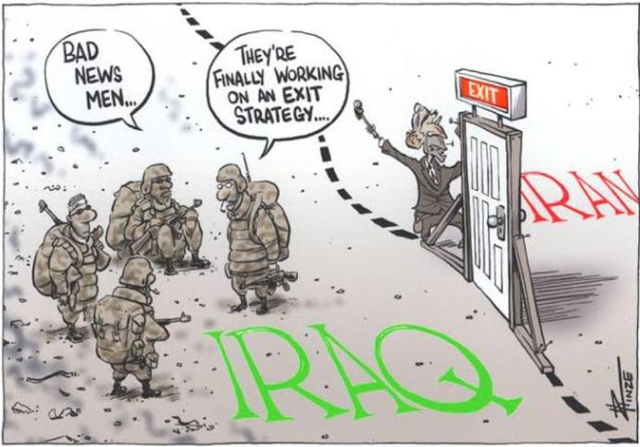

Hanin Ghaddar, the Friedmann Fellow at WINEP specializing in the Levant, provided insights into Iran's influence in Lebanon. Ghaddar emphasized that Hezbollah, Iran's primary

instrument of control and the first successful export of the Islamic Revolution, is now more comfortable and influential not only in Lebanon but also in the broader region.

According to Ghaddar, Hezbollah has evolved into a regional actor rather than solely a Lebanese entity. It is involved in Iranian training, logistics, and even soft power missions throughout the Middle East and beyond. Hezbollah holds significant importance for Iran as it serves as both a success story and a reliable backup option. When Iran's other assets face challenges or Israeli attacks, Hezbollah can step in and provide support in Syria, Iraq, and other areas.

Ghaddar pointed out that Hezbollah's presence has transformed weak states, particularly Lebanon and Syria, into failed states. In Lebanon, Hezbollah has solidified its political influence, effectively controlling the parliament and obstructing progress on necessary reforms. The notion of Hezbollah being a "state within the state" has evolved into a clear reality: Hezbollah is now essentially the state itself.
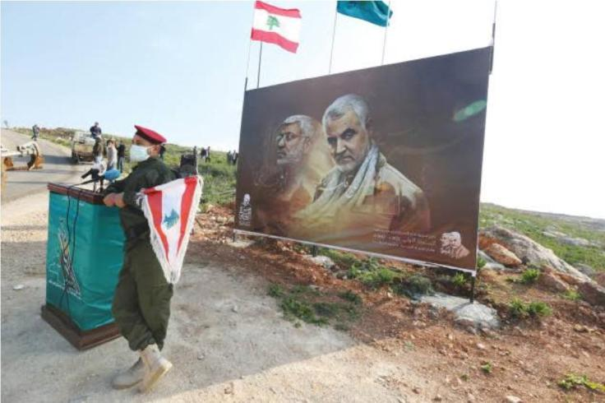

Lebanon has become a launching pad and base for Iran's operations, as illustrated by the Beirut blast in August 2020. The ammonium nitrate responsible for the explosion was brought into the city by the Islamic Revolutionary Guard Corps (IRGC), intended to support the Assad regime's use of barrel bombs in Syria. Lebanon bore the cost of this regional maneuver.

Ghaddar highlighted that the international community has prioritized stability over the risks associated with change or reform. However, continuing on the current path is leading to instability and hindering much-needed reforms.

In general, the analysts agreed that the Iranian regime has achieved a significant level of control across the region. In Yemen, the Iranians have gained a powerful position, enabling them to strike against their rival Saudi Arabia through the Houthis. While Lebanon and Iraq

show cautious signs of shifting political trends against Iran, there is currently no challenger to the hard power instruments of the clerical regime in these countries.
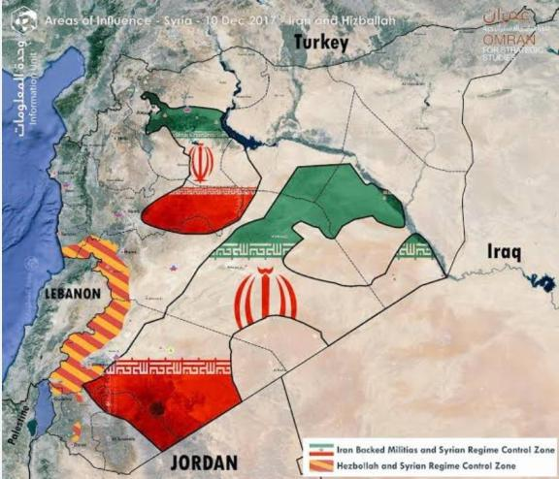

- Israeli Practices and settlement activities affecting the rights of the Palestinian people and other Arabs in the territory

Overview

The Israeli practices and settlement activities you mentioned refer to the ongoing situation in the Israeli-Palestinian conflict. It's a complex and contentious issue with different perspectives and interpretations. I'll provide you with a general overview of the topic.

The Israeli government has established settlements in the occupied territories of the West Bank and East Jerusalem since the 1967 Six-Day War. These settlements are communities where Israeli citizens live, often supported by government incentives. They are considered illegal under international law, specifically the Fourth Geneva Convention, which prohibits an occupying power from transferring its civilian population into the territory it occupies.

Critics argue that these settlements undermine the prospects for a future Palestinian state by fragmenting and encroaching upon Palestinian territory, impeding the contiguity and viability of a future Palestinian state. Palestinians and many members of the international community consider the settlements as an obstacle to the Israeli-Palestinian peace process.

The expansion of settlements involves the appropriation of Palestinian land, the demolition of Palestinian homes, and the displacement of Palestinian communities. Palestinians living

in close proximity to settlements face various restrictions on their movement, access to resources, and daily life, which can result in human rights violations.

Furthermore, the construction of Israeli-only roads, checkpoints, and the separation barrier, which Israel argues is necessary for security reasons, can also restrict the freedom of movement of Palestinians and impact their livelihoods.

The United Nations and many countries have expressed concerns about the settlements and their impact on the rights of Palestinians. Several UN resolutions, such as UN Security Council Resolution 2334 (2016), have reaffirmed the illegality of Israeli settlements and called for their cessation.

Israel, on the other hand, maintains that the settlements are a legitimate response to its security concerns and are vital for the Jewish people's historical and biblical connection to the land. The Israeli government argues that the status of the settlements should be determined through negotiations with the Palestinians, rather than through international pressure or legal determinations.

It's important to note that this overview provides a simplified explanation of a complex and multifaceted issue. The Israeli-Palestinian conflict involves a long history, diverse narratives, and varying perspectives. To gain a more comprehensive understanding, it is advisable to consult various sources and explore different viewpoints.

Zionism

Founded by Theodor Herzl in 1897, Zionism is an organized movement that promotes the establishment of a Jewish state and centers the ideology of Jewish nationalism. Modern Zionism was a revulsion to the antisemitism movement which was gradually escalating in Europe and was a response to the “Haskala” in the late 19th century.

Until 1948, the priorities of Zionism were to re-establish the sovereignty of Jews on Israeli soil and to save Jews from the antisemitic discrimination and oppression in the diaspora.

Since the establishment of Israel in 1948, Zionism is mainly focusing on defending the country, dealing with the possible threats to the safety and sovereignty, and protecting Jews in the diaspora against any possibility of a genocide attempt.

Arab Nationalism and the Arab Response to Zionism

As part of the people of the Ottomans in the 19th century, Palestine’s Arab population perceived themselves as Ottoman subjects.

In 1856, the Ottomans established the “Hatt-ı Hümayun”, a guarantee for all Ottoman subjects assuring that they all have equal rights, whether Muslim or not. Despite that, the Muslims kept viewing the Jews as dhimmis (people protected by, but still subordinate to Muslims.)

After the “Young Turk Revolution” in 1908, Arab nationalism grew rapidly around the area and most of them perceived Zionism as a threat, though a minority considered it as a path to modernity.

Chronology

Second Temple Period

Jews lived in Rome for a long time, 2000 years to be exact — longer than any European country they ever resided in. Between 115 and 117 AD, Jews in Libya, Egypt, and Lydda rebelled against the Roman Empire because of the attacks on them. With a lot of Romans and Jews slaughtered, the population of Cyprus significantly decreased and new settlers had to be deported, and the Jews were forbidden from living there until the time Arabs conquered the area.

The Bar Kokhba revolt took place in 132 AD. The uprising was led by Simon Bar Kokhba, a Jew that ruled as nasi (“prince” in biblical Hebrew) and was considered a long-awaited messiah by some of the rabbis. Based on the Bar Kokhba revolt coinage, the newly-established Jewish state was named “Israel”. But eventually, the revolt got crushed by the emperor Hadrian, with serious casualties.

The last Byzantine-Sasanian War (602-629 AD)

The last Byzantine-Sasanian war was the most devastating of the two states’ wars, spanning the entirety of Anatolia and Mesopotamia, starting from the Balkans, expanding to the Caucasus, and then to Egypt. The resistance of the Persians in Syria was quite weak, so

after a long blockade and with the help of Jewish allies, Hüsrev the Second captured Jerusalem and the city was handed down to the Jews until 617. The Byzantines captured the city in 629, and the Jewish population was once again expelled from Jerusalem.

After the fall of the Crusaders, the incidents of exile and the oppression against Jews increased. They were first dismissed from England in 1290 and from France in 1306. The Jews were then forced to change religions and, upon resistance, were slaughtered in Spain.

In 1869, "Der Judenstaat" by Theodor Herzl offered a solution to the increasing anti-semitism issue in Europe. The solution was to establish a Jewish government in Palestine that was secured by the power of international law. But because of the suspicions of the Ottoman Empire, there wasn’t any significant progress on the topic.

The Balfour Declaration, 1917

Approved by the League of Nations in 1922, The Balfour Declaration was established by the British government, and it aimed to announce Britain’s support for the establishment of a "national home for the Jewish people". The declaration had two different indirect results. Its statements were incompatible with the Sykes-Picot Agreement, a secret convention between Britain and France, and the Ḥusayn-McMahon correspondence, which in turn contradicted one another.

It was hoped by the British government that the declaration would improve the Jewish opinion, particularly in the United States, to the side of the Allied Powers against the Central Powers in World War 1. They also hoped that a pro-British Jewish population settled in Palestine would help to protect the approaches to the Suez Canal and ensure an important communication route to British colonial possessions in India.

The declaration resulted in two different situations. The first result was the conflict between the Arabs and Jews in the Middle East: the conditions of the mandate and the Jewish immigration caused Arabs to rebel. They attacked Jewish localizations, and the British couldn’t protect the citizens, which caused the formation of "Haganah", the main Zionist organization of the Jewish population in Mandatory Palestine at the time. The “Arab revolt”, later addressed as “The Great Revolt”, burst out mainly due to the increasing Jewish immigration which was between 1936-1939.

Thanks to the accelerating momentum of the Zionist movement, which aimed to establish an independent Jewish state in the late 19th and early 20th centuries, the second result was that the Zionists finally reached their goal, and an independent state was formed.

The Balfour Declaration managed to provide the direly needed major political support and recognition to the Zionist movement.

Some historians have also interpreted the British government's support on establishing a Jewish state in Palestine as a way of gaining favor with Jewish communities worldwide since the Zionist movement had a big influence in some countries like the United States.

The Hebron Massacre, 1929

The Hebron Massacre, carried out by Muslim Arabs, is the slaughtering of approximately sixty-seven Jews in Hebron.

Because of its associations with biblical patriarchs and the Islamic belief that it is the stopping point along Muhammad’s miʿrāj, the city of Hebron has significant importance in Judaism and Islam.

Due to the status of the Western Hall and Al-Aqsa mosque, both in Jerusalem, the tension between Arabs and Jews had been escalating prior to the massacre. It was rumored that Jews aspired to reclaim the Temple Mount, which the Muslims referred to as Haram al-Sharif.

This idea of Jews gaining control of the Temple Mount in Jerusalem caused big distress and provocation among the Arab people.

Another provocative reason was Hajj Amin al-Husseini, the mufti of Jerusalem, starting a campaign in 1928 to reassert Muslim rights over the Western Wall. Al-Husseini wanted a new construction in front and on top of the Wall, though a horrible incident marred this process: the bricks from the construction fell on the prayers.

Jewish leaders immediately requested an intervention from the British authorities but no active interaction took place. As a response, hundreds of Jewish nationalists marched to the Wall on August 14, 1929, chanting slogans like “The Wall is ours” while raising the Jewish national flag. It was claimed that the Jewish youth attacked the Arabs and cursed at Muhammad.

A nationalist preacher encouraged a Muslim group to fight the Jews during the morning prayer. He emphasized that they must fight until the last drop of blood. Guns were being fired to excite the crowd, and as a result, a crowded group of Arabs, infuriated by the rumors about the Jews' plans to attack al-Aqsa Mosque, spoke to Husseini, who was originally

supposed to calm the crowd but instead excited them further. Thus, the Arabs attacked the Jews in the Old City of Jerusalem and started burning buildings down.

On August 24, Yal Grodzinski, a tourist from Poland, saw a group of Arabs heading their way to Jerusalem with sticks, swords, and knives in their hands. Afterward, Grodzinski tells an incident that happened in a house.

“We all ran to strengthen the door and went around the rooms like crazy... the screams of the women and the cries of the babies filled the space of the house... we set up boxes and tables... but when we saw that the attackers broke the door with axes... we left the door and started running from room to room, but in every room, we found a hail of stones ... When I entered one of the rooms, I saw my mother standing by the window and shouting 'Save him'. I looked through the window and saw a crowd of wild Arabs laughing and throwing stones... I grabbed my mother and put her behind the bookcase... I put another young lady in there and a 12-year-old boy and one of the boys from the yeshiva, and finally I went in there too... we were suffocating and sat on top of each other and we heard the sound of the Arabs bursting into the room, the sound of their singing that mingled with the cries of the beaten and their sighs. Ten moments later there was silence...loud shots were heard, probably from the police.” (Groudzinski, August 1929)

The Arab Revolt (The Great Arab Revolt), 1936

Beginning with abrupt and unconstrained attacks from the remaining followers of Sheikh ʿIzz al-Dīn al-Qassām, who was killed by the British in 1935, The Arab Revolt was the first rebellion of the Palestinian Arabs.

According to a report released in July 1937 by a royal commission led by Lord Robert Peel, two main reasons of the rebellion were the Arabs' desire for independence and the fear of the potential establishment of a Jewish homeland.

The Arabs began their protests by boycotting Jewish products, though these protests gradually but inevitably evolved into terrorist attacks against the Jews and the British.

The intensity of the revolt led the British to review and modernize their policy in Palestine — the potential of a war with Germany was growing greater by day, and the British needed to establish strong relationships with Arabs, since the activity of British machinery depended on Middle Eastern oil. The Jews had no choice but to support Britain against Nazi Germany.

The rebellion consisted mainly of terrorist activity by the Arabs against the institution of the British Mandate, which ruled Israel, and against the Jewish people. These incidents included rampages against British soldiers, attacking Jews, and setting fire to Jewish properties.

The rebellion also included some internal acts of terrorism among the Arab people as well.

They were mostly against the critics of the uprising.

The rebellion didn’t achieve its goal; the requests of Arabs were not accepted by the British, and there wasn’t any significant harm to the Jewish residentials by the terrorist attacks. Dependence on Arabs grew less with time, and their economy inevitably shrunk, therefore becoming insignificant.

The United Nations Special Committee on Palestine (UNSCOP)

The UNSCOP was formed on May 15, 1947 as a response to the British government’s request from the General Assembly to “make recommendations under article 10 of the Charter, concerning the future government of Palestine”. The British government also asserted that a special committee was established to provide the General Assembly with relevant reports. This Special Committee was granted a wide range of authority and power so that it could collect, track, and analyze all information regarding Palestine, and then reach conclusions to be able to recommend solutions.

The recommendation was adopted by the GA and set up the UNSCOP to investigate and, if possible, devise a solution for the conflict in Palestine.

The commission was boycotted by the Arab Higher Committee, saying that the Palestinian Arabs’ rights deserved to be recognized on the basis of principles of the UN Charter, because it was self-evident and could not continue to be the subject of investigation.

The United Nations Partition Plan, 1947

The United Nations Partition Plan recommended a partition of Mandatory Palestine at the end of the British mandate. The UN General Assembly adopted the Plan as Resolution 181 (II) on 29 November 1947.

The aim of the resolution was to create independent Arab and Jewish States and a Special International Regime for the city of Jerusalem. It was stipulated by Part I of the Plan that the Mandate would be terminated in no time, and the British would withdraw immediately on 1 August 1948. No later than 1 October 1948, the states would come into existence two months after the withdrawal.

The Plan aimed to address the claims of two conflicting movements: Palestinian nationalism and Zionism.

The Partition was accepted by the Jewish Agency for Palestine and by most Zionists, but the Arabs rejected it and indicated a disinclination to accept any type of territorial division, stating that it was a violation of national self-determination in the UN Charter, which granted the right to decide people’s own destiny. So, the Arabs declared that they had the intent to take essential actions to avoid the implementation of the resolution.

Immediately afterward, a civil war flared up in Palestine and the plan couldn’t be implemented.

1947-1948 Civil War in Mandatory Palestine

The civil war broke out after Resolution 181 (II), which was mentioned above, recommending the adoption of the Partition Plan for Palestine, since the Arabs thought that the resolution was a violation of self-determination according to the UN Charter.

During the war, a clash between Jewish and Arab communities took place while the British intervened only on an occasional basis even though they had the obligation to maintain order in the area.

According to Benny Morris, an Israeli historian, the result of this war was a "decisive Jewish victory"; on the other hand, the Palestinian Arab military power was crushed.

The Founding of Israel, 1948

Arabs were reassured in 1945 by President Roosevelt that the United States would not interfere without conferring both parties —Jews and Arabs— despite the fact that the United States of America declared its support for the Balfour Declaration of 1917. However, on May 14, 1948, when the head of the Jewish Agency, David Ben-Gurion, announced the long-awaited establishment of Israel, U.S. President Harry S. Truman immediately recognized the new state.

Truman appointed several experts to work on the Palestinian issue soon after he took the office. In the summer of 1946, Truman established a special cabinet committee to enter into negotiations with a parallel British committee to discuss the future of Palestine.

The Palestine issue was reviewed by The United Nations Special Commission on Palestine and a partition of Palestine into a Jewish and an Arab state was recommended. The UN passed Resolution 181, also known as the Partition Resolution, with the intention of dividing Palestine when the British Mandate was scheduled to end in May 1948.

The resolution also stated that the area surrounding Jerusalem, which has religious significance to both parties, would remain a corpus separatum under international control administered by the UN.

The Arab-Israeli War of 1948

A few hours after the establishment of Israel, war was declared by the Arab Leagues against Israel. There was no information about the borders of Israel besides the “Eretz Israel”.

On May 15, 1948, the Secretary-General of the UN received a telegram from the Arab League’s secretary. The telegram was stating that the Arab League felt obligated to intervene in the situation in order to provide peace, safety, and order in Palestine. A need for the establishment of a new, democratic Palestine state was also stated in the telegraph.

So, to achieve this goal of a new, democratic state, Egypt, Jordan, Syria, and Iraq's armies attacked from 3 different directions and made significant progress. But Israel’s well-planned defense backfired the attacks.

At the end of the war, Israel increased its lands in Palestine that were gained with the Partition Resolution from %56 to %78. About 700,000 Palestinian Arabs, hoping that they could return, left the area because of the war.

The war ended in 1949, with a ceasefire signed between Israel and its Arab neighbors.

The Six-Day War, 1967

The Six-Day War — also named the June War or the 1967 Arab-Israeli War — took place between 5th and 10th of June 1967. It was fought between Israel and multiple Arab nations, who were primarily Egypt, Syria, and Jordan.

Background and Escalation

Before the actual start of the war, attacks conducted against Israel by inexperienced Palestinian guerrilla groups had increased, causing Israel to make costly reprisals. Israel struck the village of Al-Samūʿ in November 1966, leaving 18 dead and 54 wounded. In addition, in May, Soviet intelligence reports indicated that Israel was planning to create a

campaign against Syria, and, even though it was inaccurate, this information put further strain on the already tense relationship between Israel and its Arab neighbors.

In response to some mobilizations of its Arab neighbors, Israel prepared a sudden preemptive air attack that destroyed more than 90% of Egypt’s air force on the tarmac. A similar air assault left Syrian air forces vulnerable as well. Without any cover from the air, the Egyptian army was left unprotected.

Consequences

A crushing victory was achieved by Israel in merely three days, conquering the entirety of the Gaza Strip and the Sinai Peninsula up to the East Bank of the Suez Canal.

The Arab armies suffered enormous losses of arms and equipment, and of course, severe casualties.

The war was also a starting point of a new period in the Israeli-Palestinian conflict, because it caused a massive outpour of hundreds of thousands of refugees and over 1,000,000 Palestinians into the land occupied and ruled by Israel.

In November, the UN passed UN Resolution 242 and called Israel to withdraw from the territories it had captured during the war in exchange for lasting peace. This became the basis of diplomatic efforts for Israel and its neighbors, including the Camp David Accords with Egypt.

Operation “Lutani” 1978

On March 14, 1978, Israel – in alliance with the South Lebanon army, which mostly consisted of Christians – invaded southern Lebanon and tried the push the Palestinian militant groups away from the Israeli border as a response to the Coastal Road massacre (Palestinian forces had forcibly stopped a bus and murdered Israeli occupants on March 11, 1978.). As a result of the conflict, about 2000 Lebanese and Palestinians died.

The Camp David Accords 1978

Also known as the “Framework for Peace in the Middle East”, the 1978 Camp David Accords were the agreements between Israel and Egypt on September 17, 1978. It led two states to sign a peace treaty the following year.

Background

The United Nations Partition Plan for Palestine was voted by the UN in 1947, to establish a Jewish state, an Arab state, and an independent Jerusalem under a UN trusteeship, but Arabs opposed partition. The first Arab-Israeli war erupted when the mandate ended on May 15, 1948, and Israel proclaimed its independence. The establishment of a separate Arab state didn’t succeed. Furthermore, Egypt occupied and took control of the Gaza Strip along the Mediterranean Sea, and Jordan asserted sovereignty over the West Bank including East Jerusalem. As mentioned in this study guide, Israel occupied those territories as well as the Golan Heights and Egypt’s Sinai Peninsula during the Six-Day War.

The U.S. President Jimmy Carter dedicated himself to creating a broadscale Middle East peace settlement aiming to encourage the withdrawal of Israel from the occupied territories and Arab recognition, which would be an agreement based upon the example of the UN Resolution 242.

Carter organized meetings with the leaders of the Middle East early in his presidency and was especially encouraged by the thoughts of the president of Egypt, Enver Sedat, who defended the idea thatthe Israeli-occupied Sinai Peninsula should be returned to Egypt, and a much stronger relationship should be formed with the United States.

Thereafter, the U.S. president met with the prime minister of Israel, Menahem Begin, and found out that he is willing to consider the measures that Carter had discussed with Sadat.

The Summit

Two leaders accepted Carter’s invitation and the summit began on September 5. As the days passed, the possibility of a settlement at Camp David appeared to be bleak. Sadat threatened to leave and Carter started to plan to return to the White House. On the final day, an agreement was reached, however, at the last minute, Begin agreed to allow the Knesset (the unicameral legislature of Israel) to decide the settlements Israelis had built on the Sinai Peninsula.

The Egypt-Israel Peace Treaty 1979

After the Egyptian president visited Israel in 1977, followed by intense negotiations, peace between the two parties was agreed upon and settled. The treaty had two main topics: the withdrawal of armed forces from the Sinai Peninsula, which was still ruled by Israel ever since it was occupied in 1967 during the Six-Day War; putting an end to the continuous state of war that had prevailed since the 1948 Arab-Israeli War started; and finally, mutual recognition of the two states. The two leaders signed the treaty; Anwar Sadat as the President of Egypt, and Menachem Begin as the Prime Minister of Israel. The witness of the treaty was Jimmy Carter, the President of the United States.

The treaty was the first official document where Egypt recognized Israel, being the first Arab country to do so.

1987-1991: The First Intifada

The First Intifada is the rebellion of Palestinian people against Israel’s occupation of Palestine soil which brought forth the constant fear of getting evicted, oppression, unlawful deaths, collective arrests, and the demolishing of Palestinian households.

The Israeli historian Benny Morris describes the reason for the intifada as an "all-pervading element of humiliation", caused by the long-lasting occupation which he refers to as "always a brutal and mortifying experience for the occupied" and was "founded on brute force, repression and fear, collaboration and treachery, beatings and torture chambers, and daily intimidation, humiliation, and manipulation".

With time, the Palestinian tactics of attacks evolved. At first, they were throwing rocks and Molotov cocktails at Israeli targets, and then shifted to rifles, hand grenades, and explosives. This change was mostly attributed to the Israeli military attacking unlawfully and mercilessly, and the police were “just taking retaliatory actions”.

The death of a great number of Palestinian people came with international condemnation. In the Security Council’s resolutions 607 and 608, Israel was requested to put a halt to the violence exerted by the army and the mass killings. In 1988, most of the countries in the UN General Assembly condemned Israel because of the approach they had during the Intifada.

The Oslo Agreement 1993

Also known as the Oslo Accords, the Oslo Agreements were the agreements between Israel and Palestine Liberal Organization (PLO) and were considered a “peace process”.

It was based on the 1978 Camp David Accords, and therefore, was quite similar to them.

Although the final goal of Camp David was to have a "peace treaty between Israel and Jordan, taking into account the agreement reached in the final status of the West Bank and Gaza", the Oslo Agreement was only between Israel and PLO.

The Oslo Process started with the secret negotiations between Israel and PLO. A number of agreements were reached, but the Oslo Process ended after the failure of the Camp David Summit in the year 2000 and the break of the Second Intifada.

The Camp David Summit 2000

The United States President Clinton called the Camp David Summit, which took place from July 11 to July 24, with the intention of bringing together the Israeli Prime Minister, Ehud Barak, and the Chairman of the Palestinian Authority, Yasser Arafat.

The expectation of the get-together was to end the prevalent Israeli-Palestinian clash. The division of territory, management of Jerusalem and the Temple Mount, refugees and the Palestinian right to return, additional security measures, and settlements were the primary topics.

Unfortunately, the Summit failed to reach any conclusions.

2000-2005: The Al-Aqsa Intifada (The Second Intifada)

A portion of the fundamental reasons for the Second Intifada were: a sense of anger as a result of the stalled negotiations between Israeli and Palestinian parties and the ongoing Israeli occupation that continued, even after the Oslo agreements. As a result, the failure of the Camp David Summit in 2000 was one of the main causes of the intifada, since it was the last hope for reaching an agreement and putting an end to the Israeli-Palestinian peace process at the time.

The then-candidate Prime Minister, Ariel Sharon, also started a chain reaction that inevitably triggered the Second Intifada. The Israeli opposition leader at the time, he made a tranquil visit to the Al-Aqsa Mosque, which was referred to as the Temple Mount by the Jews. Even though the visit itself was eventless in its nature, the Israeli police assaulted the visitors with elastic bullets and tear gas, causing protests and riots.

The Second Intifada is believed to have ended with the 2005 Sharm el-Sheikh Summit.

The Sharm el-Sheikh Summit, 2005

The Summit took place on 8 February 2005, at Sharm el-Sheikh in the Sinai Peninsula. It was a gathering of four Middle Eastern leaders: the Prime Minister of Israel, Ariel Sharon; the President of the Palestinian Authority, Mahmoud Abbas; the President of Egypt, Hosni Mubarak; and King Abdullah II of Jordan. The summit intended to end the Second Intifada that has been going on for four years.

Even though no agreement was signed, in their closing statements, Sharon and Abbas explicitly stated their intention to stop all violent activity, which marked the formal end to the Second Intıfada. The commitment to the Road map for the peace process was confirmed by all parties, and Sharon also agreed to withdraw from West Bank towns and release 900 Palestinian prisoners.

The Gaza-Israeli Conflict 2006-present

Besides being a part of the continuing Israeli-Palestinian conflict, the dispute was also considered as a power struggle between some parties like Egypt, Iran, Turkey, and Qatar.

The conflict started when Hamas, an armed Palestinian Islamist party, won the 2005 Gaza Strip election and separated the Palestinian government into two: there was the Fatah government in the West Bank, and the Hamas government in Gaza. This situation escalated the conflict further.

Timeline of the Gaza-Israeli Conflict

August 2005 After 38 years of occupying Gaza, Israeli forces withdrew from the area, leaving the settlements and surrendering the area to the control of the Palestinian authorities.

January 2006 In a Palestinian legislative election, Hamas got the majority of seats.

December 2008 Before the agreement of a ceasefire, approximately 1,400 Palestinians and 13 Israelis died because of Israel's launch of a 22-day military offense in Gaza after rockets were fired at Southern Israel.

July-August 2014 A seven-week war occurred due to the kidnapping and killing of three Israelis. During the war, more than 2,100 Palestinians died in Gaza along with 73 Israelis.

May 2021 During Ramadan, weeks of tension accumulated which lead to an aggressive attack from Israel. Hundreds of Palestinians got injured by Israeli forces at Al-Aqsa Mosque. Hamas demanded Israel withdraw their security forces from the area. Israel launched air raids on Gaza as a response to rockets fired from Gaza.

August 2022 Including women and children, more than 30 Palestinians died in air attacks by Israeli planes.

January 2023 An armed raid was done to the Jenin refugee camp – a refugee camp for Palestinians which is located in the northern west bank – by the Israeli border police and the Israeli army. UN experts stated: “We deplore the Israeli army’s latest violent attack against the Jenin Refugee Camp, and the killing and wounding of Palestinians on Thursday. It shows a dangerous trajectory of violence in the occupied West Bank, continuing the alarming upward trend from 2022".

Amnesty International, a non-governmental organization that focuses on human rights, found the killings unlawful and blamed “Israel’s apartheid system” for the ongoing violence, and the Palestinian presidency described it as a “massacre”.

February 2023 An incursion by Israel took place in West Bank, Palestine. The stated aim by Israel was to search the members of the Lions’ Den, a Palestinian independentist armed group. On March 1, 2023, The New York Times published an analysis of videos covering the incident. Videos showed that "Israeli soldiers used deadly force against unarmed Palestinians, killing at least four people who did not appear to pose a threat". (New York Times article March 1, 2023, by Haley Willis, Christiaan Triebert, Hiba Yazbek, and Patrick Kingsley)

May 9 2023 An operation called “Operation Shield and Arrow” took place in the Gaza Strip which included a series of airstrikes by Israel. These airstrikes in the area caused the deaths of 13 Palestinians. Three members of the Palestinian Islamic Jihad, a doctor, five women, four children, and more than 20 people were injured.

A violation of the ceasefire that has been implemented to suppress the exchange of fire across the border occurred when Israel did a surprise bombing with forty military aircrafts. It lasted for approximately 2 hours, starting at 2 AM local time. The deaths of 13 individuals were confirmed by the Palestinian health ministry, and 20 were injured.

Acts of Violence and Human Rights Violations by Israel

This topic has been tackled by many groups, including non-governmental organizations, human rights activists, and intergovernmental organizations. The research has particularly focused on the Israeli-Palestinian conflict.

In the area surrounding the Occupied Palestinian Territory (OPT), and the area between the Mediterranean Sea and the Jordan River there are about 13.6 million Palestinians and Jewish Israelis.

Israeli authorities privilege Jewish Israelis and discriminate against Palestinians on a daily basis in most aspects of life. As a direct result of this discrimination, authorities have limited and forcibly separated Palestinians.

As described in this study guide, in certain areas, these privations are so severe that it’s considered a crime against humanity of discrimination and oppression under international law.

B’Tselem, a Jerusalem-based non-profit organization whose aims are to research human rights violations in the OPT, claims that the Arabs in Jerusalem have no residency rights, which leads to a housing shortage among the Arabs of Jerusalem.

Other examples of human rights violations done by Israel

Creation of a restriction on movement

Palestinians face various restrictions during daily life including checkpoints, roadblocks, and the separation barrier, which is also called the “Israeli West Bank barrier” or “apartheid wall”. The wall is considered an essential barrier against Palestinian terrorism by Israel but the Palestinian consensus on the situation is that it’s a factor of racial segregation and a representation of Israeli apartheid.

Demolition of Palestinian property

The demolition of Palestinian property is a method Israel has been using in the occupied territories since the Six-Day War to achieve various aims. It led to the forced displacement of Palestinians, and critics often emphasize that these actions contribute to the expansion of Israeli settlements.

The Israeli Committee Against House Demolitions, founded in 1997, was a committee opposing Israeli settlements. They described themselves as peace and human rights advocates and aimed to end the Israeli occupation on Palestinian soil, and to achieve a balanced and long-standing peace between the two states and their people. They also estimated that Israel had destroyed 55,048 Palestinian structures as of 2022.

The proponents of this method claim that it decreases violence, but the critics state that it hasn't been proven effective and will probably cause even more violence.

A Palestinian human rights organization criticized the actions by saying it’s a form of collective punishment and a war crime under international law.

Amnesty International claims that Israeli authorities are also systematically denying building permit requests by Arabs, probably to legitimize their actions.

Military Operations

During military operations like the Gaza conflicts there have been claims of excessive use of force, harming civilians, and incidents resulting in civilian casualties.

Administrative Detention

Meaning a person's imprisonment without committing a crime or a trial, administrative detention is actually supposed to be disincentive, but there isn’t any time limit to the detention. The logical base of the action is that the person might have a plan to break the law at a later date.This makes the people who are detained helpless, with no way to disprove unknown allegations, having no idea when they will be free.

In the West Bank, not including East Jerusalem, these detentions have been carried out under the order concerning Security Provisions. The order authorizes the military commander of the West Bank to put people in detention for up to six months.

Limitations of Water Resources

One of the most devastating consequences of Israel’s apartheid policies on OPT has been restricting Palestinians’ access to adequate resources of clean water.

Right after Israel’s occupation of the West Bank, including East Jerusalem and the Gaza Strip, Israeli authorities consolidated complete power over all water resources in the OPT. After 50 years, Israel is still controlling and restricting Palestinians' access to water in a state in which they can’t meet their needs or a fair dispensation of shared water resources.

Golan Heights

Located in southwestern Syria, Golan Heights is a rocky plateau that has significant political and strategic importance that was a part of Syria until 1967, who tried to reclaim it during the 1973 Middle East war. Even though Syria inflicted heavy losses on Israeli forces, the attack was unsuccessful. In 1974, an armistice was signed between the countries.

During the Six-Day War, Israel captured most of the area and occupied it in 1981. Internationally, this single-sided annexation didn’t get recognized and Syria has been demanding the area back.

In 2000, two states tried to negotiate over the area and possibly reach a peace agreement, but the attempts failed.

Strategic Importance

The area has naturally fertile soil and is a good source of water for a drouthy region because the rainwater from Golan’s catchment flows into the Jordan River.

On the other hand, the Heights give Israel an important advantage against Syria because from the top of the Heights, Southern Syria, and the capital Damascus are clearly visible, therefore monitoring Syria’s movements is laborless. Thus, the topography of the area provides a natural buffer to Israel against any possible military action from Syria and provides protection from civil war.

Current Situation

In 2008, discussions between the two states were renewed with the mediatorship of Turkey. But again, the discussions fell because of the resignation of the Israeli Prime Minister Ehud Olmert. Now, the Syrian side of the Quneitra crossing is in control of Assad’s forces.

Supported by the United Nations Truce Supervision Organization (UNTSO), the United Nations Disengagement Observer Forces’ (UNDOF) efforts managed to create a much more stable environment in Golan Heights, especially when compared to the past.

There is a 400-kilometer square area called “Area of Separation," often called a demilitarized zone between both countries’ armies.

There is also an “Area of Limitation” extending 25 kilometers beyond the “Area of Separation” that limits the number of troops the states can have.

Alhough it’s illegal under international law, despite Israel disputing this, there are more than 30 Israeli settlements in the area which are home to over 20000 Israeli. Israelis live alongside about 20000 Syrians who didn’t escape despite Golan being captured.

Special Committee on Israeli Practices

The Special Committee to Investigate Israeli Practices Affecting the Human Rights of the Palestinian People and Other Arabs of the Occupied Territories, also known as Special Committee on Israeli Practices was established by UN General Assembly Resolution 2443 (XXII) on 19 December 1968 in order to monitor the implementations of human rights in occupied territories. The committee prepares yearly General Assembly draft resolutions and some other documents and reports to the General Assembly through the Fourth Committee, SPECPOL.

Israel refuses to permit the committee to access the problematic territories and also refuses to participate in its investigations.

Requests of the General Assembly to the Special Committee on Israeli Practices:

- Investigation of Israeli policies in OPT, East Jerusalem, and other Arab territories which have been occupied by Israel since 1967, especially the violations of the Geneva Convention -four treaties with three additional protocols that establish international legal standards for humane procedures in war.-.

- Consulting the International Committee of the Red Cross -a committee that ensures peoples’ humanitarian protection and assistance in case of a war or violation of human

rights- to ensure that the well-being and human rights of the people in the territories are safeguarded

3. Investigation of the treatment of Arab and Palestinian people in detention centers.

The following part of the study guide is only added in order to provide extra information and won’t be a part of the resolution.

Other Human Rights Violations Around the World

China-Uyghur Genocide

The Chinese government has been committing human rights violations such as mass detention, torture, compulsory sterilizations and contraception, brainwashing, forced labor, medical experiments, and organized mass rape and sexual torture against the Uyghur Turks living in Xinjiang.

Myanmar-Rohingya Genocide

An international war crime committed by the military of Myanmar, the Rohingya genocide is a series of ongoing killings of Rohingya people and has two phases to date: a military crackdown that took place between October 2016 to January 2017, and August 2017-present.

The crisis created the world’s largest refugee camp in Bangladesh because over a million Rohingya had to flee to other countries. Most countries refer to the incident as “ethnic cleansing”.

Syria-Human Rights Violations During the Civil War

Taking into consideration that the majority of the abuse and crime has been committed by the Syrian government, various human rights organizations, and the United Nations also state that the violations have been committed by both parties; the government and the

rebels. The Assad regime has perpetrated brutal repression, human rights abuses, war crimes, and crimes against humanity throughout the course of the conflict.

Afghanistan-Women’s Rights

Since the Taliban took control of the country in 2021, they’ve been violating various human rights such as women’s and girls’ right of education, work, and free movement; dispelled the system of protection for those suffering from domestic violence; and girls have been forced to marry at an early age.

Bibliography

https://en.m.wikipedia.org/wiki/Turkish_occupation_of_northern_Syria

https://uhrp.org/report/the-bingtuan-chinas-paramilitary-colonizing-force-in-east-turkestan/

https://newint.org/blog/2016/07/12/the-new-colonialism-the-case-of-western-sahara

https://en.m.wikipedia.org/wiki/Russian_imperialism

https://www.sciencespo.fr/research/cogito/home/imperialism-revealed-in-the-war-rus sia-exposed/?lang=en

https://en.m.wikipedia.org/wiki/Saudi_Arabian%E2%80%93led_intervention_in_Yem en

https://en.wikipedia.org/wiki/History_of_Israel#Early_Roman_period_(64_BCE%E2%80%93 2nd_century_CE)

https://en.wikipedia.org/wiki/Timeline_of_the_Israeli%E2%80%93Palestinian_conflict

https://tr.wikipedia.org/wiki/Siyonizm#:~:text=Resm%C3%AE%20olarak%2C%20hareket%2 C%20Avusturya%2D,Yahudi%20Devleti

https://en.wikipedia.org/wiki/1929_Hebron_massacre

https://he.wikipedia.org/wiki/%D7%98%D7%91%D7%97_%D7%97%D7%91%D7%A8%D7 %95%D7%9F_(%D7%AA%D7%A8%D7%A4%22%D7%98)

https://he.wikipedia.org/wiki/%D7%94%D7%9E%D7%A8%D7%93_%D7%94%D7%A2%D7 %A8%D7%91%D7%99_%D7%94%D7%92%D7%93%D7%95%D7%9C

https://www.jewishvirtuallibrary.org/the-1936-arab-riots https://history.state.gov/milestones/1945-1952/arab-israeli-war https://www.britannica.com/event/Arab-Israeli-wars https://tr.wikipedia.org/wiki/%C4%B0srail_tarihi https://www.britannica.com/place/Palestine/The-Arab-Revolt https://www.britannica.com/event/Six-Day-War https://en.wikipedia.org/wiki/1978_South_Lebanon_conflict https://www.britannica.com/event/Camp-David-Accords https://en.wikipedia.org/wiki/First_Intifada https://www.britannica.com/topic/intifada#ref1261889 https://en.wikipedia.org/wiki/Oslo_Accords https://en.wikipedia.org/wiki/Second_Intifada https://www.britannica.com/place/Israel/The-second-intifada https://www.makan.org.uk/glossary/second_intifada/

https://www.aljazeera.com/news/2020/9/28/palestinian-intifada-20-years-later-israeli-occupat ion-continues

https://en.wikipedia.org/wiki/2023_Gaza%E2%80%93Israel_clashes

https://news.un.org/en/story/2023/01/1132882

https://en.wikipedia.org/wiki/Gaza%E2%80%93Israel_conflict

https://www.aljazeera.com/news/liveblog/2023/5/11/israel-palestine-live-news-gaza-rocket-unit-co mmander-killed

https://www.aljazeera.com/news/2022/8/7/timeline-israels-attacks-on-gaza-since-2005

https://en.wikipedia.org/wiki/Timeline_of_the_Israeli%E2%80%93Palestinian_conflict

https://www.amnesty.org/en/latest/campaigns/2017/11/the-occupation-of-water/

https://en.wikipedia.org/wiki/Israeli_demolition_of_Palestinian_property

https://en.wikipedia.org/wiki/Israeli_West_Bank_barrier

https://en.wikipedia.org/wiki/Human_rights_in_Israel

https://www.ohchr.org/en/press-releases/2022/03/special-rapporteur-situation-human-rights-occupied-palestinian-territories#:~:text=Israel's%20continued%20policies%20and%20practic es,transfers%2C%20and%20colonisation%20of%20land.

https://www.amnesty.org/en/location/middle-east-and-north-africa/israel-and-occupied-palesti nian-territories/report-israel-and-occupied-palestinian-territories/

https://en.wikipedia.org/wiki/Israeli_Committee_Against_House_Demolitions

https://www.btselem.org/administrative_detention

https://www.britannica.com/place/Golan-Heights

https://www.reuters.com/article/us-usa-israel-golanheights-explainer-idUSKCN1R22IR

https://www.bbc.com/news/world-middle-east-14724842

https://en.wikipedia.org/wiki/Special_Committee_to_Investigate_Israeli_Practices_Affecting_the_ Human_Rights_of_the_Palestinian_People

https://www.icrc.org/en

https://en.wikipedia.org/wiki/Geneva_Conventions

https://en.wikipedia.org/wiki/Rohingya_genocide

https://en.wikipedia.org/wiki/Rohingya_genocide

https://www.amnesty.org/en/latest/news/2023/03/afghanistan-un-human-rights-council-must-address-talibans-ongoing-relentless-abuses/#:~:text=Since%20they%20took%20control%20 of,rules%3B%20and%20contributed%20to%20a

