TABLE OF CONTENTS
- Letter from the Secretary-General
- Letter from the Under-Secretaries-General
- Presentation of the Committee
- Rules and Procedure
- Legacy of the French Revolution
- The Franco-Prussian War
- The End of the Empire
- Reaching an Agreement
- The Cannons in Paris
- The Paris Commune
  - The Committee
    - Mobilizing a Defense
    - Establishing a New Government
    - Dealing with the Economic Situation
    - Working with Factions
    - Gathering Followers and Spreading the Word
- The Character List
Letter from the Secretary-General
Letter from the Under-Secretaries-General
Dear Delegates,
It is our pleasure to welcome you to this crisis cabinet, the Paris Commune of 1871, of the Istanbul University Model United Nations Conference of 2023. We, Sude and Mert will be serving as your Under-Secretaries-General during the conference.
Our cabinet, the Commune government in Paris constitutes what is regarded as the first successful workers' revolution, as most elected members hailed from working-class backgrounds. The committee will start right after the elections of March 26th, 1871, and then you, the delegates, will have the chance to rewrite French history as you see fit.
We look forward to seeing all of you have to offer to the commune and expect every one of you to be well-read - going beyond the guide - and give your very best for the cabinet.
Looking forward to meeting you all,
Good luck.
Sudenaz Seda Bayram
Mert Sırman

Presentation of the Committee
The committee is comprised of elected members of the Paris Commune, following the elections of March 26th of 1871. The council declared Paris to be an independent commune, the goal being for France to become a state of several self-­governing communes. As such, the committee only has governance over the city of Paris, and not the rest of France. They do have at their disposal the National Guardsmen, who helped the working class take control of Paris in the first place, though other than that little power to enforce their laws, meaning that the council has to rely heavily on the respect the Parisians have towards them. The main goal of the committee should be to try and spread their vision of French citizens being truly equal, while all the while defending themselves against the Thiers government in Versailles.

Rules and Procedure
The time frame of the committee: Starting on March 28th of 1871, the way the committee will progress will depend largely on the delegates and chairs (both are also participants). The committee will make decisions and take action through Personal Directives and committee Directives. Individuals or groups can try to use their power and resources to influence the committee and the governance of Paris through notes to Crisis, which will ultimately decide the consequences of such actions. Communiqués are public declarations or private communications with individuals or groups. The crisis will embody the people you are trying to contact and update you on your communiqué accordingly. Rules for committee, joint and personal communiqués follow the same rules as directives. Please note that you shouldn't assume your communiqués are secure just because you mark them as secret. You may want to include specific measures to prevent sabotage or sensitive information from getting leaked.

Legacy of the French Revolution
The last century leading up to 1871 saw great turmoil in France, starting of course with the French Revolution of 1789, when the French people, mainly the Parisians, brought an end to the monarchy. The Revolution proved that the people did have the ability, and the power, to decide who ruled them. It also saw the rise of certain factions that continued to play an important role up until the Commune, namely the Jacobins, the Blanchists, and the Girondins, and the rise in popularity of socialist and anarchist parties. The tone was set for the 19th century: the people, mainly the Parisians, were unhappy with their government yet few seemed to know precisely what they wanted. From 1793 to 1871, France saw 8 changes of power, including two republics, 2 empires, and one return to the monarchy. It would take little to upset the French people.

The Franco-Prussian War
The main trigger for the uprising that preceded the Commune was the Franco-­Prussian war that started in 1870. The chancellor of the North German Confederation, Otto von Bismarck, sought to unify Germany rapidly, as it was split into Protestant states in the North and Catholic in the South. He felt that to achieve this, he would need to rally all the Germans around a single cause, and one thing that all Germans shared was a hatred for France following Napoleon I's invasion during the First Empire. Similarly, Louis­ Napoleon Bonaparte III, nephew to the previous emperor, was elected President in 1848, with a sweeping 74% of the votes, and later staged a coup, proclaiming a Second Empire. He hoped to maintain support in his Empire by taking back what the French felt was rightfully theirs, the Alsace-­Lorrain region, which had been lost to Prussia under Napoleon I. Both sides needed this war for political reasons, and all that was left was to find a pretext. It presented itself in 1869, when the Spanish Parliament sought to give the vacant throne to King Wilhelm I of Prussia's nephew, even though the Spanish throne had previously been occupied by the descendent of the French line, the Bourbons. On the 2nd of July 1870, the French Ambassador to Prussia asked the King to sign a document renouncing his claim to the Spanish throne, yet insulted, he refused. As a result, the French Chamber on July 15, 1870, declared war on Prussia.

The End of the Empire
Yet the results did not favor the French Emperor, and by September 19, 1870; Paris was under siege after Napoleon III capitulated at Sedan 17 days prior and was taken prisoner. The Parisians remained defiant, and the National Guard moved the city's cannons into 'safe' districts away from the city limits, yet as we will later see, this was decisive in the setting up of the Commune. On September 4th, the Third Republic was proclaimed, with General Trochu at the head of the Government of National Defense. The leaders of the government later moved to Bordeaux, to avoid the siege and properly govern the country. Yet the new leaders faced internal threats, as the radicals and unhappy workers that had amassed in Paris over the past century took to the streets during several demonstrations. The National Guard assembled in the center of the city, demanding that a new government, a Commune, be elected. Trochu had few men available to him to fight both the Prussians at the Paris gates and the uprising inside. Tensions were rising inside the city, resulting in the Hotel de Ville getting stormed on October 31st, with shots narrowly missing Trochu. On November 5th, municipal councils in each of the twenty arrondissements of Paris voted to elect mayors, with five councils electing radical opposition candidates. Meanwhile, the leader of the conservative faction in the National Assembly, Adolphe Thiers, was trying to gather support for France in foreign countries but found little. He reported to Trochu that Paris had no other solution than to negotiate an armistice. There were several attempts at negotiating, though Thiers rejected the offer of the 31st of October on Favre's orders, the foreign minister of the Government of National Defense, as Bismarck demanded Alsace and Lorraine. Furthermore, in Paris, shouts of "No armistice" were heard during the demonstrations. The city remained under siege throughout the winter, which turned out to be a brutal one. Parisians had to endure many shortages, especially food, coal, and medicine, bringing on famine, darkness, and confusion.

Reaching an Agreement
By mid­ January, the French army had suffered great losses and agitation only increased within Paris, especially among the political clubs and the National Guard. After the city was bombarded for several days, President Trochu resigned on the 20th of January and Favre was allowed to lead the cabinet towards an armistice. Negotiations with Bismarck lead to a three-week agreement signed on the 28th of January, which mandated a cease­fire, the surrender of Parisian forts by the Prussians, a vote by the assembly on whether to continue the war after the three-week deadline, and an indemnity of 200 million francs was levied on France. On the 8th of February, national elections were held, proving that France was still largely monarchist, but Paris favored Republicans and socialists. The new Parliament chose Adolphe Thiers as President on February 17, and he was in favor of peace and his first goal was to restore order. Though either side was permitted to denounce the armistice after March 3rd, the Germans instead pulled their troops out of Paris. And this marks the beginning of the uprising leading to the Commune.

The Cannons In Paris
The siege of Paris proved difficult due to famine and cold, which only increased the unrest. After the Prussian troops left the city after a small two ­day invasion from March 1­3, the National Guard prepared for conflict by organizing a Central Committee. Thiers saw the threat and ordered the removal of the cannons from the Parisian districts, which has been moved there during the siege. Yet the National Guard took control of the first to defend the city against any attack by the national government, making the cannons the symbol of authority over Paris, which Thiers was determined to regain. He convinced his Council of Ministers to order an attack on Paris to take back the cannons, even though the army was weak, demoralized, and many too sympathetic with the Parisians. On March 18th, soldiers entered Paris through Montmartre, where most of the cannons were collected, yet they were met by revolutionary national guardsmen, who were later joined by fellow members of the Guard. Though the army successfully seized cannons in other parts of Paris, the Montmartre situation quickly boiled over, as soldiers joined the surrounding crowd, and General Lecomte was taken prisoner, to be tried and executed. Meanwhile, General Clement­ Thomas was recognized by soldiers, arrested, and then shot by a crowd of angry guardsmen. The Lecomte met the same fate minutes later. Barricades were being raised throughout the working ­class neighborhoods of Paris as Thiers withdrew the troop to Versailles, already planning his next attack on Paris. He and the rest of the government evacuated to Versailles as well on the 18th of March. The National Guard had control of Paris.

The Paris Commune
Overnight, guardsmen filled the empty offices at the Ministry of Finance, of the Interior, and of War, and the Central Committee started meeting in the Hotel de Ville. Though some wished to march on Versailles, most agreed that more legal authority needed to be established in Paris, so a delegation of mayors of the arrondissement, led by the republican Georges Clemenceau, was sent to negotiate independence for Paris with the Thiers government and elections were called for the 23rd of March. 48% of Parisians voted in the Commune elections held on the 26th of March, with mainly upper-class citizens abstaining. In the end, the Council had just 60 members. Nine of the winning candidates were Blanquists, some of whom were also candidates of the First International, the most influential workers union in Paris. Twenty­ five, including Delescluze, and Pyat, classified themselves as "Independent Revolutionaries;" about fifteen were from the International; the rest were from a variety of radical groups. A variety of professions were represented by the Commune council members. As the winners were announced the next day, the National Guard held a large ceremony and parade in front of the Hotel de Ville.

The Committee
The committee begins on this day, March 28th of 1871, the first meeting of the Commune council members. Time is key, as many obstacles must be dealt with in a short period. You, the delegates, are an elected member of the council and are faced with several difficulties.

Mobilizing a Defense
The Thiers government has been gathering its strength and troops in Versailles following its flight from the capital. The council is very much aware that the Versailles government is planning to strike Paris and regain control of the city. Several options present themselves to you: march on Versailles with the National Guard before they do; try to continue negotiating for Parisian special independence; prepare for the oncoming attack; take away their power and control over the French national army.

Establishing a New Government
The new Commune government also needs to establish itself as an official governing entity to earn respect and support from Parisians. Decisions need to be made concerning the values, symbols, and laws that your government wants to put forward to appease the tension in the city. Furthermore, respect and acknowledgment are needed from foreign countries to become a true, recognized government capable of going up against the Thiers government.

Dealing with the Economic Situation
As the Commune is seen as the first successful workers' revolution, the working class is expecting a great deal from its new government. Certain areas of the city are still decimated by the war, with rubble and the remnants of barricades. The lower class has been hungry since the siege, and even before then, and it needs bread. Their living conditions are miserable in many cases and most lack any form of education. Shortages of all kinds still abound following the siege. There is little to no possibility of social mobility, and little access to medical care. Yet actions such as rebuilding the city and helping the workers are hindered by the financial situation of Paris, which is in debt due to war expenses, and the new government does not have a treasury, nor does it have the influence or respect to seek loans from outside France. Taxing the people is not favorable, as they expect you to improve their situation, not worsen it.

Working with Factions
While dealing with these issues, the council also needs to reconcile political views within, as many of the elected members have very radical views. They must also balance their legislative functions as well as their executive and military ones, so there is little time for disagreement. Remember that the time constraint is significant, as an army is amassing at your doorstop and your people are prone to uprisings and barricades.

Gathering followers and Spreading the Word
Another goal of the Commune is to spread their ambition of turning France into a confederation of independent communes. You must spread the word whilst avoiding the Thiers government and convince other cities that it is worth defying the French army to create independent governments. The biggest difficulty will be in the rural areas of France, where there are few workers and little caring over who governs them. Keep in mind that even Paris needs to be completely allied to your goal, as there are still groups that oppose the new government from within, especially the upper ­class that has remained.

Character List
Raoul Adolphe Georges Rigault (7th district), (16 January 1846 in Paris, 24 May 1871 also in Paris) was a journalist and French Socialist revolutionary, best known for his role during the Paris Commune of 1871. In addition to saving Pierre-Auguste Renoir from the firing squad and leading a brutal, "Jacobin"-style" police operation during the Paris Commune, he is best known for his execution of Archbishop Darboy and his unwavering hatred of religion.
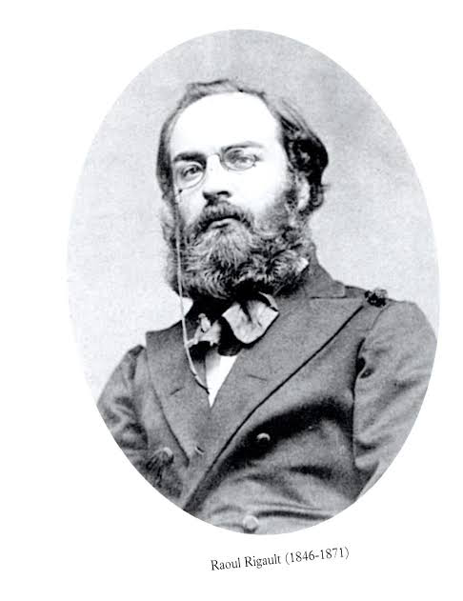

Louis Eugène Varlin (6, 17, 12th district), born on October 5, 1839, in Claye ( Seine-et-Marne ) and died on May 28, 1871, in Paris, is a socialist and libertarian activist, member of the First International and the Paris Commune.
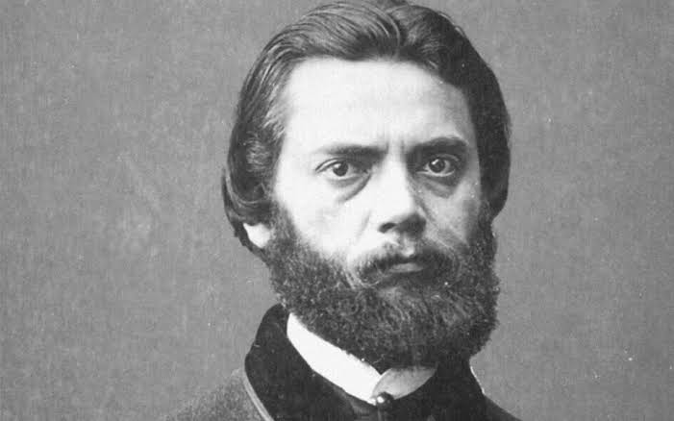

Charles Hypolite Louis Gérardin (17th district), born in Saint-Louis ( Haut-Rhin ) on December 27, 1843, and died in Paris on May 12, 1921, is a personality of the Commune of Paris. During the siege of Paris by the Germans (September 1870-March 1871), he was elected commander of the National Guard and became a member of the Republican Central Committee of the Twenty arrondissements.
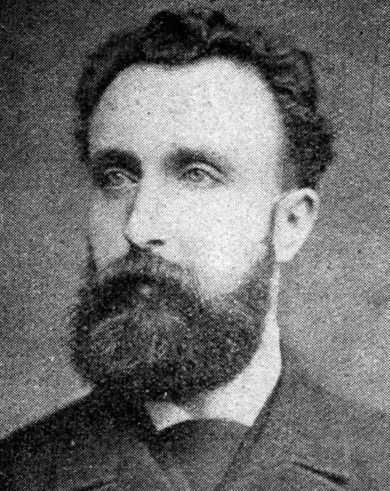

Armand Antoine Jules Arnault or Arnaud (3rd district), born on February 6, 1831, in Lyon and died on August 6, 1885, in Paris, is a personality of the Paris Commune. During the Siege of Paris by the Germans, on January 7, 1871, he signed the Red Poster, which denounced the capitulationist policy of the Government of National Defense and called for the creation of a Commune in Paris. A member of the National Guard, he was elected to its central committee.

Emile-Victor Duval (13th district), born in Paris on November 27, 1840; passed away there on April 4, 1871. Blanquist socialist; from France. worker; a pioneer by profession.
Duval served as a member of the Federal Council of the First International's Paris sections before becoming the Union of Founders' secretary and then its president. He participated in the fight against the anti-national and compromising measures of the bourgeois "government of national defense" after the revolution of September 4, 1870. One of the rebels' leaders on March 18th, 1871, was Duval. He served as a military commandant, a representative at the police prefecture, and ultimately one of the three commanders of the revolutionary Parisian armed forces. On Mar. 26, 1871, the 13th district elected him to the Paris Commune of 1871. He became a member of its Executive and Military Commissions. During the Communards’ attack on Versailles on Apr. 3, 1871, he commanded one of the three columns. Duval was taken prisoner and shot by the Versailles forces.
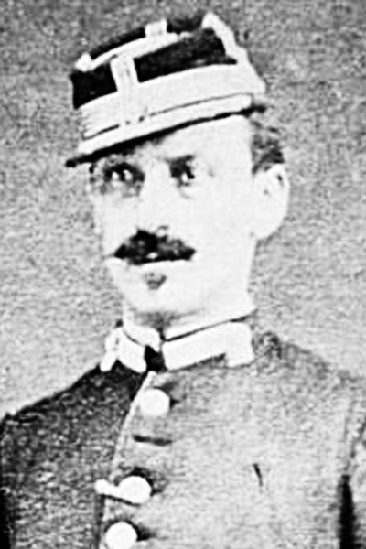

Francois Louis Parisel (15th district), born on October 17, 1841, at La Guillotière and died on July 5, 1877, in Newark, New Jersey in the United States, is a personality of the Paris Commune. He directs the Scientific Delegation. Exiled to the United States, he practiced medicine and was an activist in the socialist ranks. On March 26 1871 he was elected to the Council of the Commune by the 7th arrondissement; he sits on the Subsistence Commission and then on the Scientific Delegation.

Eugène Edme Pottier (2nd district) (4 October 1816 – 6 November 1887) was a French revolutionary, poet, freemason, and transport worker. Pottier was elected a member of the Paris municipal council - the Paris Commune, in March 1871. Following the Commune's defeat, in June 1871 he wrote the poem L'Internationale, which became the International Workingmen's Association anthem during its last years (1871–1876) and has been used by most socialist and left-wing political internationals since.
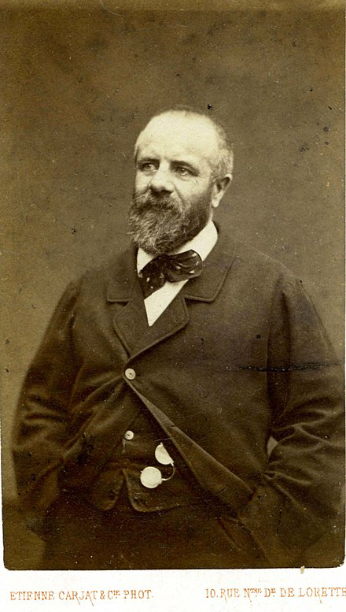

Louis Charles Eugène Protot (11th district) (27 January 1839 –17 February 1921) was a French lawyer (avocat) and a political opponent of the Second Empire. During the Paris Commune in 1871, he was minister of justice for a month before going into exile until 1880. After his return to France, he was prevented from working at the Bar and earned a living as a specialist in Oriental languages.

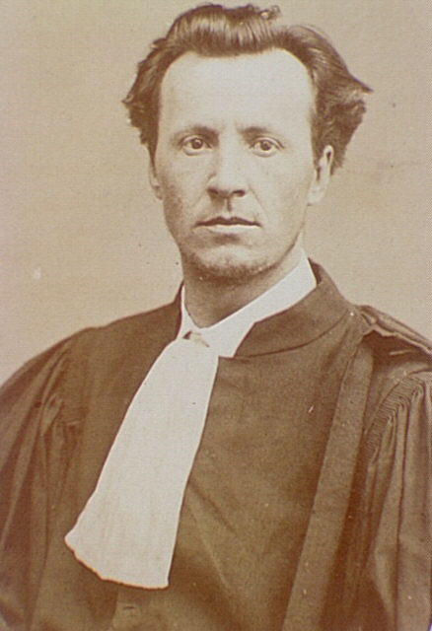

Paul Philémon Rastoul (10th district) (1 October 1835; Thézan-lès-Béziers, Hérault - 1875) was a French physician best known for his role in the Paris Commune of 1871. Rastoul studied medicine in Montpellier from 1855 to 1862 and moved to Paris in 1863 where he began practicing. During the Paris Commune, Rastoul was elected to represent the 10th arrondissement at the Communal Council. He was put in charge of medical services in Paris. After the Commune, Rastoul was arrested and imprisoned in France before being deported to New Caledonia in 1873 where he was allowed to practice medicine and partially recover his liberty. Following the 1874 escape of a group including Henri Rochefort, Rastoul was sent to the Isle of Pines. In March 1875, Rastoul and nineteen others attempted to escape from the island on a raft but drowned.

Albert Frédéric Félix Theisz (12th, 17th district), born in Boulogne-sur-Mer February 13, 1839and dead January 10, 1881, in the 3rd arrondissement of Paris, is a French Communard, elected to the Council of the Commune. On March 26, 1871, he was elected to the Council of the Commune, by the 12th and 17th arrondissements (he chose the 17th ); he sits on the Commission for Labour, Industry and Trade. He became postmaster on April 5. He signs the minority manifesto, He fights on the barricades during Bloody Week.
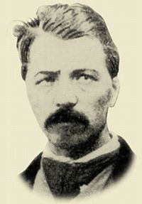

Gustave Tridon (5th district) (Edme-Marie-Gustave), born in Châtillon-sur-Seine ( Côte-d'Or ) on January 1, 1841, and died in Brussels on August 29, 1871, is a French lawyer, politician, journalist, writer, and communard. In the elections of February 8, 1871, he was elected deputy of the Côte-d'Or for the National Assembly He resigned in Bordeaux after having voted, on March 1, against the ratification of the preliminaries of peace signed between the government of Adolphe Thiers and Germany. On March 26 1871 he was elected to the Council of the Commune by the 5th arrondissement by 6,469 votes out of 12,422 voters; he was appointed to the Executive Commission, then to the War Commission.
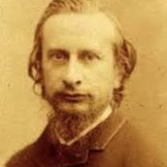

Raoul Urbain (7th district), born on September 22, 1837, in Condé-sur-Noireau and died on March 4, 1902, in Paris XII e, is a personality of the Commune of Paris. During the siege of Paris by the Germans from September 1870 to March 1871, he enlisted in the National Guard and was active in the Pré-au-Clerc club. It is part of the Republican Central Committee of the Twenty Boroughs. During the uprising of March 18, 1871, he occupied the town hall of the 7th arrondissement. On March 26, 1871, he was elected to the Council of the Commune by the 7th arrondissement; he sits on the Education Commission, then on the Foreign Relations Commission and the War Commission.
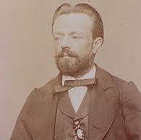

Jules Vallès (15th district) (11 June 1832 – 14 February 1885) was a French journalist, author, and left-wing political activist. At the start of 1871 Jules Vallès at the initiative of the "Comité central républicain des Vingt arrondissements" edited the "Affiche Rouge" posted on January 7: the first call for the proclamation of the Paris Commune. On March 11, Vallès was judged for his participation in the October plot. He escaped from the tribunal after hearing himself condemned to six months in prison, and his Le Cri du Peuple which he had started on February 22, banned from further appearance. On March 18, the Commune was officially proclaimed; on March 21, Le Cri du Peuple reappeared to become one of the most successful newspapers of the Commune - together with Père Duchêne. On March 26 he was elected by the 15th district (Vaugirard: 4,403 votes out of 6,467 voters) to the Conseil de la Commune; nominated to the Commission of Public Education (March 29).
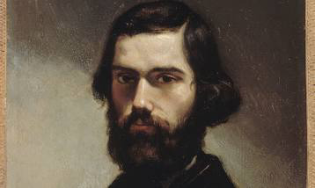

Auguste-Jean-Marie Vermorel (18th district)(21 June 1841 – 20 June 1871) was a French socialist writer, editor and journalist, and leader of the Paris Commune. After the end of the siege of Paris by the Germans (September 1870 - March 1871), he retired to the provinces but returned to Paris after the establishment of the Paris Commune on March 18, 1871. On March 26, he was elected to the Council of the Commune by the 18th arrondissement; He served on the Justice Commission, then the Executive Commission, and finally that of the Sûreté générale.
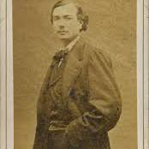

Louise Michel (29 May 1830 – 9 January 1905) was a teacher and important figure in the Paris Commune. Following her penal transportation to New Caledonia, she embraced anarchism. When returning to France she emerged as an important French anarchist and went on speaking tours across Europe. The journalist Brian Doherty has called her the "French grande dame of anarchy." Her use of a black flag at a demonstration in Paris in March 1883 was also the earliest known of what would become known as the anarchy black flag.
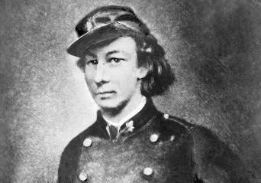

Gustave Flourens (20th district) (4 August 1838 in Paris – 3 April 1871) was a French Revolutionary leader and writer, son of the physiologist Jean Pierre Flourens (who was Professor at the Collège de France and deputy in 1838-1839). He was also the elder brother of Émile Flourens, who became minister of foreign affairs under the Third Republic. On 18 March he joined the population's uprising, was elected a member of the revolutionary Commune by the 20th arrondissement, and was named general. Gustave Flourens was one of the most active leaders of the insurrection, and after a sortie against the Versailles troops on the morning of 3 April, he fled into an inn near the bridge that separates Chatou and Rueil.
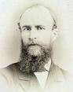

Théophile Charles Gilles Ferré (18th district) (6 May 1845 – 28 November 1871) was one of the members of the Paris Commune, who authorized the execution of Georges Darboy, the archbishop of Paris, and five other hostages, on 24 May 1871. He was captured by the army, tried by a military court, and shot at Satory, an army camp southwest of Versailles. He was the first of twenty-five Commune members to be executed for their role in the Paris Commune.
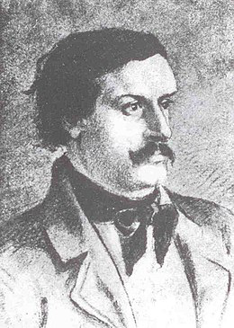

Jules Andrieu (1st district) (Paris, September 30, 1838 - Jersey, February 25, 1884) became a personality of the Commune of Paris (1871).

Charles Amouroux (4th district) was born in Chalabre ( Aude ) on December 24, 1843, and dead May 23, 1885, in Paris ( XXth arrondissement ) He is a personality of the Paris Commune. After the proclamation of the Republic, on September 4, 1870, he is a member of the National Guard and is elected to its Central Committee. He is a member of the International Workers' Association. He was elected to the Council of the Commune by the IVth arrondissement in the elections of March 26 by 8,150 votes.
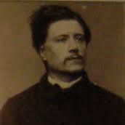

François Jourde or Francis Jourde (5th district), born on July 4, 1843, in Chassagne (Puy-de-Dôme) and died on March 20, 1893, in Nice, is a personality of the Commune of Paris. Active during the Paris Commune, he was a delegate to the Central Committee of the National Guard ( 160th battalion ). During the elections of March 26, he was elected to the Council of the Commune for the Vth arrondissement.
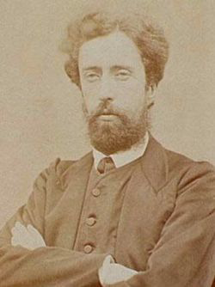

Jean François Paschal Grousset (18th district) (7 April 1844, in Corte – 9 April 1909, in Paris) was a French politician, journalist, translator, and science fiction writer. Grousset was published under the pseudonyms of André Laurie, Philippe Daryl, Tiburce Moray, and Léopold Virey. He was elected a member of the Paris Commune, becoming a member of its executive committee and Delegate for External Affairs.
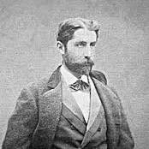

Marie Édouard Vaillant (8th district) (26 January 1840 – 18 December 1915) was a French politician. He was one of the four editors of the Affiche Rouge (red poster) calling for the creation of the Paris Commune. In the elections of February 1871, he stood as a revolutionary socialist candidate for the National Assembly but was not elected. In March 1871 he was elected by the 20th arrondissement to the council of the Commune where he oversaw work on education.
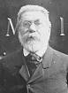

François Léopold Charles Hosteins or Charles Ostyn (19th district), known as Charles Ostyn, was born in Paris on October 20, 1823, of Belgian parents, and died in Argenteuil ( Seine-et-Oise, now Val-d'Oise ) on July 22, 1912 (at 88), is an anarchist figure in the Paris Commune. On March 26, he was elected to the Council of the Commune by the 19th arrondissement; he sits on the Subsistences Committee and then on the Public Services Committee.
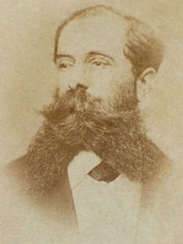

Arthur Ranc (9th district) (20 December 1831 – 10 August 1908) was a French left-wing politician and writer. He was elected to the National Assembly in February 1871 but resigned rather than subscribe to the peace. He had been elected mayor of the 9th arrondissement of Paris in the autumn of 1870, and in March was sent by the same district to the Commune, from which he resigned when he found no reconciliation was possible between the mayors and the Commune. In July he became a member of the municipal council of Paris, and in 1873 was returned to the National Assembly for the department of the Rhône, and took his place on the extreme Left.
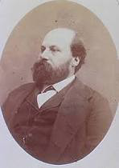

Alfred Billioray (14th district) born on May 1st, 1841 in Naples and died on February 27, 1877, in Nouméa is a French painter and a personality of the Paris Commune. During the siege of Paris by the Germans (September 1870-March 1871 ), he is a member of the National Guard and of the Vigilance Committee of the 14th arrondissement where he is a good organizer. Without being a candidate, he was elected to the council of the Commune by the 14th arrondissement. He sits on the Public Utilities Commission (March 29) and then to finance (April 21st).
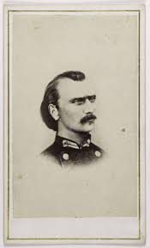

Charles Félix César Longuet (16th district) (14 February 1839, Caen – 5 August 1903, Paris) was a journalist and prominent figure in the French working-class movement, including the 1871 Paris Commune, as well as a Proudhonist member of the General Council of the First International or International Working Men's Association (1866–67, 1871–72). He served as Corresponding Secretary for Belgium (1866), delegate to the Lausanne (1867), Brussels (1868), the London Conference (1871), and the (1872). He was also the editor of the publication Journal Officiel. Longuet participated in the Paris Commune of 1871 and, after its defeat, moved to England as a refugee where he met Karl Marx.
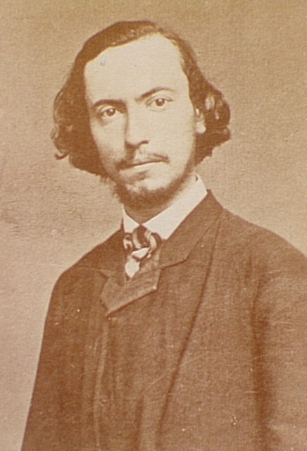

Jean-Baptiste Chardon (13th district), born in Souvigny ( Allier ) on July 19, 1839, and died in Vierzon-Villages(Cher) on November 24, 1898, is a French coppersmith, annuitant, and communard. He is a personality of the Paris Commune. On arch 26, 1871, he was elected to the Council of the Commune by the XIIIth arrondissement. He was a member of the War Commission and then of the General Security Commission (April 5). He was the military commander of the prefecture of police and a member of the first court-martial named April 16( OJ of the Commune, April 17). After Bloody Week he was sentenced to death in absentia by the court-martial, but he managed to take refuge in Switzerland in the company of Eugène Protot.
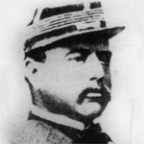

Bibliography

"La Commune De Paris." ‐ Association Des Amies Et Amis De La Commune De Paris 1871. N.p., n.d. Web. 08 July 2014. http://www.commune1871.org/?La‐Commune‐de‐Paris,223
"Causes of Franco‐Prussian War." FrancoPrussianwar.com Franco‐Prussian War 1870‐1871. N.p., n.d. Web. 07 July 2014. http://francoprussianwar.com/#causes
"Chronologie: The French Commune." Marx.org. N.p., n.d. Web. 08 July 2014.
A Brief History Of The World's First Socialist Working Class Uprising"1871: Paris Commune." 1871: The Paris Commune (n.d.): n. pag. Web. http://libcom.org/files/1871The%20Paris%20Commune.pdf

